Primary 2/3 / Miss Connelly Literacy Overview wk beginning 18.01.21
Patna Primary School Chilli Challenge: Mild, Spicy, Hot, Extra Hot
Monday | Tuesday | Wednesday | Thursday | Friday
Writing  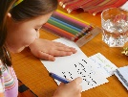  We are learning to write a letter.  Task  Write a letter to a friend or adult from school and tell them how you are getting on with home learning.  What I am Looking For (WILF):  - the correct features of a letter.  -writing in full sentences.  -using the correct punctuation.  Can you include one sentence in your letter?  Can you include 2-4 sentences in your letter?  Can you include 2-3 paragraphs in your letter? | Phonics  We are learning to say, make/break, blend, read and write phonemes.  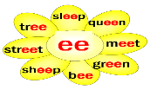  Tasks  Create your own phoneme flower.  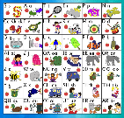  Revise some of the phonemes and single sounds we have already learned.  https://www.thinglink.com/mediacard/1340989677775093762  Flashcards  Use the flashcards from the resource pack or make your own to practice your sounds!    Join our phonics  lesson with Miss  Connelly! | Spelling  We are learning to use our strategies to decode tricky words!  Our Strategies  -sound out the word?  -look for joined phonemes?  -any words inside of the word?  -is it a compound word?  -can you chop it up?  go, be, you, was  this, that, then, with  fly, bring, Mr., two  tell, large, spell, still, saw  Task  Can you make a spelling pyramid?  Challenge- can you create some silly sentences?  Remember it is important you can spell the word as well as read the word! | Reading  We are learning to identify the differences between fiction and non-fiction texts.  Task  Sorting Activity  https://glowscotland  -my.sharepoint.com/  :b:/g/personal/  eaemma_connelly  _glow_sch_uk/EeRl9  JU7ceBHpgAMWxbkJTM  BChluojPAJjKidYnSL  jEimw?e=nuLqQ3  Scavenger Hunt  https://glowscotland  -my.sharepoint.com/:  b:/g/personal/eaemma  _connelly_glow_sch_uk  /EX89etKS3eRAuOfpxQ  xQypwBC22vxjv6karpm  y2ETo-tFA?e=Uckn4j | Grammar  We are learning to recognise verbs and tenses.  A verb is a doing word or an action word.  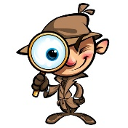  Task  Grammar Detective  https://glowscotland-  my.sharepoint.com/:  w:/g/personal/eaemma  _connelly_glow_sch_uk  /EQL5Ke1c7JNAjOuqt6U  7UFMBMRMjrFVKxkHU7c  ku2BMQgg?e=P2LTm1
Primary 2/3 / Miss Connelly Maths & Numeracy Overview wk beginning 18.01.21
Patna Primary School Chilli Challenge: Mild, Spicy, Hot, Extra Hot
Monday | Tuesday | Wednesday | Thursday | Friday
Multiplication and Division: Arrays  Watch Miss Connelly’s lesson.  Suggested Activities  Arrays Practical Activity  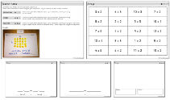  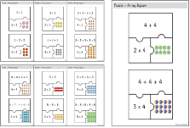  Array Jigsaws  Array Worksheets  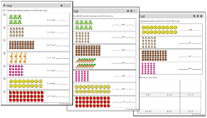 | Multiplication and Division: Double Representations  Watch Miss Connelly’s lesson.  Suggested Activities  Making Doubles Practical Activity.  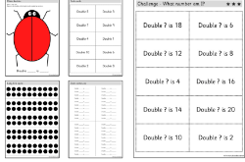  Dice Doubles Game  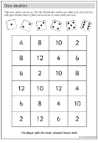 | Multiplication and Division: Times Tables Practice.  Watch Miss Connelly’s lesson.  Suggested Activities  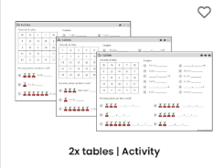  2x Table Activity  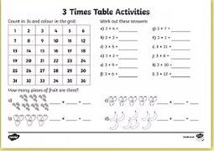  3x Table Activity  Practice the times tables that you already know. Remember p2 we have only started times tables but you can still have a go!  https://www.topmarks.co.uk/maths-games/hit-the-button | Multiplication and Division: Times Tables Practice.  Watch Miss Connelly’s lesson.  Suggested Activities  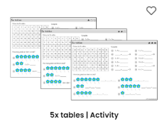  5x Table  Activity  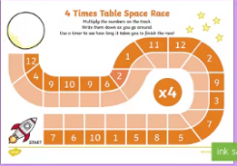  4x Table  Activity  6x Table 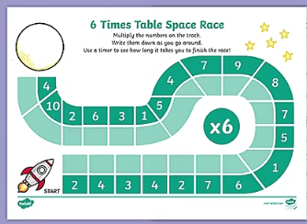  Activity | Multiplication and Division: Times Tables Practice.  Watch Miss Connelly’s lesson.  Suggested Activities  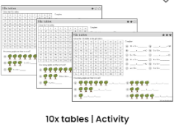  10 x Table  Activity  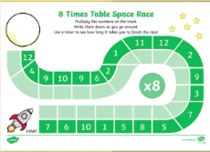  8x Table  Activity  100 Square Splat:  Splat the stations of your chosen times table. Can you spot any patterns?  https://www.topmarks.co.uk/learning-to-count/paint-the-squares

