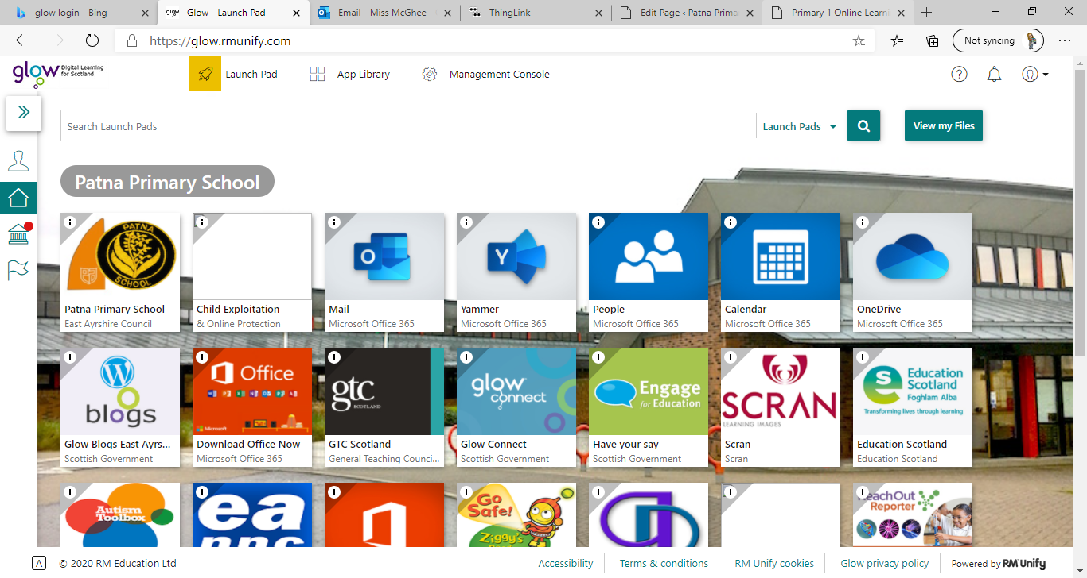**Primary 1** / Miss McGhee   
Patna Primary School   
Literacy Overview 18.01.21

|  |  |  |  |  |
| --- | --- | --- | --- | --- |
| **Monday** | **Tuesday** | **Wednesday** | **Thursday** | **Friday** |
| Attention and Listening   Choose a story from the library corner. After you have read the story link about the following questions. Who is in the story?  What happens in the story?  What’s your favourite part of the story?  **Draw a picture of a character in the story**  Revise the “k” sound- can you find the castanets in the classroom?  Tiger Music Wooden Finger Castanets: Amazon.co.uk: Musical Instruments | Phonics  Learn the sound ‘a’. Click on thing link and complete the activities.    [https://www.thin glink.com/media card/1340989677 775093762](https://www.thinglink.com/mediacard/1340989677775093762)  Pin on Kidlets | Phonics  Learn the sound ‘t’. Click on thing link and complete the activities.  [https://www.thin glink.com/media card/1340989677 775093762](https://www.thinglink.com/mediacard/1340989677775093762)  Jolly Phonics Song - t - YouTube | Mark Making  At the Beach - Lesson 2 - Shaving Cream Sight Words - Half Pint Kids  Decodable BooksCan you practice writing your name?   You could choose from sand, foam or paint?    Practice forming the letters   **Kk Aa Tt** | Attention and Listening  What Am I?   Place around 6 objects on the floor- for example a spoon  a car a teddy bear etc  Give the clues and find the right objects.   “You use me to eat a yogurt… what am I?”   “I have four wheels…. What am I?” |