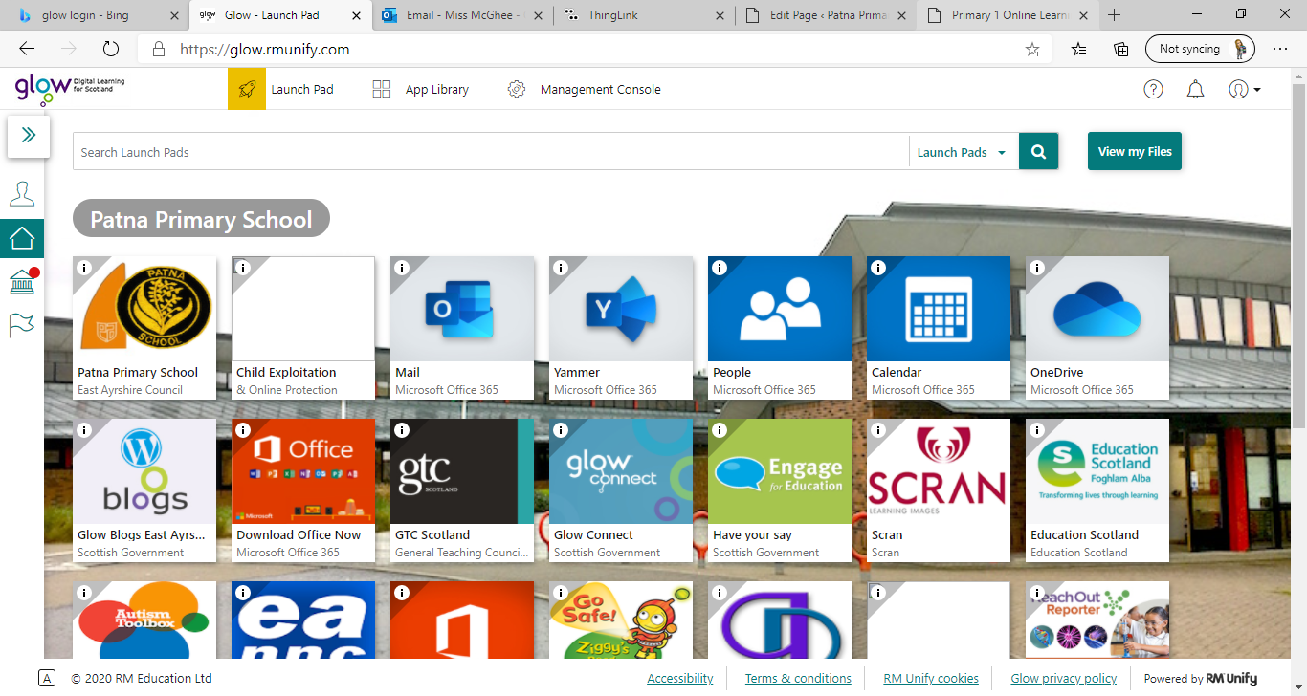**Primary 1** / Miss McGhee   
Patna Primary School   
Literacy Overview 18.01.21 Chilli Challenge Task Difficultly: Mild, Spicy, Flaming Hot

**Video to follow!**

|  |  |  |  |  |
| --- | --- | --- | --- | --- |
| **Monday** | **Tuesday** | **Wednesday** | **Thursday** | **Friday** |
| Handwriting  Dictated sentences: **The cat is sad. Ground, Grass and Sky Alphabet Strips (teacher made)I went to the park.  The bus is very big.**   Letter formation  Practice the following letters. Please make sure you are following the correct letter formation. This week we are practicing ladder letters:  l i u t y | Video icon » SAT-7 UKPhonics    Flashcards Please practice your single sound flashcards.    This week we are revising the sounds:  yY and zZ  Click on the hyperlink to find each sound. Here you can watch videos about the letter and its sound. You can take part in activities, games and letter formation practice. [https://www.thin glink.com/media card/1340989677 775093762](https://www.thinglink.com/mediacard/1340989677775093762) | Spelling  Spelling test  How many of the following words can you spell correctly? a the  at I  the in  New Spelling Words: ***an am***  ***is me***  ***and my***  Rainbow words:  For example  **an is and**   Bubble spelling | Reading  Reading  Read pages 1 and 2 from our reading booklet. Please click the link below to access: [https://glowscotland -my.sharepoint.com/:b: /g/personal/eashannon _mcghee1_glow_sch_u k/EZTLFHLsPh9Gp- rHkUtrvtQBwybng 7UIdDbWB1rY8SQ 7sw?e=2bp9uC](https://glowscotland-my.sharepoint.com/:b:/g/personal/eashannon_mcghee1_glow_sch_uk/EZTLFHLsPh9Gp-rHkUtrvtQBwybng7UIdDbWB1rY8SQ7sw?e=2bp9uC)  Bugclub  Chose a book to read on BugClub  (Miss McGhee will provide more support on how to access BugClub during Monday’s ‘check in’ phone calls) | Video icon » SAT-7 UKWriting  The Three Little Pigs  **Listen to the story  Re-tell the story  Make a story map with labels**  *Follow along during Miss McGhee’s daily lesson video* |

**Primary 1** / Miss McGhee   
Patna Primary School   
Numeracy Overview 18.01.21 Chilli Challenge Task Difficultly: Mild, Spicy, Flaming Hot

|  |  |  |  |  |
| --- | --- | --- | --- | --- |
| **Monday** | **Tuesday** | **Wednesday** | **Thursday** | **Friday** |
| Number  Ordering Can you make your own flashcards with the numbers 1-30. Give them a mix.  Can you order numbers  **1-10 1-20 1-30  Extra activity:** [Lesson: Ordering numbers up to 20 | Teacher Hub | Oak National Academy (thenational.academy)](https://teachers.thenational.academy/lessons/ordering-numbers-up-to-20-6rt3ad) Watch the ordering lesson on the national academy   Skip Counting Can you count in 2s? This is something new to try with an adult at home. | ICT Tuesday  [[IVOR] Bud's Number Garden (bbc.co.uk)](https://www.bbc.co.uk/games/embed/education-ivor-starting-school?exitGameUrl=https%3A%2F%2Fbbc.co.uk%2Fbitesize%2Farticles%2Fzd4b382)  [Curious George . Hide and Seek | PBS KIDS](https://pbskids.org/curiousgeorge/busyday/hideseek/)    [Counting in 2s Interactive Mad Maths (snappymaths.com)](http://www.snappymaths.com/multiplication/countin2s/interactive/icountin2s/icountin2s.htm) | Number  Estimation- number sense  Estimation means: To find a value that is close enough to the right answer, usually with some thought or calculation involved.  Play an estimation game at home- place buttons on a plate- look at them for a few seconds before an adult covers them. Record your estimation- was it close?  Justify and talk through your answer. Remember it’s not just a “guess” Extra activity: [https://glowscotland-my.sharepo int.com/:b:/ g/personal/eashannon_mcghee1_glo w_sch_uk/EQ2b7owuzvxOqChqKW Mli7QBKFD9mtL8F1xlVRR5Mj9LoQ ?e=Yi5gPE](https://glowscotland-my.sharepoint.com/:b:/g/personal/eashannon_mcghee1_glow_sch_uk/EQ2b7owuzvxOqChqKWMli7QBKFD9mtL8F1xlVRR5Mj9LoQ?e=Yi5gPE) | It’s Nothing New  Measurement: Length Non-standard units Go outdoors or stay inside and do some non-standard measuring. You can use your hands/ counters/ stones or socks to **estimate** the length of objects.  Deanna McLennan Ph.D on Twitter: "Using nonstandard objects from around the  house (blocks, legos) to measure treasures from nature. Record your  observations in different ways. What's the tallest dandelion you can find? #  Extra Activity:[Measuring in Centimetres (topmarks.co.uk)](https://www.topmarks.co.uk/maths-games/measuring-in-cm) | Calculations  Subtraction: Use concrete objects to help you or try on your own.  **3 - 2=**  **2 - 1=**  **4 - 2=**  **6 - 2=**  **7 - 1=**  **8 - 3=**  **10 - 4=**  **9 - 3=**  **11 - 4=**  **13 - 3=**  **10 - 5=** |