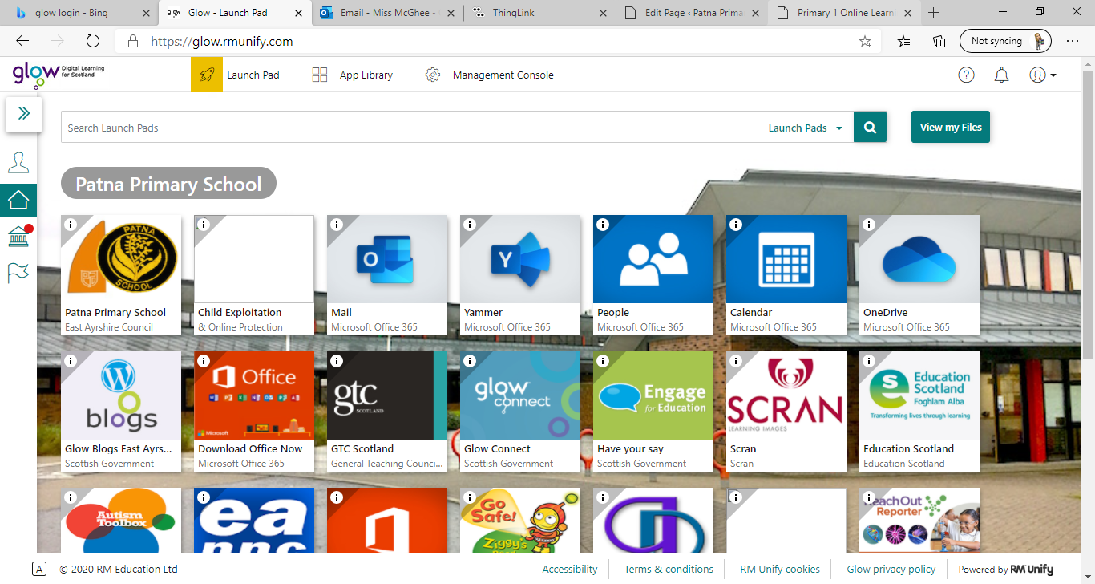**Primary 1** / Miss McGhee   
Patna Primary School   
Literacy Overview 11.01.20 Chilli Challenge Task Difficultly: Mild, Spicy, Flaming Hot

**Video to follow!**

|  |  |  |  |  |
| --- | --- | --- | --- | --- |
| **Monday** | **Tuesday** | **Wednesday** | **Thursday** | **Friday** |
| Handwriting  Practice writing your name:  Ground, Grass and Sky Alphabet Strips (teacher made)**Copy write your name**  **Write your first name independently**  **Write your first and second name independently**   Letter formation  Practice the following letters. Please make sure you are following the correct letter formation. This week we are practicing curly letters:  c a d g q  [Letter Formation Curly Letters - YouTube](https://www.youtube.com/watch?v=4BcrxN9EKCc) | Video icon » SAT-7 UKPhonics  Please practice your single sound flashcards. You should have a set of flashcards at home.   This week we are revising the sounds:  qQ and uU  Click on the hyperlink to find each sound. Here you can watch videos about the letter and its sound. You can take part in activities, games and letter formation practice.  [https://www.thin glink.com/media card/1340989677 775093762](https://www.thinglink.com/mediacard/1340989677775093762) | Spelling  Today we are revising our spelling words. Can you practice spelling the following words: **a the**  **at I**  **the in**  Creative spelling ideas:  -**Pyramid Writing**  For example:  w  we  wen  went  - **Newspaper words:**  Find your words in  an old newspapers  or magazines, cut  Learn, Cutout Newspaper Letters Stock Image - Image of learn, newspaper:  39010471them out  -**Messy words:**  Write your words in  shaving foam or whipped cream | Reading  Today try reading your common words flashcards.   **a at the I in it an is and am me my did as he**    Word Hunt: Hide your common words around the house and go on a word hunt  Word Twister: Choose 8 words to write on the ground- “put your foot on ‘at’”  Word Splat: Place the flashcards on the floor. Can you splat the correct word with a wooden spoon | Video icon » SAT-7 UKWriting  CVC Writing Strips by Tara West | Teachers Pay Teachers  CVC Bingo: Pick a picture and write the word. How many words can you write independently?   **Can you write the word**  **Can you write the word and use it in a sentence**  **Can you write the word and use it in a super sentence** |

**Primary 1** / Miss McGhee   
Patna Primary School   
Numeracy Overview 11.01.20 Chilli Challenge Task Difficultly: Mild, Spicy, Flaming Hot

**Video to follow!**

|  |  |  |  |  |
| --- | --- | --- | --- | --- |
| **Monday** | **Tuesday** | **Wednesday** | **Thursday** | **Friday** |
| Number  Pictures of Number 1-10 | Free printable numbers, Printable numbers, Numbers  preschoolPractice counting forwards and backwards to **10, 20, 30** With an adult can you tell them the numbers that come before and after:  **3 5 6 2 7 4**  **11 8 10 9 14 15 19 21 25 29 13 22**  Practice subitising! Watch the videos below: [Videos that Teach Subitizing - Lucky Little Learners](https://luckylittlelearners.com/videos-that-teach-subitizing/)  Can you recognise and read the numbers: **1-10** **1-15** **1-30** You may want to make your own flashcards | ICT Tuesday    [Learn to Count up to 10 with Underwater Counting Maths Game (topmarks.co.uk)](https://www.topmarks.co.uk/learning-to-count/underwater-counting)  [Coconut Ordering - Comparing Numbers, Prices, Mass, Length and Capacity (topmarks.co.uk)](https://www.topmarks.co.uk/ordering-and-sequencing/coconut-ordering)    <https://www.topmarks.co.uk/learning-to-count/teddy-numbers> | The Joy of a Pocket-sized Cotton Ten Frame | Creative STAR Learning | I'm a  teacher, get me OUTSIDE here!Video icon » SAT-7 UKNumber  Learning About Ten Frames | Creative Kindergarten | Ten frame, Ten frames,  CreativeCreate your own ten frame at home like the ten frame trains we use in school. You could draw your frame or make it from sticks or tape.  Use pasta or buttons as counters and show the following numbers:  **4 1 6 3 2 5  7 6 2 9 10 12 14 17 8 16 20 13** (for numbers beyond 10 remember you will need two grids)  [Ten Frames (didax.com)](https://www.didax.com/apps/ten-frame/) | Video icon » SAT-7 UKIt’s Nothing New  3D Shape Hunt - Photo Activities for Preschoolers - Life At The ZooRevision time! Can you name the 2D and 3D shapes.   Go on a shape hunt around your home 😊 | Calculations  **You may use concrete materials/ objects to help you work out the answer.** Addition Mat with counters & dry wipe pen -Numeracy Teaching Aid -  EYFS/KS1/SEN | eBay  2 + 2= 1 + 3=  3 + 2= 5 + 5=  4 + 3=  7 + 2=  8 + 1= 4 + 4= Have an adult read out the calculation and write it down using the correct symbols. |