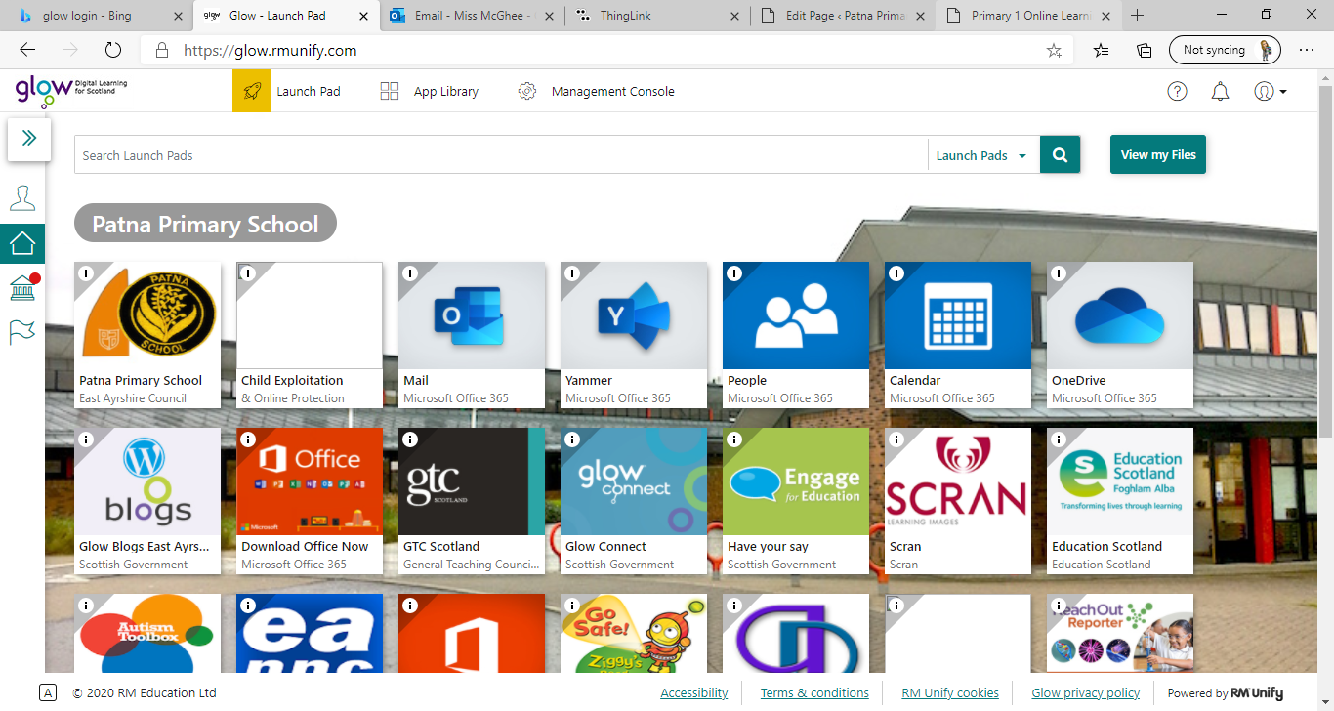**Primary 1** / Miss McGhee   
Patna Primary School   
Literacy Overview 11.01.20

|  |  |  |  |  |
| --- | --- | --- | --- | --- |
| **Monday** | **Tuesday** | **Wednesday** | **Thursday** | **Friday** |
| Attention and Listening   Listen to or read the following story.  What happens at the beginning, middle and end?  Who is in the story? Where does the story take place?      [The Smartest Giant in Town - Julia Donaldson audiobook. Children's story book read-aloud - YouTube](https://www.youtube.com/watch?v=6gw-wfxFrfA) | Phonological Awareness    Syllable activity   Can you clap or tap the following words?   How many syllables do they have?  **jumper**  **dog**  **crocodile**  **smartest**  **stop**  **rainbow**  **elephant giant** | Phonological Awareness  Rhyme activity   Can you match the words that sound the same?  [Words that rhyme with bug game (roythezebra.com)](https://www.roythezebra.com/reading-games/words-that-rhyme-with-ug.html) | Mark Making  Can you draw a giant?  You could draw a giant on the iPad Use some paint  Or a wet paint brush  Get someone to draw around your body with chalk to see how tall you are. Can you add  eyes, ears, nose and mouth? | Attention and Listening  What Am I?   Place around 6 objects on the floor- for example a spoon  a car a teddy bear etc  Give the clues and find the right objects.   “You use me to eat a yogurt… what am I?”   “I have four wheels…. What am I?” |