Anxiety is a common emotion, and it is likely that at one point or another we have all experienced it. We recognise that for some children and young people, these feelings of anxiety might make it more difficult for them to cope with everyday events. Parents and carers whose child is anxious may feel that their anxiety is also heightened as a result. The good news is that there are many things that we can do to help ourselves and our children to manage this anxiety.
Anxiety is a normal emotion experienced by almost everyone. There are many things we can do to manage it when it does occur.

Anxiety can be confusing for the person experiencing it and those around them and it can be difficult to know how best to respond.

Yelling
Creates power battles where children dig their
heels in more, adults become frustrated
Peaceful
methods
You might worry that 'being soft;
encourages the problem
Judgement
You might feel judged, creating
increased anxiety for yourself

Anxiety for children
Imagine facing your greatest fear – close your eyes and really think about it for a moment. In our
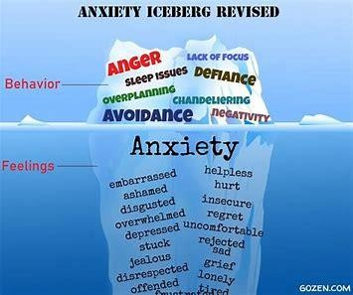
children’s minds their worry becomes their greatest fear and then we expect them to face it daily. Even though there is no real threat/danger, to the child the danger is real and insurmountable. As a parent/carer it can be heart-breaking and frustrating to
watch your child deal with anxiety. Anxiety and the Body
When our body gets anxious, we experience physical symptoms which can include sweat, sickness, headaches and increased heart rate to name a few. These are automatic reactions and can invoke a fight or flight respond – increased aggression or running away.

Despite these difficulties we can offer support and work on ways to cope, calm the body and reduce fear by creating safe predictable environments, trusted adults and positive experiences. It is essential that you work with your child to find effective ways to reduce their anxiety.
Ideas for Children and Young People to manage anxiety


Basic relaxation techniques

Squeeze a lemon in your hands, releasing the juice into a bowl. Stretch your arms over your head reaching for the sky.
Shrug your shoulders tight and curl up into a ball, like you are hiding in a tortoise shell.

Wrinkle your nose like you are trying to get a bug off it.

Imagine it has been raining and you are standing barefoot in the mud! Imagine you are squishing your toes in it – wriggle your toes about in your shoes.

Notice and stop!
Pay attention to when you start to worry. If you feel your tummy starts to ache and you start breathing faster take note of it and take action! Tell yourself to ‘STOP!’ and do something that will take your mind off it like speaking to someone or watching TV. Keep a diary of your worries in words or pictures.


Mental Health Toolbox
Think about all of the things you can do that will make you feel less anxious and write them down. Think of these things as tools that you can take out of your ‘toolbox’ when you feel worried or are letting your negative thoughts get on top of you.
Weigh it up
If you have a negative thought or believe something bad to be true, think about the evidence you have to back those thoughts up. Write down all the things that prove it to be true then all of the things against it and see how needless your worry or negative thought is.




It’s all about the music! Make up a play list of songs that make you feel calmer and happier. Try playing it when you feel anxious and track how much it helps over the course of a week.
Be positive
Aim for writing down three positive thoughts or things that you experience each day or each week. You could also write down one thing you are thankful for each day (E.G. the sunshine/ a good dinner/ laughing with a friend on the phone etc.). You could create a ‘positive thoughts’ scroll and decorate it with your favourite colours or stickers.
Practice positivity by turning the negative words you use against yourself into powerful tools that work in your favour: I am enough! I am worthwhile I can do this I am a good person
Hand of control

Be active
Aim for taking part in physical activity for 30- 60 minutes a day. Go a walk close by or play in the garden.
Place your hand on a piece of paper and draw around it. On the inside of your hand write down everything that is within your control (homework, putting your phone away etc.) then write down what you can’t control around the outside (what people think of me, the questions I’ll get asked in the exam etc.). Remember your answers and look at them when you next feel anxious or unable to control something.
You can only take charge of yourself and how you act and behave – remember that (though this may frustrate us) you can’t control the actions of others; let them go!
2

REFRIGERATOR REMINDERS - Stick these handy reminders onto your fridge…
  TAKE TIME FOR YOU  Arrange to meet or call a friend or another parent, have a chat and share your plans for returning to school after a period of absence.  Suggest walking to school together or arrange to meet up after school starts.  Try to have some ideas of how you will manage. Show confidence even if you feel a bit wobbly. Model deep breathing techniques… “I’m a little worried right now but I’m going to take three deep breaths.”  Above all, be kind to yourself.  We’ve all been through exceptional circumstances. |  | SCHOOL  Share anything important with your school. Let school know about family changes, positive achievements or challenges experienced.  If something works for your child to calm them at home when they are anxious, share this tip with school.  We all want what is best for your child and working together we can achieve that.

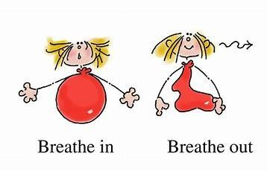

YOUR CHILD
Support your child to contact a friend from school, chat online or spend some time together.
Encourage your child to think of ways that they can be kind to others and pay attention and praise your child when you notice them doing this.
It can be unsettling not knowing what may happen. Help your child focus on all the things they do know, such as how to get to school, what they will wear, seeing a friend.
Teach breathing techniques and make it fun… “Let’s pretend we are blowing out all your
birthday candles.”
Name feelings and try to problem solve together “I wonder if you are feeling sad just
now…what could we do together to help.” Read stories or watch movies where the character
has overcame scary situations.

Helping your child feel less worried
5. Discuss with your child their reluctance and anxiety about going to school. Try to explore their concerns (often easier said than done) and try to establish if there are specific worries about aspects of school.
4. Reduce the amount of time your child has to think about the event. Often the hardest part for children who are anxious is the run up to the scary event. Therefore, you should try to keep this waiting period to a minimum.
3. Model calm
Children copy their parents’ behaviours, and so it is important to also consider how your own anxiety might be affecting your child. If you are anxious, your child will pick up on it and feel more worried. So, when you want to reduce your child's anxiety, you must manage your own anxiety first. You can do this by modelling how you successfully manage anxiety; let your child know when you are
using a coping skill… “I’m feeling a little bit nervous about that, I’m going to take a few deep breaths to calm myself down”. If you model these skills and look for the positive in situations, so will your child.
1. Empathise and encourage
It is important to let your child know that overcoming anxiety is hard work, and that you are proud of their efforts. Show that you understand their experience and are listening to what they have to say while trying not to reinforce their fears. The message you want to send is, "I know you're scared, and that's okay, and I'm here. I'm going to help you get through this."
Help your child to understand that worry, fear and anxiety are all normal emotions and that they can learn to manage and cope with these normal responses to difficult or scary situations. Make sure you recognise and celebrate their achievements in facing their fears. Reinforce these
achievements and build on every small win. Don’t avoid everything that causes anxiety – gradual exposure to challenging situations is important because that is what builds resilience.
2. Don’t ask
leading questions
Whilst it is important to encourage your child to talk about their worries, asking leading questions should be avoided as this can reinforce anxiety. For example, try asking “How are you feeling about today?” rather than “Are you worried about school today?”

Final Thoughts…
6

The language and words we use can help to soothe and calm a child/young person.
Here are eight different aspects of language, with some examples provided for each, as we consider the kinds of messages some young people may need to hear as they return to education following a period of absence.

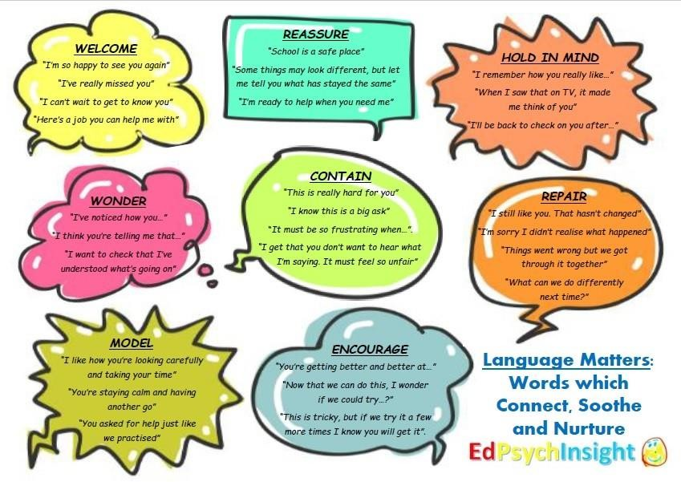
https://www.epinsight.com/post/language-matters-words-which-connect-soothe-nurture

