What Changes Happen in a Teenager’s Brain?
Teenagers’ brains are still under construction — especially the parts responsible for planning, decision-making, and managing emotions. This explains why teens can be mature one moment and impulsive the next.
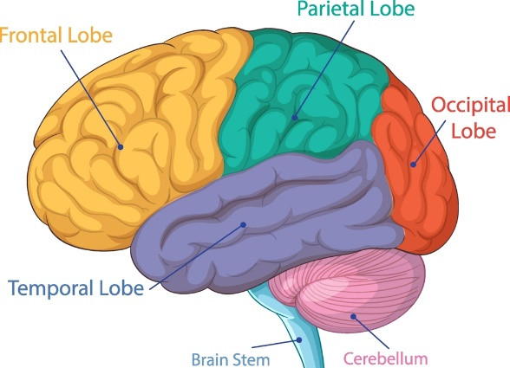

🔍 1. The Brain Develops from Back to Front
The last part of the brain to fully mature is the prefrontal cortex — the area responsible for:
- Planning
- Problem-solving
- Judgement
- Understanding consequences
- Self-control.
This area won’t fully develop until the mid-20s. Until then, teens rely more on the amygdala, the emotional centre of the brain. This means they often feel first and think later.
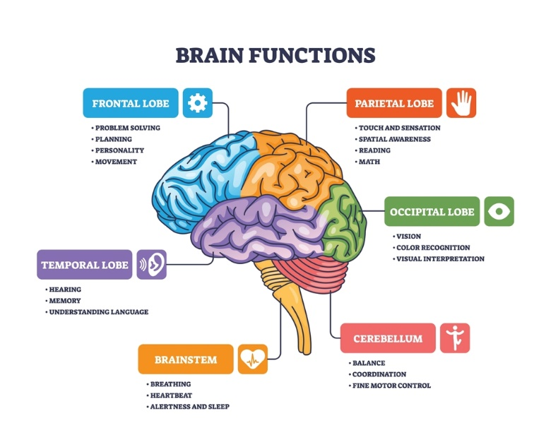

🔥 2. Emotions Feel Bigger and More Intense
Because the emotional part of the brain develops earlier than the rational part:
- Feelings can be stronger and harder to manage
- Reactions may seem dramatic or unpredictable
- Teens may struggle to explain their behaviour afterwards.
This isn’t defiance — it’s biology. Their emotional system is running at full power while the control system is still wiring up.
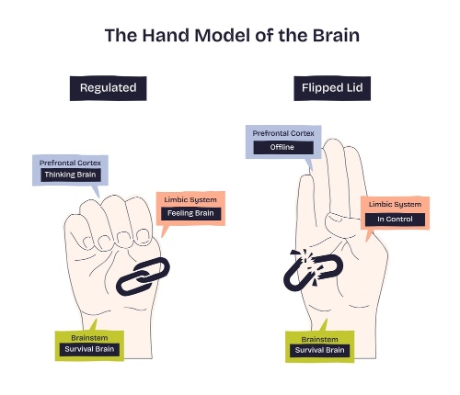

🎢 3. Increased Risk-Taking and Sensation-Seeking
Teen brains are wired to seek:
- New experiences
- Excitement
- Peer approval.
This is because the reward system in the brain becomes extra sensitive during adolescence. Teens get a bigger dopamine “hit” from exciting or risky situations, especially when friends are watching.
This helps them learn independence — but it can also lead to impulsive decisions.


👥 4. Peer Influence Becomes More Powerful
Teenagers’ brains are highly tuned to social signals.
They are:
- More sensitive to rejection
- More influenced by friends’ opinions
- More motivated by belonging
- This is a normal part of developing identity and social skills.


😴 5. Sleep Patterns Change
Teenagers naturally:
- Feel awake later at night
- Need 8–10 hours of sleep
- Struggle with early mornings.
This shift is biological, not laziness. Lack of sleep affects mood, concentration, and behaviour.

🧩 6. The Brain Is Being Rewired
During adolescence, the brain goes through a process called synaptic pruning:
- Unused connections are removed
- Frequently used connections become stronger.
This makes the brain more efficient — like upgrading a computer. But during the process, thinking and behaviour can feel inconsistent.


🌱 7. Teens Are Learning to Become Independent Adults
All these changes help teenagers:
- Form their identity
- Learn independence
- Develop emotional intelligence
- Build adult thinking skills.
The behaviours that feel challenging are often signs of healthy development.

