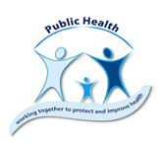**Supporting children & young people’s mental wellbeing**

**Guidance for parents and carers**

It is normal for children and young people to be worried during this COVID-19 pandemic. There are simple things the people around children and young people can do to help them cope

* Keep as many routines as possible to encourage stability
* Acknowledge that it is ok to be concerned, and reassure that things will get better
* Be positive; help them to think about things they can do to make them feel good
* Help to set small achievable goals each day or each week
* Check in with them regularly

**Day-to-day tips for how you can support your child's mental wellbeing**

* Limit the amount of news and information they hear about coronavirus.
* Talk openly about mental wellbeing– Just as you might encourage them to eat fruit and veg to keep their bodies healthy, talk openly about, for example, being physically active in order to take care of their minds.
* Do yourself what you would like them to do– Children often learn from copying what they see around them. If you are taking care of your own mental wellbeing, it's easier for them to see what good habits look like.
* Notice any changes in your child's moods or behaviour– Young people tell us how they're feeling in many ways, not always verbally. Learning what is normal for your child makes it easier to notice when things change, which may be a sign that they're struggling

**How to have a conversation about mental wellbeing with a child or young person**

* Try to **understand the situation** that the child or young person is in without telling them what you think
* **Taking part in other activities** while the conversation is progressing can be helpful
* Listen carefully, be patient and friendly and **give your full attention**
* Give advice **when asked for it or after checking** if they would like advice
* Encourage your child or young person to share their thoughts and experiences by asking **questions** like the examples below

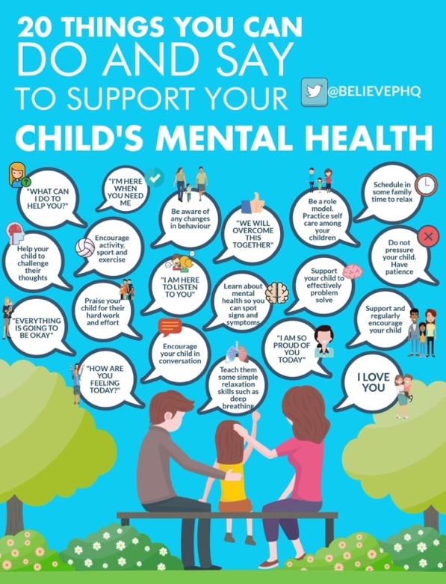

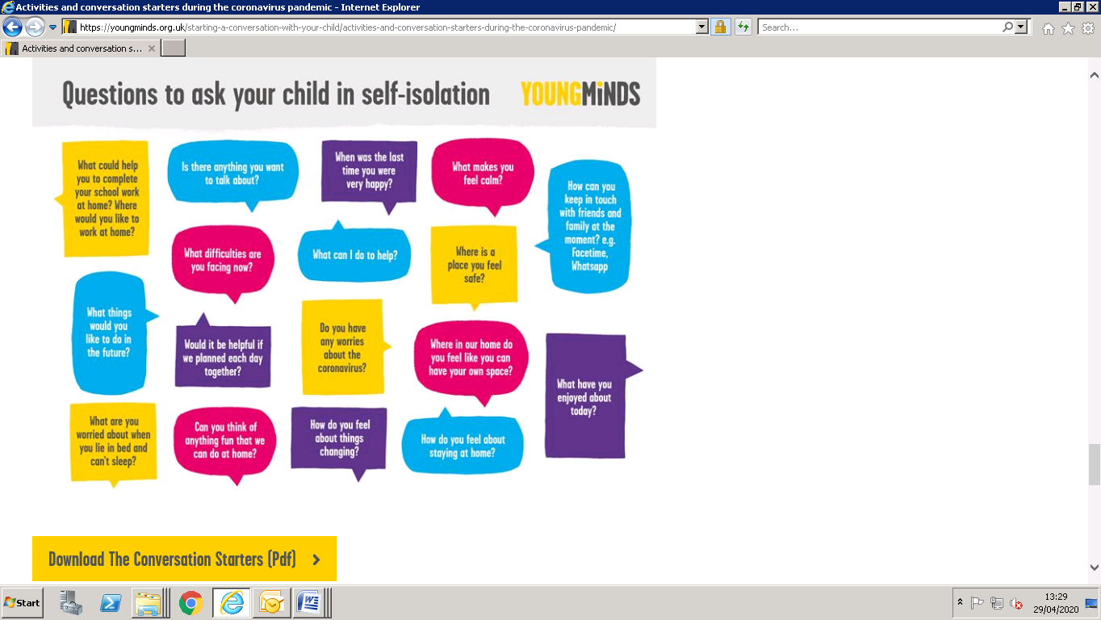

**10 ways children & young people can improve their mental health & wellbeing**

During social distancing we may have to rethink how we encourage children and young people to look after their wellbeing and adapt some of the ways below:

* Eat healthily and keep hydrated
* Keep physically active
* Ensure you get enough sleep
* Take time to do things you enjoy
* Keep in touch with friends and family
* Take a break and time to relax
* Talk about how you are feeling
* Accept and value who you are
* Care for others or for animals
* Don’t be afraid to ask for help

**Wellbeing Activities**

In the same way we encourage children to look after their physical health every day, we should encourage them to look after their mental health & wellbeing every day. Help them to think of some activities that they usually enjoy. This can be anything at all whether it is a hobby, an activity or a task. During social distancing they may not be able to do some of the things that they usually enjoy doing. Encourage them to adapt them for the house or to use this time to try some new ‘Wellbeing Activities’ from our suggestions below:

* Online exercises
* Play a board game
* Baking or Cooking
* Help around the house
* Walking or cycling
* Create a daily ‘to do’ list
* Learn a new skill online
* Gardening
* Colouring or Craft
* Have a ‘clear out’
* Look through old photos
* Start a journal
* Spend time outdoors
* Read a book or magazine
* Phone or video call friends or family
* Dance or listen to music
* Make a ‘happy playlist’
* Yoga

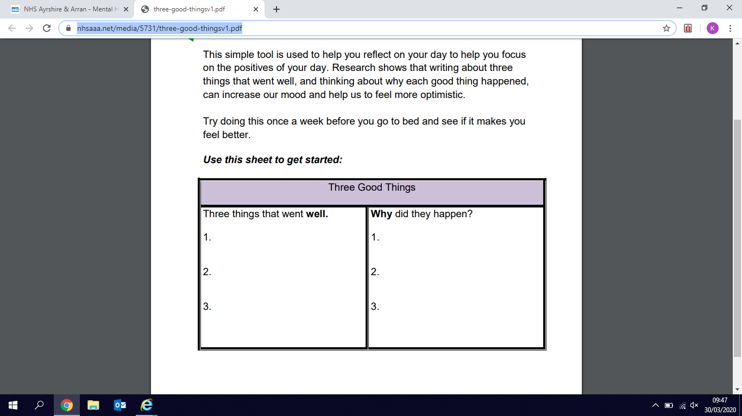**Gratitude & positivity**: thinking about three things that went well or made us smile can improve our mood, help us feel more positive and able to cope. **Small things are best**! It can be anything from a smell, sound or touch. It can be something you have done or something someone has done for you. Use the template to help your child write down their ‘**3 Good Things’** regularly if that helps:

**Apps and Websites**

There are a range of apps and websites available to support children and young people’s mental health and wellbeing

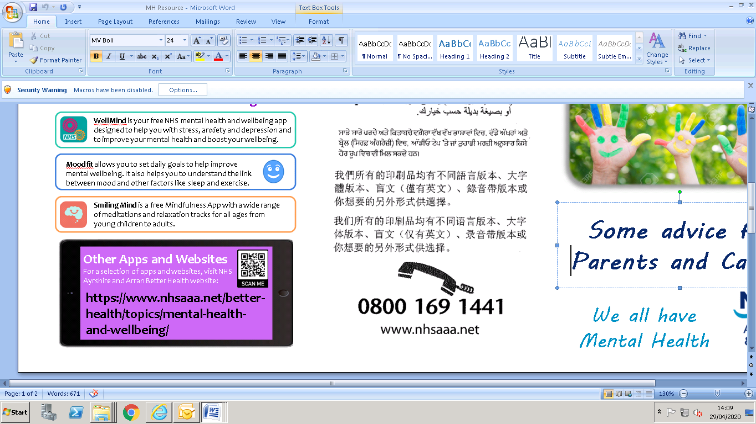



**If you are worried or need someone to talk to, below are some telephone help lines that offer confidential support:**

* Parentline-0808 028 22 33
* Breathing Space-0800 83 85 87
* Childline-0800 1111
* NHS 24-111



The Better Health Hub (BHH) service provides support and information on a range of matters that can impact **health and wellbeing**.

BHH staff can also help people to identify ways to take care of themselves during the current COVID-19 outbreak. Contact the service on 01563 825611. You can leave a message for a call back.

[Please click here for more information about how to get in touch using telephone or video call (Near Me/Attend Anywhere).](https://www.nhsaaa.net/media/10290/bhh-covid-poster-feb-2021.pdf)

Alternatively, you can email [**AA-UHB.BetterHealthHub@aapct.scot.nhs.uk**](mailto:AA-UHB.BetterHealthHub@aapct.scot.nhs.uk%20%20)

**Additional information**

The links below contain a lot of useful information on how to support your child during the outbreak of COVID-19

[**Improving children & young people’s mental health & wellbeing**](https://blogs.glowscotland.org.uk/na/public/naccovid19/uploads/sites/18472/2020/03/27120821/MIS19-119-GD-Children-and-young-people-mental-health-and-wellbeing.pdf)**(**parents/carers leaflet) [**Cool Heads**](https://www.moodcafe.co.uk/media/43769/Cool%20Heads%202014.pdf)

[**Ru worried**](http://www.healthscotland.com/uploads/documents/153-RU%20Worried-June2019-English.pdf)

[**Ru sad**](http://www.healthscotland.com/uploads/documents/152-RU%20Sad-August2019-English.pdf)

[**Phrases for calming anxious children**](https://www.youtube.com/watch?time_continue=18&v=v67RnOyHSEk&feature=emb_logo)(YouTube video by Dr Pooky Knightsmith)

[**Young Minds parent’s helpline**](https://youngminds.org.uk/find-help/for-parents/parents-helpline/)

<https://clearyourhead.scot/>

<https://twitter.com/BelievePHQ> (Simple eye catching posters for families and children)

<https://www.gov.uk/government/publications/covid-19-guidance-on-supporting-children-and-young-peoples-mental-health-and-wellbeing/guidance-for-parents-and-carers-on-supporting-children-and-young-peoples-mental-health-and-wellbeing-during-the-coronavirus-covid-19-outbreak>

<https://www.parentclub.scot/topics/coronavirus>

<https://www.parentclub.scot/articles/talking-to-your-kids-about-coronavirus>

<https://www.who.int/emergencies/diseases/novel-coronavirus-2019/advice-for-public/healthy-parenting>

<https://www.childrenssociety.org.uk/coronavirus-information-and-support>

<https://www.childrenscommissioner.gov.uk/2020/04/03/angry-fed-up-isolated-coronavirus-and-childrens-mental-health/>

<https://www.annafreud.org/what-we-do/anna-freud-learning-network/coronavirus/>

<https://youngminds.org.uk/find-help/for-parents/supporting-your-child-during-the-coronavirus-pandemic/>

<https://www.unicef.org/coronavirus/covid-19-parenting-tips>

<https://www.mentalhealth.org.uk/coronavirus/talking-to-children>