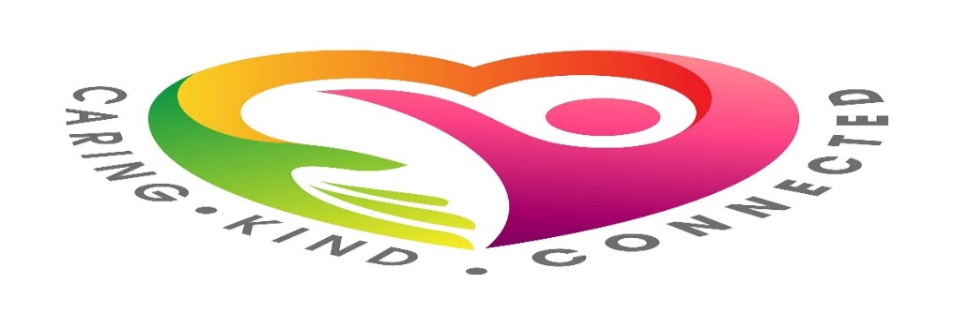
WELLBEING SUPPORT DIRECTORY
INTRODUCTION
LOOK AFTER YOUR WELLBEING

These are worrying and uncertain times. The coronavirus outbreak has changed daily life for us all in Scotland and has had a real impact on how many of us are feeling. It's ok to not feel yourself right now but you can find support within these pages to help get you through it.
The important thing is to talk to someone and share how you are feeling – whether that’s a friend, family member or by reaching out to one of these organisations.
Use this directory to find the right support for you; from practical financial advice to hints and tips on managing your mental wellbeing throughout these challenging times.

Contents
MENTAL WELLBEING 4
MINDFULNESS 5
LOOK AFTER YOURSELF 5
THE BETTER HEALTH HUB 6
IT’S GOOD TO TALK 7
COMMUNITY CONNECTORS 8
MENTAL HEALTH 8
MENTAL HEALTH PRACTITIONERS 9
PHYSICAL ACTIVITY 10
RELATIONSHIPS 10
FINANCIAL 11
FOOD PROVISION 12
ALCOHOL AND DRUGS 13
PROTECTING PEOPLE 14
CHILD PROTECTION 14
VIOLENCE OR ABUSE 15
EATING DISORDERS 15
ALZHEIMERS 16
DEPRESSION 16
BULLYING 17
SEXUALITY 18
SEXUAL ABUSE 18
BEREAVEMENT 19
SUICIDE 20
SELF HARM 22

MENTAL WELLBEING
During this challenging time, many of us may be feeling anxious or stressed as we all try to adapt to our new ‘normal’. Here are some hints and tips for you to try.
If you are feeling anxious or stressed here are some things you may want to try:
- Breathe: Take a few deeper breaths than normal. A long slow in breath (from your stomach) and a long slow out breath; paying attention to your breathing. Feel a sense of letting go on the out-breath.
- Ground yourself: Feel your feet on the ground - notice any sensations like tingling or heat or cold. Paying attention to your feet takes your attention away from thoughts and difficult emotions.
- Smile: You may not feel like smiling, but doing it will automatically relax tension in your body and may light up someone else’s day if they see you.
- Notice: Take notice of one thing you can be grateful for, right now in this moment e.g. help from others; a comfy bed, the taste of tea or coffee; messages from friends; daffodils etc.
Being more mindful can help reduce feelings of anxiety or stress and can help improve self-compassion, the quality of sleep and improve relaxation. Visit the Mind website for further relaxation tips.
5 Senses Technique
If you start to feel anxious or overwhelmed try using the ‘5 Senses’ techniques to reduce those feelings:
- Look for 5 things you can see around you
- What are 4 things you can touch?
- Listen for 3 things you can hear
- Concentrate on 2 things you can smell
- And 1 thing you can taste
If you are feeling particularly anxious or feel you may be experiencing a panic attack, use this quick and effective technique until you start to relax:
- Breathe in for 4 seconds
- Hold your breath for 7 seconds
- Exhale for 8 seconds
- Repeat as necessary

MINDFULNESS
Practising Mindfulness every day can help reduce that feeling of anxiety and can improve self-compassion, the quality of sleep and improve relaxation.
To help you become more mindful, here are some useful tips:
- Set aside some time. You don’t need any special equipment but you do need to set aside some time and space.
- Observe the present moment as it is. The aim of mindfulness is not attempting to achieve a state of eternal calm. The goal is simple: try to pay attention to the present moment without judgement.
- Let your judgements roll by. When we notice judgements arise, make a mental note of them and let them pass.
- Return to observing the present moment as it is. Our minds often get carried away in thought. That’s why mindfulness is the practice of returning again and again, to the present moment.
- Be kind to your wandering mind. Don’t judge yourself for whatever thoughts crop up; just practice recognising when your mind wanders and gently bring it back.
While practising mindfulness, it’s helpful to remember the following:
- Situations cannot create feelings – only your thoughts about the situation can
- Notice unhelpful thoughts and replace them with helpful thoughts
- Take note of which behaviours make you feel better or worse
- Turn your focus and be present with the task or environment
- Avoidance makes anxiety worse; try and face what is making you feel anxious
- Let go of expectations; enjoy and appreciate
Visit the Mindfulness Scotland website for further guidance on how to practice Mindfulness.

LOOK AFTER YOURSELF
It is important to remember to take the time to look after yourself.
- Eat and drink regularly and healthily and get enough sleep
- Keep connected. Speak to friends and family – it’s good to talk!
- Be kind to each other
- Practice mindfulness, meditation or yoga – even if it’s just for 10 minutes a day
- Go for a walk and listen to your favourite music
- Read a book or magazine – take a break from social media

Visit the Clear Your Head Scotland website for more helpful tips on how to manage anxiety.

THE BETTER HEALTH HUB
The Better Health Hub is a service provided by NHS Ayrshire & Arran, providing individual support for those who are concerned about their ability to stay healthy during the pandemic, or those that support them. The telephone service is open Monday, Tuesday and Wednesday from 10am-4pm. Thursday from 10am to 12noon on 0758 417 4428 or email AA-UHB.BetterHealthHub@nhs.net.
They are happy to ring callers back if they are worried about mobile phone charges. You can also send a text message and they will get in touch.
The Health Information and Resources Service (HIRS) can provide a free print and post service for health and wellbeing information. Please telephone 01292 885924 on Monday, Wednesday or Friday from 1.30pm-4.30pm to request this service. Alternatively email Jennifer.McKenzie@aapct.scot.nhs.uk.
Further information and support can be found at:
- NHS Ayrshire & Arran - Better Health Hub
- NHS Ayrshire & Arran - Keeping well during coronavirus (COVID-19)
- NHS Ayrshire & Arran - Recovering from COVID-19
You can also Visit the NHS Education for Scotland website for helpful visuals to assist with information on stress, coping and resilience.

IT’S GOOD TO TALK

Within East Ayrshire, Vibrant Communities offer guidance and help to those who live in our communities together with a Befriending Service. Telephone them on 01563 576354 or email vibrantcommunities@east-ayrshire.gov.uk.
CVO also operate Connect Call which is a telephone befriending service offering friendship and support to those who may experience social isolation or loneliness. To connect with this service email catherine.findlay@cvoea.co.uk or call 07425 517678.
Alongside Connect Calls a virtual meeting of Brew and a Blether takes place weekly. Details on how to access this can be found on the WG13 Facebook page – everyone is welcome.
Kilmarnock Station Community Village are providing a variety of free online classes such as Meditation, Anxiety Management or Mindfulness. Call 01563 573966 or email caroline@ksrht.org for details.
Time for Me can provide a range of therapies including counselling, hypnotherapy and mindfulness to support your mental wellbeing. Email timeformeangela@gmail.com for details.
Centrestage are providing a ‘checking in’ service to those who are lonely, isolated or struggling with their mental wellbeing. Contact them at https://www.centrestagemt.org.uk/ or phone 01563 551505.
NHS Ayrshire & Arran have launched a dedicated volunteer listening and support service which will operate 7 days a week from 9am to 10pm and can be accessed on 01563 826430.

Bee Busy Be Friend offer a befriending service for all ages who are experiencing feelings of loneliness and isolation. Email anniebrown@eav.org.uk or telephone 0788 0035471.
Home but Not Alone offers a befriending service for people who are experiencing increased feelings of loneliness and isolation during lockdown and beyond. Email anniebrown@eav.org.uk or telephone 0788 0035471.
Awakening Auras offer guided meditation classes every Wednesday to help support your wellbeing. Call Margaret on 07368 878564 or send a message through their Facebook page.
Yipworld provide a wide range of support services primarily for children and young people. Email info@yipworld.org or call 01290 422364.

COMMUNITY CONNECTORS
Community Connectors are aligned to GP practices across East Ayrshire working closely with practice teams and aligned practitioners. They engage with and actively support clients to access services or resources best suited to their needs.
As Community Connectors, their approach empowers people to better manage their own wellbeing through:
- Combatting isolation
- Providing motivation for lifestyle change
- Building confidence and support networks
- Linking to practical resources & helping people navigate additional services
Please ask a member of your GP practice team for more information.

MENTAL HEALTH
Clear Your Head is the new online resource from Scottish Government with tips and advice on mental and physical wellbeing.
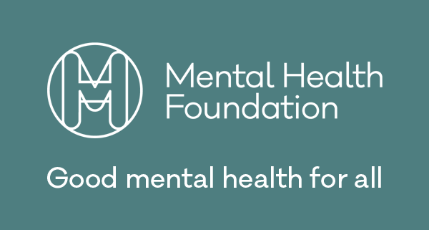
Mental Health Foundation has a new Coronavirus page with practical advice on mental wellbeing, parenting, talking to children, loneliness etc.
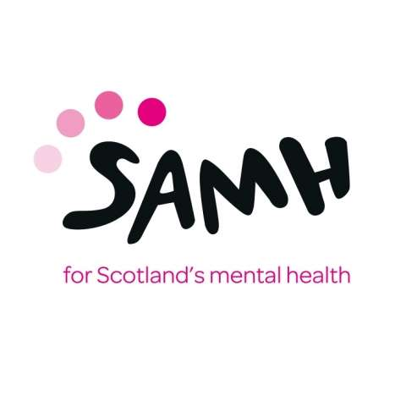

Anyone can experience poor mental health; especially now. Whether you’re looking for information or seeking support, we can help. Call 0344 800 0550 or email info@samh.org.uk
Young Scot have a variety of resources online to support your wellbeing. Call 0808 801 0338 or email info@young.scot

MENTAL HEALTH PRACTITIONERS
The Mental Health Practitioner (MHP) is a mental health professional who works within GP practices.
They offer assessment and provide guidance for adults who are experiencing mental health difficulties. The aim is to ensure people, who may be struggling with a change or deterioration of their mental health, receive a prompt, specialist mental health assessment which is accessible locally within their own GP practices.
The MHPs are based within the following GP practices in East Ayrshire:
Area Practice Telephone Number
Auchinleck Auchinleck Surgery 01290 424713
Crosshouse Crosshouse Medical Practice 01563 521506
Cumnock and Muirkirk Tanyard Medical Practice 01290 421157
Dalmellington Dalmellington Health Centre 01292 550238
Darvel and Newmilns Loudoun Medical Practice 01560 320205
Drongan Taiglum Medical Practice 01292 591345
Galston Galston Medical Practice 01563 820424
Kilmarnock Old Irvine Road Surgery 01563 522413
Kilmarnock Portland Medical Practice 01563 522411
Kilmarnock Portland Road Surgery 01563 522118
Kilmarnock The Wards Medical Practice 01563 526514
Kilmarnock and Kilmaurs Marnock Medical Group 01563 523593
Mauchline and Catrine Ballochmyle Medical Group 01290 456001
New Cumnock Valley Medical Practice 01290 338242
Patna Riverside Medical Practice 01292 532500
Stewarton Stewarton Health Centre 01560 486784

PHYSICAL ACTIVITY

Exercise can help our immune system stay strong, be less susceptible to infection and better able to recover. Any activity is better than none at all and the more activity you can plan into your day, the more physical and mental health benefits there are. Sit less, use the stairs more, walk, cycle, jog, dance or try some keep fit exercises – whatever works for you.
For more information on sports venues, gyms and fitness memberships contact East Ayrshire Leisure on 01563 554300 / 0845 724 0000 or visit their website at www.eastayrshireleisure.com. To find out more about gym membership, swimming and fitness classes contact The Galleon Centre on 01563 524014 or email adminoffice@galleoncentre.com.

RELATIONSHIPS

The Spark Relationship Helpline is a free, confidential telephone and online chat service.
You will be listened to and supported with life’s relationship challenges. Call 0808 802 2088 Tuesday and Wednesday 11am – 2pm for support with any relationship issue.
Relationships Scotland provide relationship counselling and family mediation and other family support services across Scotland. Their work supports individuals, couples and families experiencing relationship difficulties. Call 0345 119 2020 during office hours.
HomeStart East Ayrshire provide a range of support to families who may be struggling with isolation, physical health, bereavement or a range of other issues. Email admin@homestart-ayrshire.com or call 01563 526507.

FINANCIAL

Every week people face challenges, loss of employment, reduced hours, having children and breakups are just examples but they all can lead to changes in our finances. If you are facing a change in your circumstances or are just struggling with paying your bills then you’re not alone and help is at hand.
Whatever life throws at you there are organisations that can assess whether you might be entitled to some financial assistance. Everybody needs a financial health check particularly during difficult times.
East Ayrshire Money is a service which can help by putting you in touch with the right local organisation that can best provide the advice, information and support that you need. Call 0800 389 7750 or email info@eamoney.co.uk
If you are unsure if you should claim or are having difficulties with Universal Credit, call the East Ayrshire Support Team on 01563 503280 or the DWP Helpline on 0800 3285644.
Citizens Advice is Scotland’s largest independent advice network and is free, confidential, impartial and available to anyone. Call 01563 553479 or 01290 429500.
Social Security Scotland can help apply for targeted benefits to help alleviate poverty such as Best Start, Crisis, Young Carer and Funeral Support. Contact them on 0800 182 2222 for advice.
Money Advice Scotland provides signposting to free confidential and independent advice on how to deal with debt problems. Call 0800 731 4722 during office hours.
Step Change provide free, expert debt advice, no matter how large or small your debt problem is. Call 0800 138 1111 Monday – Friday 8am to 8pm and Saturday 8am – 4pm.
Gambling Anonymous Scotland provide support on controlling gambling, dealing with debt as well as providing support to family and friends who may be affected. Call 0370 050 8881 24 hours a day.
If you are having issues with your energy supplier or energy bills, contact Citrus Switch for assistance. Call the energy advice team on 07973 847981 or email ensuring you have a copy of your latest gas and electricity bills.
Home Energy Scotland offer free and impartial advice on energy saving, keeping warm at home, renewable energy, greener travel, water waste and more. Call free of charge on 0808 808 2282.
If you are 16 to 24 years old and have been unemployed for six months, you can apply for a Job Start Payment. This is a one off £250 payment to help with the costs of starting a new job. Young People can apply for the Job Start Payment up to 3 months after they commence employment by contacting Social Security Scotland on 0800 182 2222 or at www.mygov.scot/job-start-payment

Council tenants
If your income suffers as a result of coronavirus (COVID-19), please be assured we can help, whatever your financial circumstances. If you are worried about paying your rent, you should contact your neighbourhood coach who can discuss various options such as payment plans. If you are unsure who your neighbourhood coach is, please contact 01563 554400.

Home owners
The UK Government have announced measures that people with mortgages who are in financial difficulty as a result of the coronavirus will be offered at least a three month mortgage holiday – so that people will not have to pay a penny towards their mortgage while they get back on their feet. You should contact your mortgage lender directly for more information.

Homeless
If you are homeless or at risk of being homeless you can speak with a Housing Options Officer during office hours by calling 01563 554400 or by emailing homelessness@east-ayrshire.gov.uk. We can provide you with temporary accommodation as well as confidential advice and assistance to prevent you from becoming homeless. If you require assistance out-with office hours please call 0345 724 0000.

Private Landlord
If you are having difficulty paying your rent, speak to your landlord as soon as you can as there is help available. For further help and advice contact the Private Landlord Sector by emailing landlordregistration@east-ayrshire.gov.uk.

FOOD PROVISION

CVO East Ayrshire host the Ayrshire East FoodBank. For information or to place a request for food provision contact them on 01563 550951 or by email at eastayrshirefoodbank@cvoea.co.uk. They can also be contacted by private message on their Facebook Page.
There are also a number of Community Resilience Groups in East Ayrshire who can support residents who need food, someone to go shopping or collect a prescription. Call 01563 554400 to find your nearest group.
East Ayrshire Homelessness Action (EACHA) assists people in crisis during an emergency event by providing essential household and personal items or food. Email dorothycraig01@outlook.com or call 07515 402805.

ALCOHOL AND DRUGS

Ayrshire Council on Alcohol offer a free one-to-one confidential service to individuals who are concerned about their drinking. Call 01292 281238 during office hours or email info@acaayr.org.
NHS Ayrshire & Arran Community Addiction Services offer a number of different interventions including support to stop taking drugs and alcohol and mental health services-related treatment and support. Call 01563 574237 or email AA-UHB.ClinicalAddictionServices-EastAyrshire@nhs.net during office hours or NHS24 111 outwith these times.
Alcoholics Anonymous is a fellowship of men and women who share their experience, strength and hope and help others to recover from alcoholism. Call 0800 9177 650 or email help@aamail.org.
East Ayrshire Recovery Service (We are With You) provides free and confidential drug and alcohol support. Call 01563 558777 Monday to Friday 9.00am – 9.00pm and 11.00am – 4.00pm at weekends.
Know the Score provides free, confidential information and advice on drug use. Call the Helpline between 8am and 11pm 7 days a week on 0800 5875879.
SFAD support anyone who is concerned about someone else's drug or alcohol use, wherever they are in Scotland. Call the free and confidential helpline on 08080 101011 Monday to Friday 9am-11pm.
East Ayrshire Advocacy offer a peer mentor programme. Contact Irene@eaas.org.uk for details or call 01563 574442.
Patchwork Recovery Community work with partners to support to those most marginalised in our communities with practical and emotional support. Contact neilnanomg@gmail.com for details.
Recovery Enterprise Scotland run a social café providing affordable meals and volunteering opportunities and access to skills development training. Contact them on 07793 241895.
East Ayrshire Families Service (Barnardos) provides a range of services and support to families and young people affected by substance misuse. Email southwestscotlandservices@barnardos.org.uk or call 01563 530646.

PROTECTING PEOPLE

If you think someone is in immediate danger phone the Police on 999.
Our services are open and continue to provide help and support. If you know, or think you know, someone who is at risk, or is being neglected or harmed, please tell us. You can call East Ayrshire Council on 01563 554200 or 01290 427720 or email HSCPcustomerfirst@east-ayrshire.gov.uk
If you are worried about someone out of hours or over the weekend contact Ayrshire Urgent Care Service on 0800 328 7758.

CHILD PROTECTION
Action for Children protects and supports children and young people, providing practical and emotional care and support, ensuring their voices are heard, and campaigning to bring lasting improvements to their lives. Contact them on 0300 123 2112 from 9am to 5pm Monday to Friday.
Children 1st, previously known as the Royal Scottish Society for Prevention of Cruelty to Children, is a Scottish charity which aims to give every child in Scotland a safe and secure childhood. Email cfs@children1st.org.uk or call 0131 446 2300.

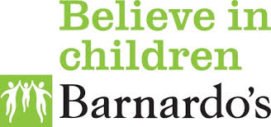
Barnardo's is the largest Children’s charity in the UK and it is committed to work with children, young people and their families or carers to help build stronger families, safer childhoods and positive futures. Call 0131 446 7000.

Thinkuknow is an online education programme from NCA-CEOP, a UK organisation which protects children both online and offline. Go to www.thinkuknow.co.uk for support and guidance materials.
The NSPCC help children who’ve been abused, protect children at risk and find the best ways to prevent child abuse from ever happening. Email help@nspcc.org.uk or call 0808 800 5000.
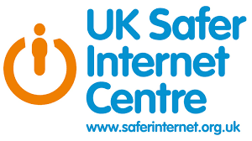
UK Safer Internet Centre is a partnership of three leading organisations: Childnet International, Internet Watch Foundation and SWGfL, with one mission - to promote the safe and responsible use of technology for young people. Email enquiries@saferinternet.org.uk or call 0344 800 2382.

VIOLENCE OR ABUSE

There are many organisations who are there to help you if you are experiencing violence or abuse:
There are many organisations who are there to help you if you are experiencing violence or abuse:
East Ayrshire Women’s Aid on 01563 536001 or info@eastayrshirewomensaid.org.uk
The Star Centre on 01563 544686 or admin@starcentreayrshire.org
Turn2Us on 01563 540252 or victimsupport.eastayrshire@victimsupportsco.org.uk
Abused Men in Scotland on 03300 949 395 or support@amis.org.uk
Modern Slavery helpline on 08000 121 700

EATING DISORDERS

The Scottish Eating Disorder Group (SEDIG) is an online support that helps people across Scotland find the support, care and understanding they need to deal with eating disorders, whether they are affecting them directly, a family member or someone you care for.
Beating Eating Disorders run a number of online support groups or call 0808 801 0677 for further information.

ALZHEIMERS

Alzheimer Scotland provides services and supports to anyone who is worried about their memory, has a diagnosis of dementia or who is supporting someone with dementia. For information and advice call the local dementia advisor team on 01563 590480 during office hours or the 24 hour helpline on 0808 808 3000.

DEPRESSION

Living Life offers free online courses covering low mood, stress and resiliency. Work out why you feel as you do, how to tackle problems, build confidence, feel happier and stay calm and much more. Call 0800 328 9655 or email enquiries@livinglifetothefull.com.

Breathing Space is a free and confidential phone service for anyone experiencing low mood, depression or anxiety. Call 0800 83 85 87 Monday – Thursday 6pm – 2am and during weekends Friday 6pm – Monday 6am.

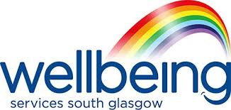
Wellbeing Services is an online service offering a variety of self-help materials for all sorts of problems that you may be facing.

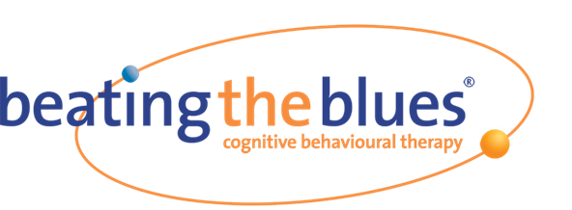
Beating the Blues is an effective treatment for people feeling stressed, depressed, anxious or just down in the dumps. Based on Cognitive Behavioural Therapy, the course is made up of 8 online sessions which last approximately an hour and help you to understand the link between how you think and how this influences your feelings and behaviours. The program teaches strategies to help you cope better in the short term and workable skills for life so that you can face the future with confidence. Contact your GP to access this online resource.

Young Minds provides information and advice about young people’s mental health. Call 0808 802 5544 Monday to Friday or if you need urgent help text YM to 85258.

BULLYING
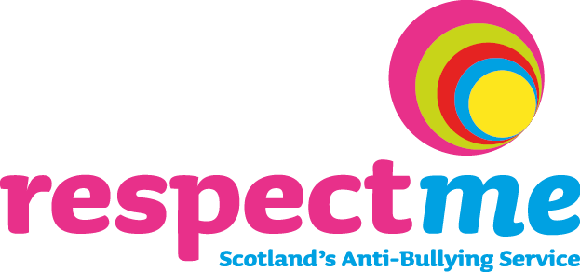

Respect Me provides practical advice and guidance on dealing with bullying behaviour. Call 0844 800 8600 or email ENQUIRE@RESPECTME.ORG.UK.
The Anti-Bullying Network supports anti-bullying work in schools and provides information on training, publications and consultancy services. Contact them at info@antibullying.net for further details.

SEXUALITY

The Tie Campaign aims to combat homophobia, biphobia and transphobia in schools. Email hello@tiecampaign.co.uk or twitter @tiecampaign.
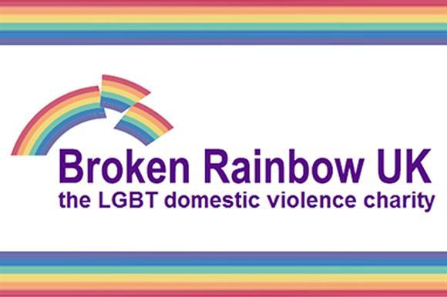
Broken Rainbow provides confidential support to all members of the LGBT communities, their family, friends and agencies supporting them. Call 0300 999 5428.
LGBT Youth Scotland is a national charity for LGBT young people, working with 13–25 year olds across the country, delivering the LGBT Charter programme to schools, organisations and businesses. Their goal is to make Scotland the best place to grow up for lesbian, gay, bisexual, transgender and intersex young people, and play a leading role in the provision of quality youth work to LGBT young people that promotes their health and wellbeing. Call 0131 555 3940 or email info@lgbtyouth.org.uk.

SEXUAL ABUSE

Break the Silence is a registered charity providing a range of supports for survivors of rape and childhood sexual abuse, aged 13 years and above. Call 01563 559558.

The STAR Centre (previously the Rape Counselling and Resource Centre) offers free and confidential support to anyone, of any ethnicity, aged 13+ who has experienced sexual violence (women, girls, men, boys and those who identify as transgender or non-binary). Email admin@starcentreayrshire.org or call and leave a voicemail on 01563 544 686.

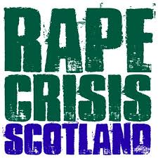
Rape Crisis Scotland provides a national rape crisis helpline and email support for anyone affected by sexual violence, no matter when or how it happened. Call 08088 01 03 02.
Speak Out Scotland provides a support service for male survivors of childhood sexual abuse. Call 0141 332 9326.
InCare Survivors Scotland is a trauma specialist counselling and advocacy support service for adults who have suffered abuse in care. Contact them on 0800 121 6027.

BEREAVEMENT

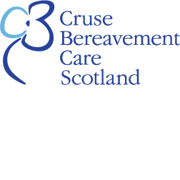
Cruse Scotland offers support, advice and information to children, young people and adults when someone dies. Call 0845 600 2227 Monday – Thursday 10am – 8pm and Friday 10am – 4pm.

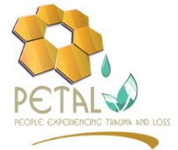
Petal Support provides counselling to people who have been affected by the loss of a family member or partner to homicide or suicide in Scotland. They are also providing additional counselling for those who have been affected by a COVID-19 bereavement. Call 01698 324502 during office hours.
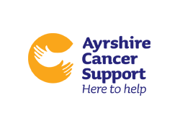
Ayrshire Cancer Support are currently providing bespoke bereavement counselling to anyone who has been affected by a COVID-19 bereavement. Call 01563 538008 during office hours or email admin@ayrshirecs.org anytime.
No One Dies Alone Ayrshire provide telephone support/befriending service for those facing end of life situations. An online support group or 1:1 online support can also be provided. Email Linda Jane McCurrach at noonediesaloneayrshire@gmail.com for details.

SUICIDE
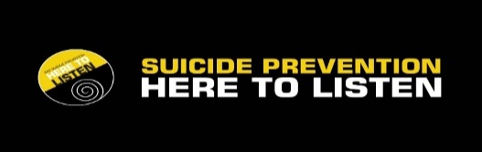

East Ayrshire Council has a dedicated Suicide Prevention website with details of Suicide First Aiders you can contact if you are in crisis together with a full range of supports.

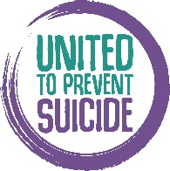
Join the movement at Scotland’s new Suicide Prevention approach at https://unitedtopreventsuicide.org.uk/ . Sign up to receive resources that can help have heathy conversations and break down the stigma.

If you need someone to talk to, call The Samaritans any time, 24 hours a day for free on 116 123 from any phone. They won’t judge or tell you what to do. They will just listen. Alternatively, it may be easier to write down how you are feeling. Contact jo@thesamaritans.org. Or try the new Self-Help App.

Beautiful Inside and Out is a charity that provides bespoke counselling and bereavement support to anyone in crisis free of charge. Call 07984 328808 or visit their Facebook page at www.facebook.com/beautifulinsideandoutscio/

Childline is a free, private and confidential service where you can talk about anything. Whatever you are worried about, whenever you need help, Childline is there for you online, on the phone, 24 hours a day on 0800 1111.

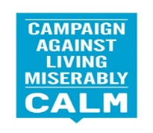
Campaign Against Living Miserably (CALM) run a free and confidential helpline and webchat 7 hours a day, 7 days a week for men or anyone who needs to talk about life’s problems. Call 0800 58 58 58 5pm to midnight every day or visit the webchat page

Papyrus is a national charity dedicated to the prevention of suicide for those under 35. If you are having thoughts of suicide or are concerned for someone, phone 0800 068 4141 or text 07786209697 for confidential support and practical advice. Opening hours are Monday to Friday 10am to 10pm, weekends 2pm to 10pm, bank holidays 2pm to 5pm or email pat@papyrus-uk.org.
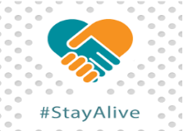
The Stay Alive app is a suicide prevention resource for the UK, packed full of useful information and tools to help you stay safe in crisis. You can use it if you are having thoughts of suicide or if you are concerned about someone else who may be considering suicide. Download from Google Play at https://play.google.com/store/apps/details?id=uk.org.suicideprevention.stayalive or download on the Apple Store at https://itunes.apple.com/us/app/stay-alive/id915458967

SELF HARM
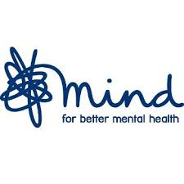
Mind can help explain possible causes for self-harm and assist in accessing treatment and support. This site includes tips for helping yourself and guidance for friends and family. Call 0300 123 3393 or Text 86463.

SAMH is an online resource to help you understand why you self-harm and gives you self-help techniques, support and guidance.

