# C:\Users\oneilc\Desktop\graphics\columba-1400.pngC:\Users\oneilc\Desktop\graphics\vibrant communities.pngC:\Users\oneilc\Desktop\graphics\east ayrshire logo.jpgC:\Users\oneilc\Desktop\graphics\sac logo.gifEast Ayrshire Parental Empowerment Programme

## Menu



#### Useful links

[Staff (Glow)](https://glowscotland.sharepoint.com/sites/EastAyrshire/eaglowcentralsitemain2019/easacglowcentralmain2019/SitePages/Parental-Empowerment-Programme(1).aspx)  [Parents](https://blogs.glowscotland.org.uk/ea/parentalempowerment/welcome/)

Four main themes

The programme is made up of 4 main themes:

* **On boarding – building relationships and a positive environment in your group**
* **Health and Wellbeing – looking after your physical and mental health**
* **Coaching – Identifying and developing your skills**
* **Understanding Learning – looking at ways we can develop your learning skills and support our family**



**Building a programme around your needs!**

Select the session you would like to be part of your journey. Each session takes about an hour to complete.

Visit the blog to get an overview of the programme to help you pick the topics you would like to cover in each theme.

|  |  |
| --- | --- |
| Theme – On boarding | Tick the box if you want to learn more about this topic |
| Pre boarding – prior to 1st meeting |  |
| * Back in the day task * Walking task * Box of happiness * On boarding clip |  |
| All on board – 1st meeting |  |
| * Diamond 9 - Being a Parent * Survival cards * CEO task (all participants) (needs added) * Connecting with nature |  |
| Post boarding – prior to next meeting |  |
| * Survey (all participants) * My journey passport * Menu card – see Prezi presentation |  |

|  |  |
| --- | --- |
| Health and Wellbeing | Tick the box if you want to learn more about this topic |
| Mental Wellbeing |  |
| The power of positive thinking (Growth Mindset) |  |
| Cooking session – Healthy eating |  |
| Relationships – Restorative approaches |  |
| Relationships – Nurture | Under development |
| Learning to relax |  |
| Connecting with nature |  |
| Enhancing your fitness | What exercise / activity would you like? |

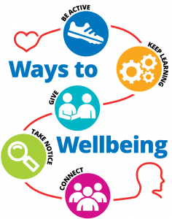



|  |  |
| --- | --- |
| Coaching | Tick the box if you want to learn more about this topic |
| Change and Loss |  |
| Conversation Matters |  |
| Problem Solving |  |
| Respectme (anti-bullying) |  |
| SMART Goals |  |
| Transitions |  |
| Community Connectors |  |

|  |  |
| --- | --- |
| Understanding learning | Tick the box if you want to learn more about this topic |
| Where two next in my learning journey? |  |
| Enhancing your listening skills |  |
| Improving your writing skills |  |
| Maths through stories |  |
| Numeracy skills |  |
| Community Awards – Ayrshire College |  |

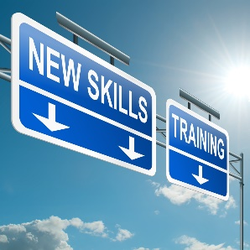

We want to create a programme which helps you to grow so if you have any ideas for sessions please let us know in the space below and we will do our best to support you.