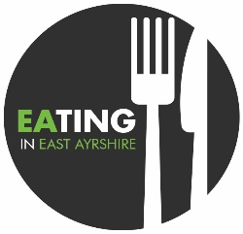

REHIS Elementary Food Hygiene (E-Learning)

The REHIS Elementary Food Hygiene Certificate is a practical course designed to give individuals a basic knowledge and understanding of the causes of food poisoning, measures for prevention and the legal aspects of food hygiene in Scotland. The REHIS Elementary Food Hygiene course is recognised by your local environmental health officer and is suitable for any food handler working in restaurants, hotels, bars, nurseries, residential homes and also those involved in day care.

This is an online E learning course easily accessible online. An email address is required to access the course.

Once the following 12 modules have to be completed an examination permit can be downloaded which can be saved, emailed or printed.

The exam will take place at a suitable premise in invigilated conditions.

* Introduction to food safety
* Microbiology
* Contamination Hazards and Control
* Food Poisoning and Foodborne Disease
* Personal Hygiene
* Design Construction and Use of Food Premises and Equipment
* Cleaning and Disinfection
* Pest Control
* HACCP and Food Safety Management Systems
* Control Measures from Purchase to Service
* Supervisory Management
* Food Safety Legislation and Enforcement

The course is delivered online and takes around six hours to complete. Candidates will be send a hard copy of the Food Hygiene Handbook and Question of Food Hygiene for Scotland workbook Tutorial Support is available to course participants either by phone 01563 576328 during working hours between 0900 -1400 Monday – Friday or by email to [susan.dunlop@east-ayrshire.gov.uk](mailto:susan.dunlop@east-ayrshire.gov.uk).

For more information or to register for a course please contact Susan Dunlop at:

[susan.dunlop@east-ayrshire.gov.uk](mailto:susan.dunlop@east-ayrshire.gov.uk)

* The cost of the course is £55 per candidate.
* Payment can be made via telephone using card payments.
* Internally by cost centre number