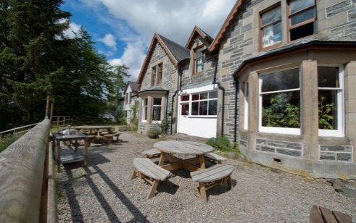 **Clothing Checklist**

**P7 Residential Trip**

|  |  |
| --- | --- |
| 2x lightweight joggies / trackies |  |
| 2x leggings / shorts |  |
| T-shirts (min. 3) |  |
| Leavers hoodie (for travelling + evenings) |  |
| 2x warm jumpers / fleeces (lightweight for drying purposes) |  |
| Woollen hat / gloves |  |
| Casual clothes for evening wear (nothing fancy!) |  |
| Pyjamas |  |
| Underwear (min. 2 pairs per day) |  |
| Warm socks (must cover ankles) |  |
| Swimming shorts / costume |  |
| Waterproof jacket |  |
| Waterproof trousers (only if you have them) |  |
|  |  |
| Trainers (dry pair) |  |
| Old trainers (these will get wet!) |  |
| Walking boots (only if you have them) |  |
|  |  |
| Small rucksack |  |
| Water bottle (very important!) |  |
| Toiletries |  |
| Towel (very important!) |  |
| Bin bag (for dirty clothes) |  |
| Insect repellent + midge net |  |
| Sunglasses / cap |  |
| Sun cream |  |
|  |  |
| Medication (to be detailed on form + handed to teacher) |  |
|  |  |
| Disposable camera (optional) |  |
| Money – max £10 in a labelled purse or food bag (optional) |  |

This is an essential list to make participation in the activities enjoyable and comfortable. There is no need to buy specialist equipment such as walking boots and waterproof trousers. One piece of luggage and one backpack per child.

**\*Do not bring expensive electronic devices or valuables\***

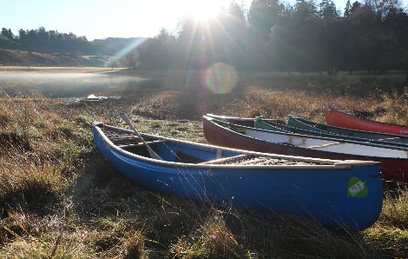**The centre will organise and provide sports specific equipment related to activities.**