Breakfast Choices in Primary 3
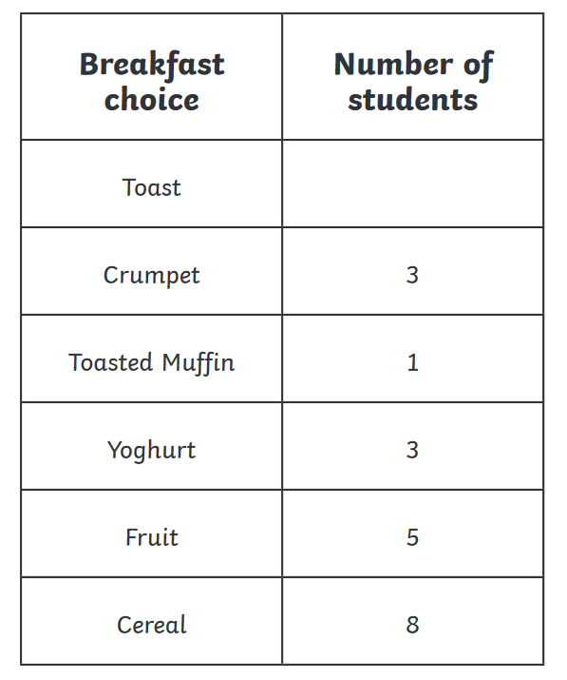
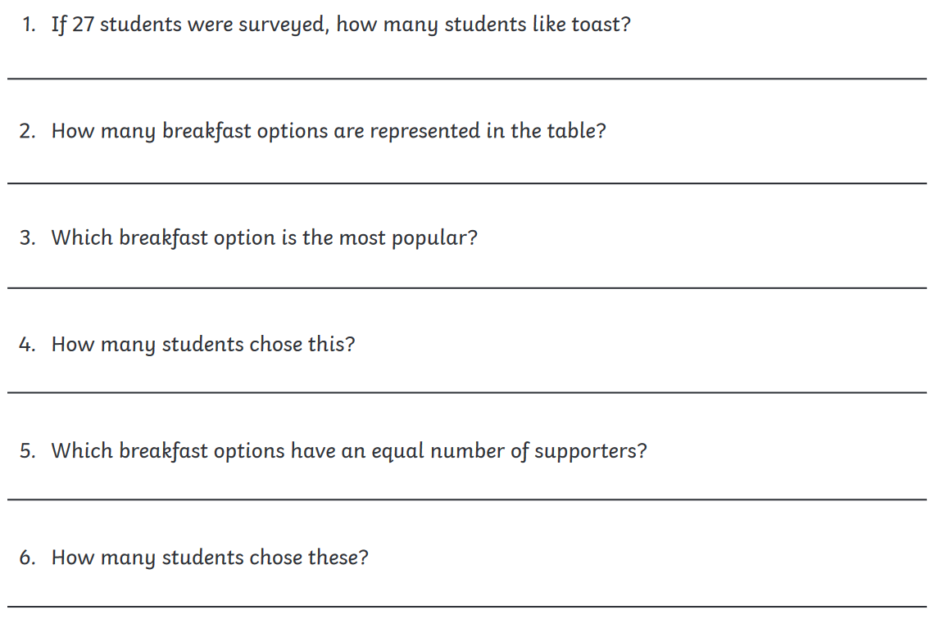
7. What is the difference between the most popular option and the least popular?
_________________________________________________________________________________
8. How many more pupils like cereal than yogurt?
_________________________________________________________________________________

