My Favourite Christmas Present
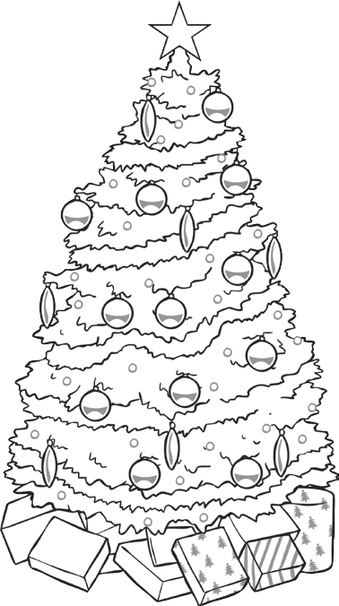
Draw a sketch of your favourite present:

What is your favourite Christmas present?

What does it do?

Why is it your favourite present?

visit twinkl.com

