The Reading Song
When I’m reading, I am succeeding
I pick up a book and take a look
My mind just starts to grow
When I’m reading, I feel so free… and
Turning pages, spending ages
With friends and on my own

CHORUS
I love to read, I love to read,
I love to read
And read and read and read
I love to read.

Any type of book, any type of theme
Study the pictures, read the word
And find out what they mean
Any type of book, any type of theme
Study the pictures, read the word
And find out what they mean

When I’m reading, I am succeeding
I pick up a book and take a look
My mind just starts to grow
When I’m reading, I feel so free… and
Turning pages, spending ages
With friends and on my own
CHORUS
Fiction, explanations,
Instructions, fairy tales
Horror books, joke books,
Cook books, mags as well
Fiction, explanations,
Instructions, fairy tales
Horror books, joke books,
Cook books, mags as well

When I’m reading, I am succeeding
I pick up a book and take a look
My mind just starts to grow
When I’m reading, I feel so free… and
Turning pages, spending ages
With friends and on my own

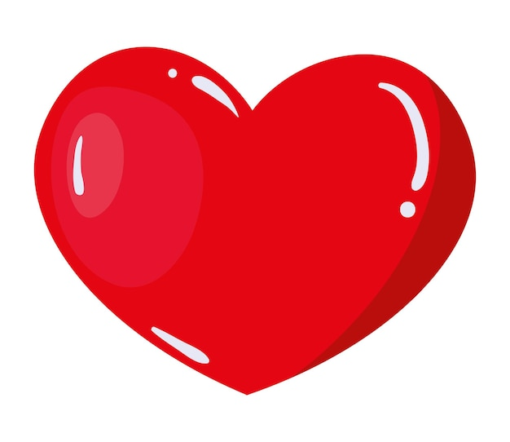
I love to read!

