World Book Day Song (George Ezra)
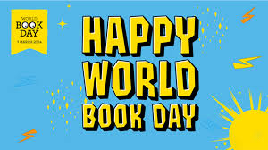
Homegrown story-maker.
See ya later!
Gotta hit the road.
Gotta hit the road.
It’s all changing on the pages.
I could read this for ages.
I could get used to this!

CHORUS
Time flies by when you’re reading a book.
Take a look and you’ll know what I mean.
Poems, comics or magazines
Take a look and you’ll see what I mean.

I’ll be reading my way.
‘Cause it’s World Book Day
Listen to what I say.
I’ll be reading my way.
‘Cause it’s World Book Day
Listen to what I say.

The inside of the cover.
Let’s discover.
What’s inside?
What’s inside?

I’ve been reading ‘round the clock.
My favourite stories I can’t stop.
I could get used to this.

CHORUS

I just read this book…Hey!
I finished. It’s done…Hey!
I can’t wait to get a new one.

PAUSE for 8 seconds

CHORUS (two times)
