1. ABC Order  Write all of your spelling words in alphabetical (ABC) order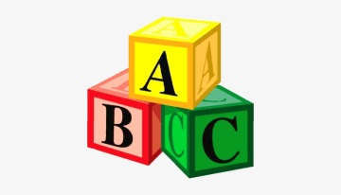 | 2. Pyramid Words  Write all of your spelling words in the shape of a pyramid. | 3. Use Technology  Type out your spelling words on the computer. Try to use at least 4 different fonts.
4. Lego Words  Use Lego to make your spelling words. | 5. Silly Sentences  Make some silly sentences using your spelling words. | 6. Bubble Letters  Write your spelling words out in bubble writing.  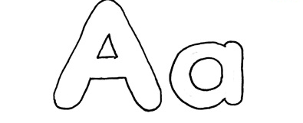
7. Collage Words  Make your words by cutting letters out of a newspaper or magazine and gluing the letters on a piece of paper to spell your words. | 8. Writing Race  Set a timer for 2 minutes. See how many times you can write each word perfectly during that time. | 9. Rhyme Time  List words that rhyme with your spelling words.
10. Super Syllables  Say your word. Listen to how many syllables it has. Clap the syllables. Write down your word in different colours to split it up into the syllables.  RO BOT  WIN TER | 11. Upper and Lower  Write your words in lowercase and uppercase.  YELLOW  yellow | 12. Definitions  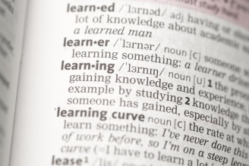  Use a dictionary, iPad or computer to find the definition of 3-5 of your spelling words.

