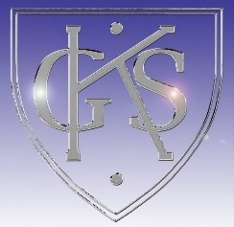
Opportunities for personal achievement
Interdisciplinary Learning
Ethos and life of the school as a community
Curriculum areas and subjects
The Curriculum - ‘the totality of all that is planned for children and young people throughout their education’

Topic
Scotland – Geography of Scotland, Scottish traditions, Significant Scottish Individuals, Scots Language, Scottish Foods.

Chinese New Year – Chinese Traditions, Chinese History, Chinese Zodiac.

Our Senses – Learning about our 5 senses.

Wider achievement celebrated at school assembly.
Super Star awards
Rising Stars
Handwriting awards
Rights Respecting Schools Representative
Scottish Poetry and Song Performance
Personal achievements and successes are communicated
by parents and shared at assembly where it is collated
on a school database.
Secret Students within class.

Shared Vision and Values
Kindness Flower
Green cards – earning house points
Literacy – Bug Club guided reading and comprehension. Scottish stories. Non-fiction focus. Imaginative and functional writing, Active Literacy. Cursive handwriting, grammar (P3) – plurals, nouns, verbs and adjectives. (P2) – joining words, question marks, exclamation marks and nouns.
Numeracy – Addition and subtraction, multiplication and division, telling the time.
Health and Wellbeing – Rights of the child
Right of the Fortnight – RRS
Weekly assemblies
Recognition board in class – class community
Group points – class community

