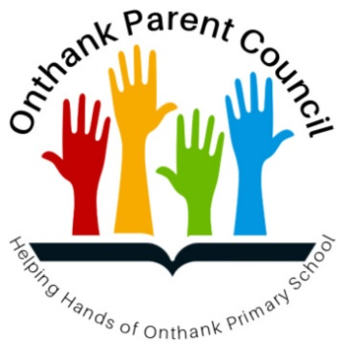
Onthank Parent Council
Social Media Policy

Aims of this Policy | Onthank Parent Council is aware of its responsibilities towards the school and our children when using Social Media. This policy sets guidelines for parents and carers on using Social Media sensibly, rationally and respectfully and the procedures for dealing with unacceptable behaviour.  This policy relates specifically to Onthank Parent Council’s social media activity and is unrelated to Onthank Primary School’s own social media policy.  Please note: Onthank Parent Council has no administrative responsibilities for the Onthank Primary School Website, Facebook Page or Twitter feed. Any queries relating to these should be directed to the school.
How We Use Social Media | Onthank Parent Council runs a Facebook Page, which is a ‘public’ page. This means the page is visible to the general public. There are two appointed administrators who approve all posts on the page. While comments on posts cannot be approved, inappropriate comments can and will be removed at the discretion of the administrators.  Onthank Parent Council also runs a WhatsApp Group and various subgroups, these are ‘private’ groups. This means the groups are NOT open to the general public.
Leavers | Parents or Carers whose children have left Onthank Primary School will be asked to leave or subsequently removed from the WhatsApp Groups. Member requests from former Onthank Parents, Carers or Pupils will be declined from the WhatsApp group.
Posts | Anything posted on the Facebook Page will appear in the newsfeed of all those who ‘Like’ the page.  Examples of posts include: reminders of Parent Council meetings, reminders of school activities. requests for help, notification of changes to school activities, thanks for help, fundraising updates, charitable causes, community notices, etc.  As always, individual issues or concerns should be raised directly with the school.  Posts that involve marketing, promoting business, especially for personal gain, will not be approved.
Names and Photographs | Members of the page and groups are welcome to share photos, however (names or photographs, especially of children) should not be posted unless you are given permission by that person or the child’s Parent or Carer.
Unacceptable Behaviour | Onthank Parent Council will have ZERO tolerance for comments or photographs which are deemed to be abusive, offensive, bullying or threatening. Any such comments or  photographs will be removed by the administrators and a warning issued to the offender. If there is repeated abuse of the page the offender will be blocked from the page and/or groups.  If problems continue on an ongoing basis then the Parent Council will discuss the use of Facebook as a communication tool, and if in agreement, will close the page.  Please note, there are procedures for schools to follow when dealing with negative comments on Social Media - this can result in police involvement.
Guidelines for Using Social Media | - Consider the long term consequences of what you post.  - Use the“10 Minute Rule”: If your emotions are high, draft your post/comment and walk away for 10 minutes, then look at your post/Comment. Is your post sensible, rational and respectful?  - Ensure that nothing is written in such a way as to bring the group into disrepute.  - Names or photographs (especially of children) should not be posted without permission.
Review | As Social Media evolves at a fast pace, this policy will be reviewed every school term to ensure it remains up-to-date and is fit for purpose.
Declaration | I confirm I have read and understood Onthank Parent Council’s Social Media Policy and will act in accordance with it.  I am connected with this organisation in my capacity as Chairperson and Social Media Administrator of Onthank Parent Council.  Signature:  Print name:  Date:

