European Country
Topic Book
Challenge P7

Learning Outcome:
I can write to transfer information

Skill/Disposition Targeted:
Research and Investigation
Creative thinking
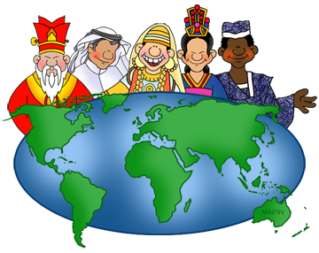
Essential Knowledge/Questions (s)
World Cultures – use a variety of skills to demonstrate an understanding of knowledge and ideas.
Challenge:
Your challenge is to research and learn about a country in Europe. This can be about any country in the Europe except Scotland as we would like you to compare your chosen place with our own country. You are therefore going to design and create your own topic book to be displayed and available for others to use in our school library.
Your challenge is to present your information in a well-presented book. Within your book, you should clearly describe how life in your chosen country differs from ours. Your readers will be particularly interested in topics listed below and if you are looking for your book to be displayed in the library, you should include at least 4 full pages of information, each on a different topic, in a mixture of written and art work.
- Facts: location, currency, languages or weather.
- Education: lessons, school hours or ages for schools.
- General life: roles of the family members, what homes look like or beliefs.
- Food: food that is commonly eaten by people of all ages, also things that may be especially for children (sweets)
- Free-time: games, dance, music or entertainment.
- Home Life: houses, jobs, food or utilities.
- Landmarks and Monuments
- Famous People from your chosen country

You may of course choose a topic of your own choice if you think it will be interesting to your readers.

Product Criteria:  Rule:  - Each learner must produce an informative topic book.  - Your book should highlight the differences between lifestyles and cultures in your chosen country with that of Scotland.  - Your book should be completed and returned on, or before Friday, 18th March 2022.  Form:  - Front cover  - Contents page  - At least 4 subject chapters.  - Clear handwriting and neatly presented information with correctly spelled words and appropriate punctuation.  - Detailed artwork relating to topical subjects.  - Glossary  - A fun page | 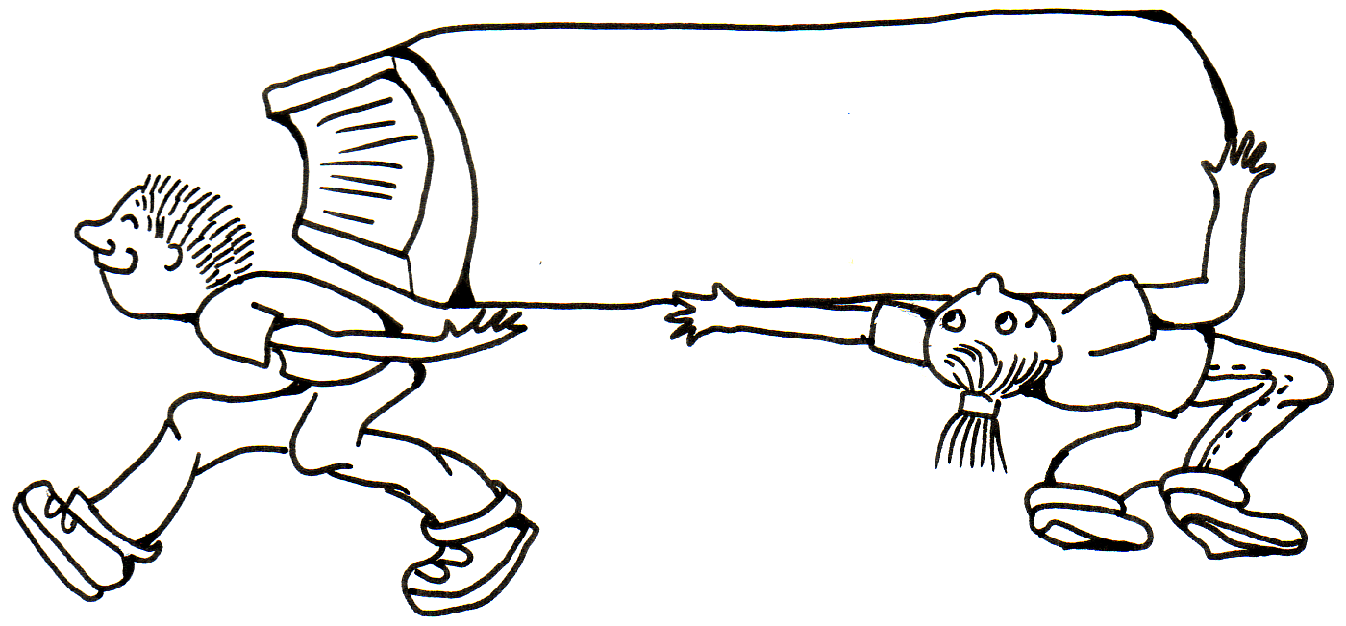  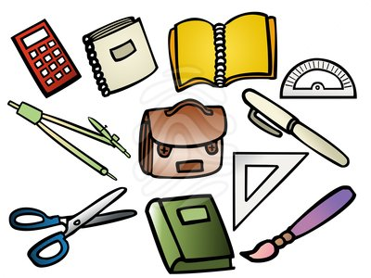
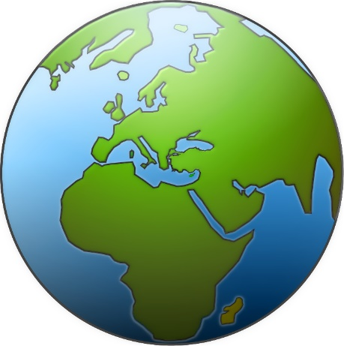 | Process Criteria:  Key Attributes/Performance Criteria: Creative thinking  - Use your imagination to transfer your knowledge of your country into a creative, informative book.
WARNING!
Please do not download material from the internet and try to include it as your own work as this will incur a failed assignment! You have been warned and as teachers we will be able to tell!

European Country Topic Book Challenge
Criterion for Assessment

Handed in on time 1 point
Front cover 1 point
Contents/Glossary pages 2 points
4 subject areas 4 points Fun page 1 point
Neat handwriting 2 point
Clearly written in own words 3 points
Appropriate punctuation (capital letters, full stops, commas, question marks and exclamation marks) 2 points
Correctly spelled common words and topic Words 2 points
Detailed art work 2 points

There will be an additional 5 floating points awarded by the teacher for exceptional effort above and beyond usual capabilities.

Total Available: 25 points

