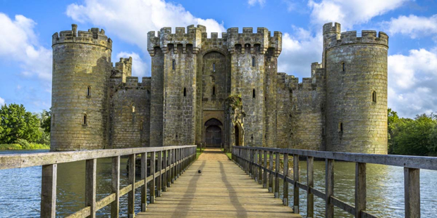

Task:
Make a 3D model of a castle. You can choose which type of castle you would like to make. Remember to include the different features we have explored in class.
You will be asked to give a 3 minute presentation to your peers describing the features of your chosen castle and how you made it.
Criteria:
- Maximum size of base: 40cm x 30cm
- Use any suitable resources
- You can model it on any type of Scottish castle
- Must be in class week beginning 24th February
- Try and make it your own effort.

