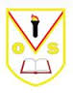

P5 2019/20 Term 3 Overview

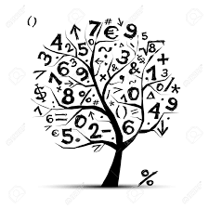

Language and Literacy across Learning

* Reading - Literacy World/Bug Club Reading activities (Rapid Readers ASN)
* Book study – The Loch Ness Monster
* Writing – Exploring the five points of characterisation: appearance, actions, thoughts, speech and effect. Instructions: recipes. Persuasive writing: use of language, layout and punctuation. Figurative language.
* Grammar – Knowledge about Language. Verbs: extend knowledge by identifying 1st, 2nd and 3rd person and past or present tense. Adverbs: identify and use in writing. Speech marks: use in writing to identify dialogue.
* Active Literacy scheme for spelling
* Phonics and Sounds (ASN)
* Nelson Handwriting
* Talking and Listening – Burns poem recitals.
* French – Weather, family members, alphabet and fruit.

Trips/Events

* Burns Competition
* World Book Day
* Castle Visit
* Primary 5 Performance tbc

Mathematics and

Numeracy across Learning

* Place value to 1 000 000
* **F**ractions, **D**ecimals and **P**ercentages
* More complex +, -, x and ÷ calculations
* **Time** - reading/understanding time, duration and timetables
* **Symmetry**/ Tessellation using 2D shapes
* Consolidation of **times tables** learned so far -please continue to practise these at home
* 3D **shape** continued (nets, prisms)

Interdisciplinary Learning

* Topic – Knights and Castles
* ICT – Internet safety, social media
* Music – Glockenspiel (Charanga), show songs
* RME – Joseph and Easter
* STEM – relating to topic and novel

Health and Wellbeing

* Fit for 15
* HWB: Internet safety, effects of smoking and alcohol (substance misuse), HeartStart.
* P.E – fitness and target, net and wall games.

