Answer these questions in your jotter or on the back of this sheet.

1. What part of the visit to the Dick Institute did you like the most and why?
2. Can you name 5 of David Walliams’ books?
3. Who usually illustrates his books?

Write one or two descriptive sentences describing this P4 memory:

Write words linked to this P4 memory under the following headings:

Nouns Adjectives Verbs

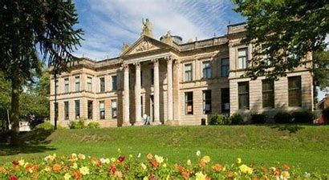

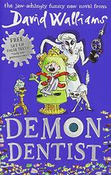

Can you think of a new title for a David Walliams book? Explain briefly what happens in this new story.

New Book: ____________________

Many explorers/archaeologists enter and search tombs. Do you think this should be allowed?

YES NO

Explain the reason for your choice:

Answer these questions in your jotter or on the back of this sheet.

1. What aspect of this topic did you find most interesting and why?
2. Would you like to of lived during this period of history? Explain your answer.
3. Why do people study ancient civilisations?

Write one or two descriptive sentences describing this P4 memory:

Write words linked to this P4 memory under the following headings:

Nouns Adjectives Verbs

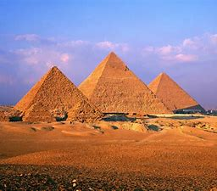

Many expeditions continue to visit the Titanic shipwreck. Do you think this should be allowed?

YES NO

Explain the reason for your choice:

Write words linked to this P4 memory under the following headings:

Nouns Adjectives Verbs

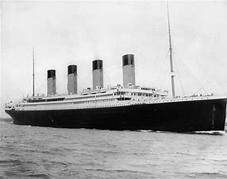

Write one or two descriptive sentences describing this P4 memory:

Answer these questions in your jotter or on the back of this sheet.

1. What caused the Titanic to sink?
2. Why did so many people die?
3. What lessons did people learn from this disaster?
4. What did it mean to be in a ‘class’ on the Titanic?
5. Which class would you have preferred if you were on the Titanic?