Digital Literacy

Learning Activities for Film & TV

First Level

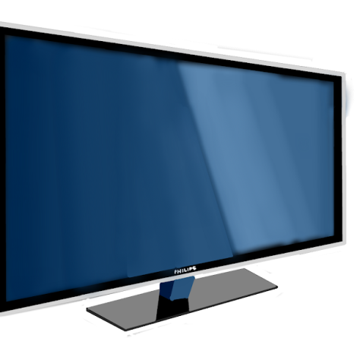

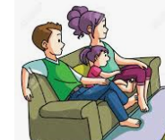
Setting
A setting is where a story takes place.
Movie settings can make us feel lots of different ways.
Have you ever watched a movie and felt scared, happy or excited?

Think about the start of the movie. Where does it happen?

Write 3 things about the start of the movie. Think about…..

TIME – was it light or dark?
SOUND – what did you hear?
CHARACTERS – who is there?

Could the story be true or is it made up?

How do you know?

Characters

Write down the name of a main character in the movie.

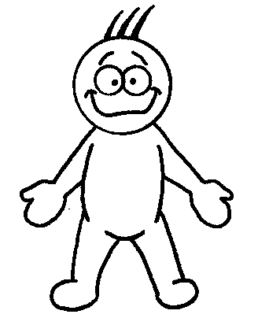
Write 3 adjectives to describe this character…

Type of character
(boy, girl, lady, man, animal)

Looks like….. What does this character do?

Write 3 sentences about that character.

Heroes and Villains

Write the names of the hero and villain in the table.

Is there more than one hero? Is there more than one villain? Put the character names into the correct columns.
Heroes | Villains

Are there any characters that you are unsure about?

Sometimes heroes do things that are not nice. Can you give an example from the movie?

Do you think a movie or a story needs a bad guy? Give a reason for your answer.
Sound

Movie makers use sound and special effects to make the movie more exciting.

Have you ever closed your eyes at a scary part?

Close your eyes when you are watching a part of the film.

Write down what you can hear.

Describe what sounds you would add if you were in charge of a movie.

The Ending

Describe how the movie ended.

Were you happy with the ending? Give reasons why or why not.

Write a new ending for your movie.

Lots of movies have a follow on or a SEQUEL. Write what would happen next if you were writing the next part of your movie.

Movie Review

Write a bit about the story of this movie in 3 sentences or less.

Rate this movie out of 5 stars.

Write what you liked about this film.

Write what you didn’t like about this film.

Find out something about one of the actors in the film.

