

**Paired Reading Journal- Notes for Teachers**

The sheets can be sent home to be optional extras to complement the paired reading programme.

The sheets are differentiated (approximate levels denoted below)

Sheets are for EARLY level

Sheets are for FIRST level

 Sheets are for SECOND level

Sheets could be suitable for all levels

Alternatively – these activities could be carried out in school.

**TOP TIP!** Make sure that similar activities to those in the sheets are understood, taught and carried out in school BEFORE they become homework.

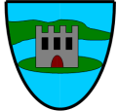



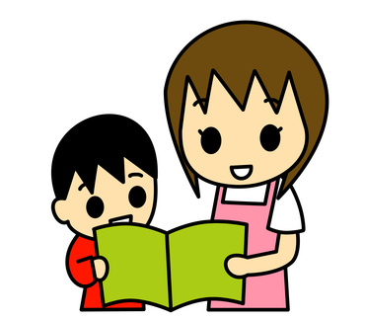

Suggestion – you can choose one activity per book you read.

But remember to ENJOY reading the book.

Suggestion – you can choose one activity per book you read. But remember to ENJOY reading the book.



Book Title:___________________

Author:_____________________

Fiction

Fiction

Book Title:___________________

Author:_____________________

Signature of adult:

I liked _________________ because

I liked _________________ because

Who was in this story?

Write the names of some characters.

Draw your favourite character(s) from the book.

Signature of adult:

Signature of adult:

Who was in this story?

Write the names of some characters.

Draw your favourite character(s) from the book.



Signature of adult:

Who was in this story?

Write the names of the main characters.

Write a short description of your favourite character – you can use words from the book, or your own words.

Draw your favourite character(s) from the book.

Fiction

Fiction

Book Title:___________________

Author:_____________________

Who was in this story?

Write the names of the main characters.

Write a short description of your favourite character – you can use words from the book, or your own words.

Draw your favourite character(s) from the book.

Signature of adult:

Book Title:___________________

Author:_____________________



Book Title:___________________

Author:_____________________

Fiction

Fiction

Book Title:___________________

Author:_____________________

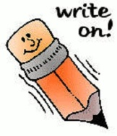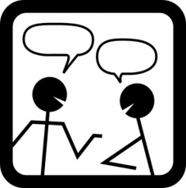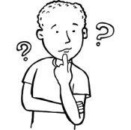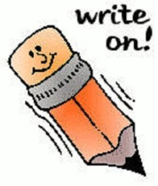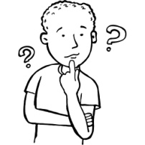

Signature of adult:

**Think about** and **talk about** and/or **write about**

Think about one of the characters – would you like to meet this character?

Can you say why –or why not?

If you were this character what would you do?

What question(s) would you like to ask this character?

**Think about** and **talk about** and/or **write about**

Think about one of the characters – would you like to meet this character?

Can you say why –or why not?

If you were this character what would you do?

What question(s) would you like to ask this character?

Signature of adult:

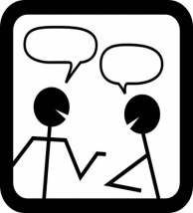

**Think about** and **talk about** and **write about**

Think about one of the characters – would you like to meet this character?

Can you say why –or why not?

If you were this character what would you do? (either in the story – or if you were in school, at home, out playing with your friends)

What question(s) would you like to ask this character?

Signature of adult:

Signature of adult:

Signature of adult:

**Think about** and **talk about** and **write about**

Think about one of the characters – would you like to meet this character?

Can you say why –or why not?

If you were this character what would you do? (either in the story – or if you were in school, at home, out playing with your friends)

What question(s) would you like to ask this character?

Fiction

Fiction

Book Title:___________________

Author:_____________________

Book Title:___________________

Author:_____________________



Fiction

Book Title:___________________

Author:_____________________

Fiction

Book Title:___________________

Author:_____________________

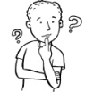

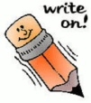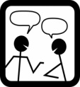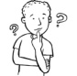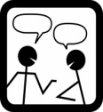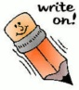

**Think about** and **talk about** and **write about**

**Give a description of the main character. You can include:**

* what they look like
* the way they talk
* the way they act/behave/what they do
* their personality
* any background information you learned about them

Character’s name:

**Think about** and **talk about** and **write about**

**Give a description of the main character. You can include:**

* what they look like
* the way they talk
* the way they act/behave/what they do
* their personality
* any background information you learned about them

Character’s name:

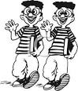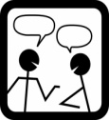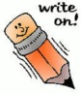

**Think about** and **talk about** and **write about**

**Pick a descriptive word(s) - adjective – from the story.**

**Write it down here _____________________________**

**Use a dictionary or thesaurus to help you find:**

<http://thesaurus.com/browse/kid> <http://www.collinsdictionary.com/>

5 **ANTONYMS**

(words that have the

opposite meaning to

your word.)

5 **SYNONYMS**

(words that have a

similar meaning to

your word)

5 **SYNONYMS**

(words that have a

similar meaning to

your word)

5 **ANTONYMS**

(words that have the

opposite meaning to

your word.)

**Think about** and **talk about** and **write about**

**Pick a descriptive word(s) - adjective – from the story.**

**Write it down here _____________________________**

**Use a dictionary or thesaurus to help you find:**

<http://thesaurus.com/browse/kid> <http://www.collinsdictionary.com/>

Fiction

Fiction

Book Title:___________________

Author:_____________________

Book Title:___________________

Author:_____________________

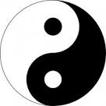



Book Title:___________________

Author:_____________________

Fiction

Fiction

Book Title:___________________

Author:_____________________

**Draw** and **label** a **setting** (place) from a description in the book.

Write down any **words** or **phrases** the author used to describe the setting.

**Draw** and **label** a **setting** (place) from a description in the book.

Write down any **words** or **phrases** the author used to describe the setting.



FICTION or NON-FICTION

FICTION or NON-FICTION

Book Title:___________________

Author:_____________________

Book Title:___________________

Author:_____________________

**Dictionary definition**

**New word**

Write down any new words or words you don’t understand.

Use a dictionary to find out what they mean. Does this help you understand what you read?

<http://www.collinsdictionary.com/>

Write down any new words or words you don’t understand.

Use a dictionary to find out what they mean. Does this help you understand what you read?

<http://www.collinsdictionary.com/>

**Dictionary definition**

**New word**



Write a **new blurb** for the back cover of a book you have read. You can add the other features you find on a back cover e.g. barcode, illustration, publisher’s logo

Write a **new blurb** for the back cover of a book you have read. You can add the other features you find on a back cover e.g. barcode, illustration, publisher’s logo

Book Title:___________________

Author:_____________________

FICTION or NON-FICTION

FICTION or NON-FICTION

Book Title:___________________

Author:_____________________



Non-fiction

Book Title:___________________

Author:_____________________

Non-fiction

Book Title:___________________

Author:_____________________



**Think about** and **talk about** and/or **write about**

Think about some of the things you have learned from this book.

Can you think of **3 fun facts**?

You can write or draw to help you remember.

**Think about** and **talk about** and/or **write about**

Think about some of the things you have learned from this book.

Can you think of **3 fun facts**?

You can write or draw to help you remember.



Non-fiction

Non-fiction

Book Title:___________________

Author:_____________________

Book Title:___________________

Author:_____________________

Write down **5 fascinating** or **fun facts** you learned from a non-fiction book. You can add an illustration below.

1)

2)

3)

4)

5)

Write down **5 fascinating** or **fun facts** you learned from a non-fiction book. You can add an illustration below.

1)

2)

3)

4)

5)



FICTION or NON-FICTION

FICTION or NON-FICTION

Book Title:___________________

Author:_____________________

Book Title:___________________

Author:_____________________





**?**

**Think about** and **talk about** and/or **write about**

Think of 3 questions you could ask about what you have read in the book.

Can you ask someone if they can find the answer in the book? You can draw or decorate in the question mark.

**Think about** and **talk about** and/or **write about**

Think of 3 questions you could ask about what you have read in the book.

Can you ask someone if they can find the answer in the book? You can draw or decorate in the question mark.

**?**



Book Title:___________________

Author:_____________________

FICTION or NON-FICTION

FICTION or NON-FICTION

Book Title:___________________

Author:_____________________



Write down **5 questions** to go with the book you just read. Make them interesting questions.

Write down **5 questions** to go with the book you just read. Make them interesting questions.



FICTION or NON-FICTION

Book Title:___________________

Author:_____________________

FICTION or NON-FICTION

Book Title:___________________

Author:_____________________



Write down **5 questions** to go with the book you just read.

Try to include different types of question e.g. literal (on the lines) or inferential ( between the lines)

Write down **5 questions** to go with the book you just read.

Try to include different types of question e.g. literal (on the lines) or inferential ( between the lines)



Non-fiction

Book Title:___________________

Author:_____________________

Non-fiction

Book Title:___________________

Author:_____________________

|  |  |  |  |  |  |  |  |  |  |  |
| --- | --- | --- | --- | --- | --- | --- | --- | --- | --- | --- |
|  |  |  |  |  |  |  |  |  |  |  |
|  |  |  |  |  |  |  |  |  |  |  |
|  |  |  |  |  |  |  |  |  |  |  |
|  |  |  |  |  |  |  |  |  |  |  |
|  |  |  |  |  |  |  |  |  |  |  |
|  |  |  |  |  |  |  |  |  |  |  |
|  |  |  |  |  |  |  |  |  |  |  |
|  |  |  |  |  |  |  |  |  |  |  |

|  |  |  |  |  |  |  |  |  |  |  |  |
| --- | --- | --- | --- | --- | --- | --- | --- | --- | --- | --- | --- |
|  |  |  |  |  |  |  |  |  |  |  |  |
|  |  |  |  |  |  |  |  |  |  |  |  |
|  |  |  |  |  |  |  |  |  |  |  |  |
|  |  |  |  |  |  |  |  |  |  |  |  |
|  |  |  |  |  |  |  |  |  |  |  |  |
|  |  |  |  |  |  |  |  |  |  |  |  |
|  |  |  |  |  |  |  |  |  |  |  |  |
|  |  |  |  |  |  |  |  |  |  |  |  |
|  |  |  |  |  |  |  |  |  |  |  |  |

* Pick out 6-8 words that are related to the topic of this book. E.g. if it’s a book about fish you might use *fin, scale, gills, water.*
* Hide the words in the wordsearch boxes.
* Use CAPTIAL LETTERS in the wordsearch
* Pick out 6-8 words that are related to the topic of this book. E.g. if it’s a book about fish you might use *fin, scale, gills, water.*
* Hide the words in the wordsearch boxes.
* Use CAPTIAL LETTERS in the wordsearch



Book Title:___________________

Author:_____________________

Book Title:___________________

Author:_____________________

Non-fiction

Non-fiction

Book Title:___________________

Author:_____________________



* Change some information from the book you read into e.g. a labelled drawing/diagram or a chart/table/graph
* Change some information from the book you read into e.g. a labelled drawing/diagram or a chart/table/graph



Book Title:___________________

Author:_____________________

Fiction

Fiction

Book Title:___________________

Author:_____________________

* Write a short summary of the whole plot. Don’t waste words!
* Things to include: main characters, setting, plot, conflict/problem, outcome/solution how it ends, any message or lesson to learn?

* Write a short summary of the whole plot. Don’t waste words!
* Things to include: main characters, setting, plot, conflict/problem, outcome/solution how it ends, any message or lesson to learn?



Fiction

Fiction

Fiction

Book Title:___________________

Author:_____________________

Book Title:___________________

Author:_____________________

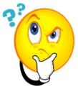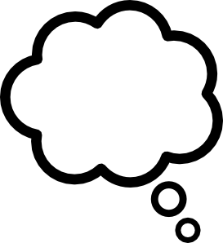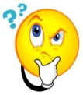

* Write about what a character might be thinking or feeling at any stage of the story.
* You can write as if you are the character (use I)
* Write about what a character might be thinking or feeling at any stage of the story.
* You can write as if you are the character (use I)

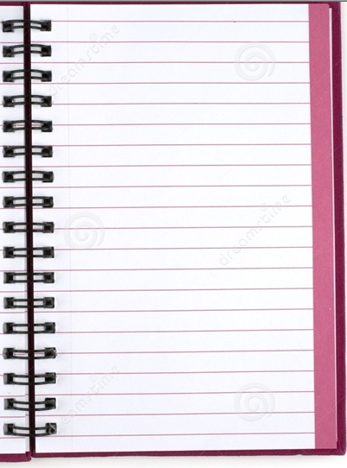

Write a diary entry that a character from the story might write after an event – something that happened - in the story.

FICTION

FICTION

Write a diary entry that a character from the story might write after an event – something that happened - in the story.

Book Title:___________________

Author:_____________________

Book Title:___________________

Author:_____________________