What do I already know about this?  - What do I already know about this topic?  - What genre or type of text is this?  - What clues are there in the title/blurb/ headings/ pictures?  - What predictions do I have?  - What might I learn from this text?  - Who and what is this text for?  Prior Knowledge | What can I do to work out words/ phrases I don’t know?  Use WORD ATTACK strategies:  - Break the word into phonemes or sounds  - Chunk the word into syllables  - Read on / read back  - Read around the word  - Look for smaller words within words  - Does it sound like any words I already know?  Metalinguistics | How can I make notes/display information/ create images in a way to help me remember and understand what I have read?  You could use:  - A flow chart  - A mind map or spider diagram  - A timeline or step plan  - A picture  - A diagram  - A story plan or story board  - Bulleted notes  Visualisation | How can I work out stated or implied messages in the text?  What clues are there in the text to help me work out things about characters / settings and plot?  Consider the author’s use of:  - Word choice  - Imagery  - Sentence structure  - Bias and persuasive techniques  Inference
Summarising  and Paraphrasing  How can I show my understanding of the text?  Consider:  - Combining information from inferences, visualisation and key messages.  - Make a list of the key ideas.  - Only include important details.  - Use my own words. | Active Literacy Comprehension Strategies  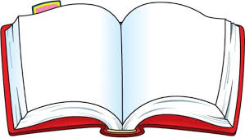 |  | What can I do to work out the author’s message?  What is the theme of the text?  Consider :  - Author’s use of inference – read between the lines.  - What does the author want me to know or feel after reading the text?  Can I justify my opinion?  Main Ideas

