P4

2020/21 Term 2 Overview

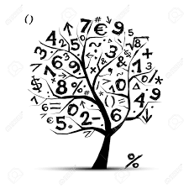

Trips/Events

* Hallowe’en Activity Day
* Dyslexia Awareness Week
* No Pens Day Wednesday
* Anti- Bullying Week
* Children in Need
* Road Safety Week
* Elf Day
* Christmas Jumper Day

Health and Wellbeing

* Anti-bullying
* Road safety
* Bonfire and fireworks safety
* PATHS Programme

Interdisciplinary Learning

* Topic – Scottish Mythical Creatures / The Water Horse by Dick King-Smith
* STEM – Building and designing a structure
* Right Respecting Schools - Article12 , Article 14
* Meanings of Christmas
* French – Pets / Animals

Mathematics and

Numeracy across Learning

* Addition and subtraction within 100 / 1000
* Money
* Symmetry
* Active maths activities
* Heinemann Active online maths games
* Number Talks Strategies
* Topmarks Maths – Hit The Button

Language and Literacy across Learning

* Writing an imaginative story
* Literacy building skills – Characterisation and setting
* Features of fiction texts
* Expand knowledge of nouns, verbs and adjectives
* Reading for understanding through the use of fiction texts
* Active spelling activities
* Bug Club – Read and complete online “bugs”