P2

2019/20 Term 1 Overview

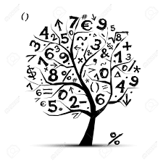

Language and Literacy across Learning

* Revise lower case letter formation
* Introduce capital letters
* Introduce and use the full stop in simple sentences
* Story writing about themselves and their experiences
* Reading for enjoyment
* Sequencing parts of a story and making predictions.
* Phonics Bug/Bug Club -- Key reading strategies – phonemes and sounding out
* Common Words

Interdisciplinary Learning

* Topic – Our Community/Autumn
* RME – Christianity
* ICT – Blogs
* Music – Charanga music
* Outdoor learning/structured activities/play opportunities
* French - greetings

Trips/Events

* Parent open afternoon
* World Porridge Day
* Litter Pick Day
* Buddy Walks

Health and Wellbeing

* Rules and routines of class
* Tooth brushing
* Growth Mind-set
* Skipping, ball skills, throwing and catching
* Rights Respecting School
* Fit 15 – Yoga, other exercise

Mathematics and Numeracy across Learning

* Revise numbers and number formation within 20
* Odd/even numbers
* Pattern making – numbers, shapes and colours
* Problem Solving
* Mental maths – counting onwards and backwards in 1s, 2s and 10s
* French numbers to 20, days of the week