LITERACY | NUMERACY/MATHS | TOPIC/IDL | HEALTH & WELLBEING
Log on and read the book allocated by your class teacher.  Remember to answer all the bugs. | 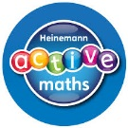  Log onto Bug Club and play the game allocated by your class teacher. | Fold your page in half and draw or write: -  - Anything you already know about Scotland.  - Anything about Scotland you would like to know more about. | Try spelling some different words whilst doing the Alphabet Workout below  e.g. Onthank, Telford. You will find the exercises below the links.  You can do this daily!
Write your teacher an email.  Tell her how you are. | Click LINK 1 below the Learning Grid: play the game.  Caterpillar Ordering | 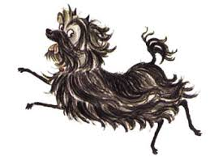  Click LINK 3 below the Learning Grid: Listen to the story.  Hairy Maclary from  Donaldson's Dairy | Give yourself and each member of your family a compliment.
Write a New Year’s Resolution for 2021. This can be something you want to continue, improve on, change or achieve. | Click LINK 2 below the Learning Grid: Check out all the activities on this webpage.  Numbers to 20 (knowing the counting sequence) | Draw a picture of Hairy MacLary and his five friends. Listen carefully to the descriptions and add those too. | Make someone a card to tell them you are thankful and why.

