Our Ref: DMacC/JGC

Date: Friday 5th June 2026

Dear Parent / Carer,

CLASS STRUCTURE 2026 / 2027

The following class structure will be in place for the 2026 / 2027 academic year:
Class | Teacher | Class Size
Primary 1 / 2 | Mrs Kane | 18
Primary 3 / 4 | Mrs Meek / TBC | 18
Primary 5 / 6 | Miss Clark / Mrs Rooney | 21
Primary 6 / 7 | Mrs Agnew | 22
For most of our classes, they will be moving forward as a single cohort.
Due to the maximum of 25 pupils for composite classes, we are required to group the existing Primary 5 pupils across Primary 5/6 and Primary 6/7. Parents of these pupils will receive a separate letter with their child’s allocation.
We continue to work hard to support transition and will be providing a chance for Primary 5/6 and P6/7 to come together some time in the remaining weeks.
Schools reopen to returning children following the summer break on Wednesday 19th August at 8:50am.
Staffing Update:
We would like to wish Miss Murray every success in her future career as she leaves us to pursue a teaching post. We thank her for all her efforts and enthusiasm over the past year.
Miss Clark will be joining the school to take up her first teaching post.
le durachdan,

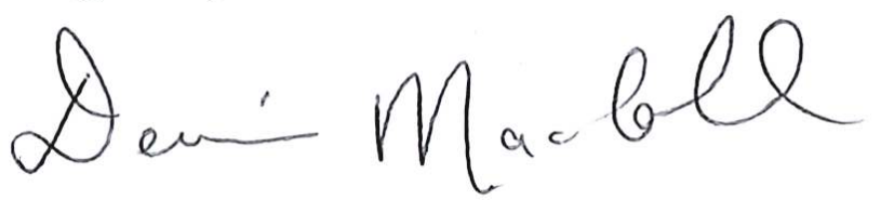

Denise MacColl
Head Teacher

