Our Ref: DM/JC

Date: Monday 20th April 2026

Dear Parent / Carer,

We would like to welcome you back following the Easter break and we look forward to seeing you for the remainder of this academic year. Please see below dates for your diary for the last term of 2026.

Dates for Your Diary - 2026
Monday 20th April | Pupils Return from Easter Break
Wednesday 22nd April | Ochiltree Cattle Show
Monday 4th May | School Holiday
Wednesday 6th May – Friday 8th May | P7 Residential to Inverclyde Sports Centre
Thursday 7th May | In Service Day
Friday 8th May | P6 to Boswell Book Festival
Wednesday 13th May | Whole School Trip to Glasgow Science Centre
Thursday 14th May | P3/4 Trip to Dumfries House
Monday 18th May | P6 STEM Transition Event at Rober Burns Academy
Monday 25th May | Health Week all week – includes Sports Day (Friday 29th May at 1:30pm)
Monday 25th May | P7 RBA 4th Enhanced Transition
Tuesday 26th May | P1 and P7 Class Photographs
Wednesday 27th May | P7 Bump Up to RBA – whole school bump up in pm with new P1 pupils
Thursday 28th May | P7 Bump Up to RBA
Friday 29th May | Report Cards – issued to parents.
Monday 15th June | 50 Years of Ochiltree Primary School – week of celebrations. See details below – please note these may be subject to change.
Friday 19th June | Summer Celebration – Prizegiving in the morning and Summer of ’76 celebration in the afternoon.
Friday 26th June | School Closes 1pm – P7s piped out.

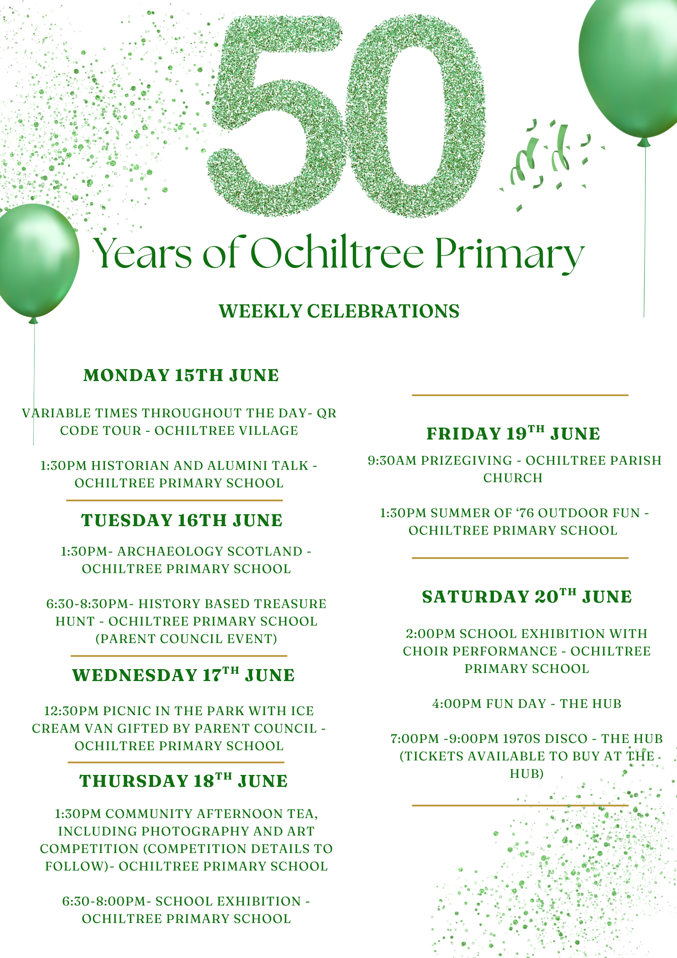
Please keep an eye on the app and on the blog for further details and updates on our activities this session.

Ochiltree Primary school has an open-door policy. If you have anything you wish to share with us, ideas or issues, we would be delighted to see you.

le durachdan,

Denise MacColl
Head Teacher

