P7 Parent/Carer Transition Evening – Monday 25th May 4pm – 6:30pm

Dear Parent/Carers,

With August fast approaching we are so excited to welcome our Primary 7 pupils to The Robert Burns Academy. We would like to invite you to a Parent/Carer evening on:

Monday 25th May from 4pm – 6:30pm at The Robert Burns Academy

- Session 1 – 4pm – 5:30pm – Presentation - Tour
- Session 2 – 5pm – 6:30pm – Presentation - Tour

During this evening there will be a short presentation to provide you with information about the school, and arrangements for the new S1s starting in August.

You will be invited to take a tour of the school and during the tour departments will be offering a chance for you to meet staff and take part in taster sessions. Situated in the hub of the school there will be a variety of partners and the guidance team for you to speak to. The Catering team will also be there with food samples.

We will be running two sessions this year to accommodate numbers. Tickets are available for you to purchase for free from Ticketsource. Please ensure you book a ticket for all members of your party including all parent/carers and pupils who wish to attend. There will be a limit of 4 tickets per family. If you do not book the correct amount of tickets seats will not be available during that session. Tickets are available on a first come, first serve basis. I encourage you to book up early to avoid disappointment!

To book tickets please follow the link below or scan the QR code which will take you to the booking page.Ticketsource will close for bookings on Thursday 21st May 2026.

http://www.ticketsource.com/baronycampus



If you do not have a booking with Ticketsource we will not be able to accommodate you during that session.

Yours sincerely,
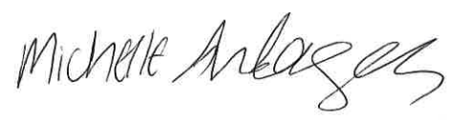
M Anderson
Depute Head Teacher (Year Head S1)

