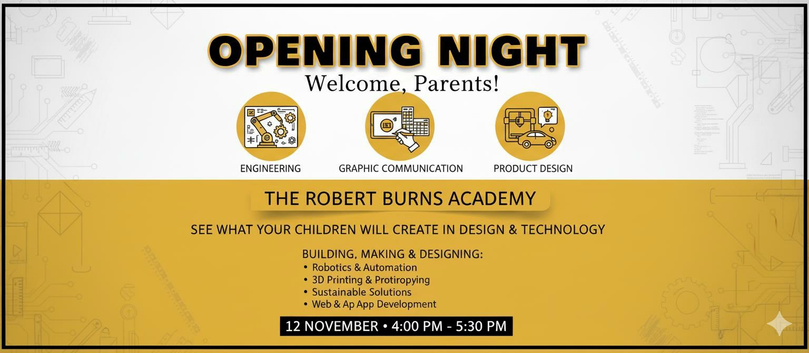
Come and see what our young people are creating!
●
Product Design
●
CAD skills
●
Woodwork and Metalwork projects
●
Laser cutting/3D printing
BUILDING, MAKING & DESIGNING
To avoid disappointment on the night and
ensure we plan for the numbers attending
please make sure you sign up beforehand
Pease email our school office to book your place including your child’s name, parent/carer name and name of Primary School.

eaRobertBurns.Ac@eastayrshire.org.uk
Welcome Parents/Carers and P7 Pupils!

