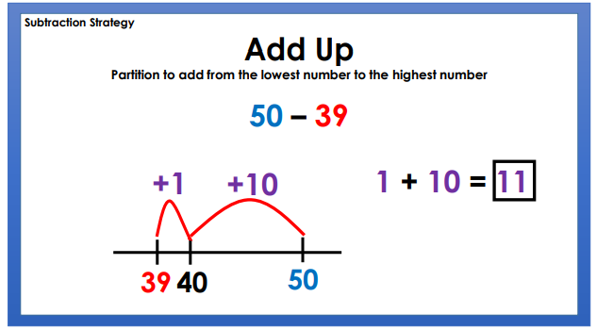

|  |  |  |
| --- | --- | --- |
| Use the counting on/adding up strategy to solve these number statements.  I’m looking for the strategy being used.  Choose a column to complete. | | |
|  |  |  |
| 1. 5 – 2 2. 10 – 3 = 3. 13 – 4 = 4. 15 – 11 = | 1. 22 – 6 = 2. 27 – 12 = 3. 29 – 5 = 4. 18 – 9 = | 1. 49 – 12 = 2. 31 – 25 = 3. 21 – 12 = 4. 62 – 13 = |
|  | | |