Homework WB 8th June 2026

Literacy
  Phonics  This week, we are working on a new sound:  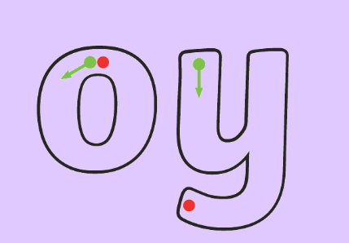      Activity: Practice writing all your words in your homework jotter.  Extension: can you write a sentence for at least two of your words? | Use any of the activities to develop your phonics skills. Can you check that you –  - can hear the phoneme in your words  - see the phoneme in your words  - say the phoneme in your words  - sound out the words  - write the words from your phoneme strips and any common words.  Encourage learners to follow the five step rule:  Say it, Break it, Make it, Blend it and Read it, then Write it.  https://ictgames.com/mobilePage/writingRepeater/index.html  Try learning your phoneme and words, through some active spelling strategies too. You could use pasta, shaving foam, porridge oats, sand to practice making your sounds and words. Can you draw a picture of something that has your sound in it? Use the word list this week to help you!  Please continue to practice all initial sounds at home:  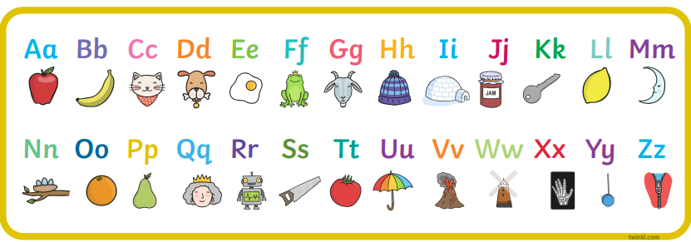  https://www.youtube.com/watch?v=wg-bW_TNmuA
  Reading  Physical reading books have been sent home in folders today. Please make sure that learners bring these every day for reading in class. New books will be given on a Monday. Please make sure learners bring their old books on a Monday, in order to get their new ones handed out. | Read through your book with an adult. Practice blending all your words.  Can you answer the comprehension questions at the back?  Challenge yourself:  Can you make up some questions of your own and ask a family member?  Think about what, when, why, where and this might help you create some questions.
  Writing  Last week’s homework focused on forming our lowercase and uppercase letters correctly.  This week, re-write the following sentences in your jotter, making sure you have used lowercase and uppercase letters in the right places.  I like school because it is fun to learn.  I see a bird in the park and he is green.  The boy plays with his toys in his room. | 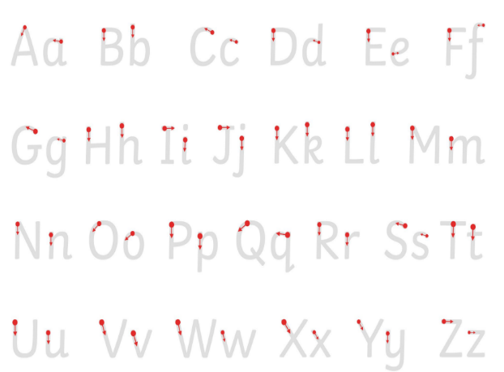
Numeracy | This week, please visit TopMarks and choose your own games to support your learning. Think about what you’ve found tricky in maths this year and use this time to help you revise:  https://www.topmarks.co.uk/  YouTube also has some really great numeracy songs to support counting, money, shape, telling the time, symmetry. Have an explore and see what you enjoy!
Other | The World Cup is about to start! Research a country from the World Cup and draw a poster with some facts into your homework jotter.  For example, can you find out their World Flag, the language they speak, their native animal.  
Contact details | If you have any issues about homework, please contact:  Miss Ronald at eaaimee.ronald@glow.sch.uk  Miss Whiteford at eavictoria.whiteford@glow.sch.uk  Miss Barrett at eajaye.barrett@glow.sch.uk

