Homework WB 4th May 2026

Literacy
  Phonics    This week, we are consolidating our recently taught joined phonemes:  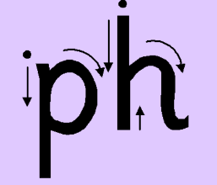      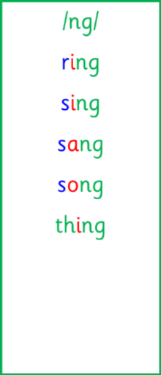  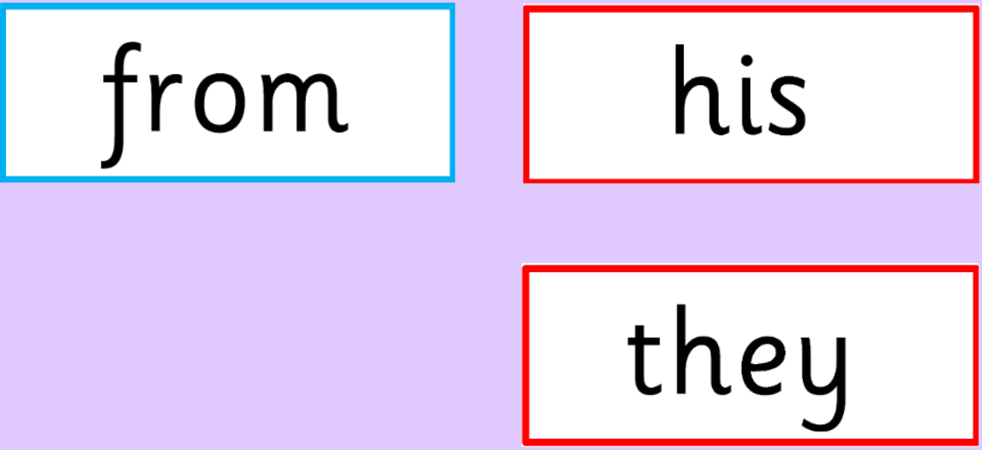     | Use any of the activities to develop your phonics skills. Can you check that you –  - can hear the phoneme in your words  - see the phoneme in your words  - say the phoneme in your words  - sound out the words  - write the words from your phoneme strips and any common words.  Encourage learners to follow the five step rule:  Say it, Break it, Make it, Blend it and Read it, then Write it.  https://ictgames.com/mobilePage/writingRepeater/index.html  Try learning your phoneme and words, through some active spelling strategies too. You could use pasta, shaving foam, porridge oats, sand to practice making your sounds and words. Can you draw a picture of something that has your sound in it? Use the word list this week to help you!  Please continue to practice all initial sounds at home:  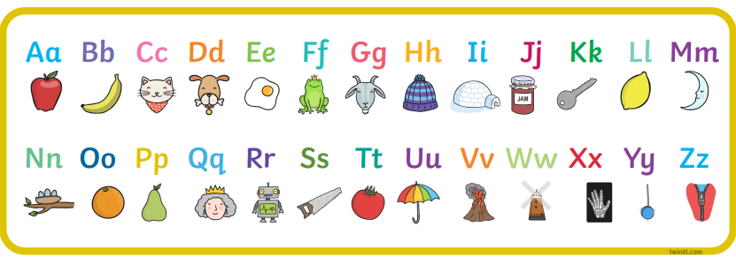  https://www.youtube.com/watch?v=wg-bW_TNmuA
    ph words of the week
    phone
    photo
    dolphin
    phonics
    graph
  Reading  Choose a personal reading story to enjoy with a member of your family.  You could even go to Stewarton library to pick and read a book!  New reading books will be sent home again on Monday 11th May. | 
  Writing  Look at the picture prompt. Write about a time that you went to the beach.  You must use the sentence starter:  “At the beach”.  For example, “At the beach, I had an ice cream with chocolate sprinkles.” | 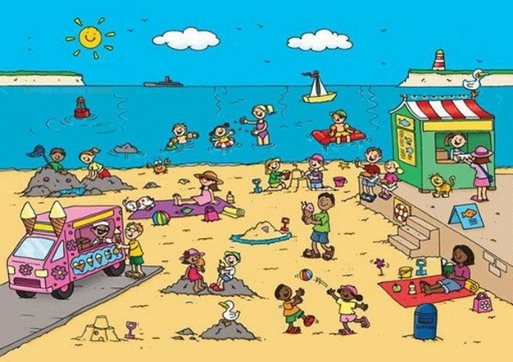
Numeracy | Subtraction  Practice your subtraction skills -  https://www.topmarks.co.uk/subtraction/subtraction-to-10  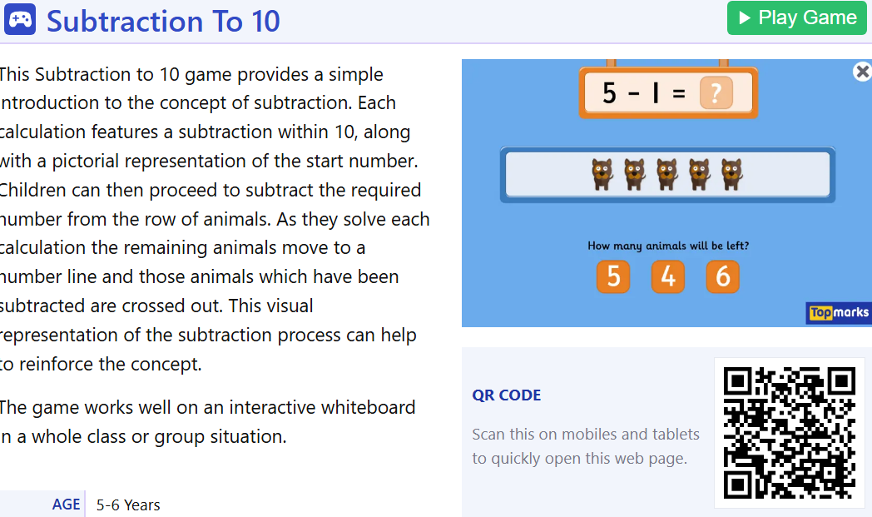
Other | Go on a minibeasts scavenger hunt. Write or draw what you find.  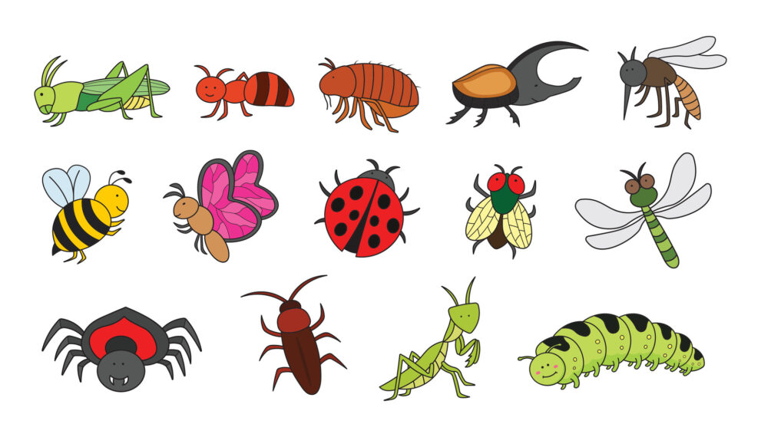
Contact details | If you have any issues about homework, please contact:  Miss Ronald at eaaimee.ronald@glow.sch.uk  Miss Whiteford at eavictoria.whiteford@glow.sch.uk  Miss Barrett at eajaye.barrett@glow.sch.uk

