Homework WB 27th April 2026

Literacy
  Phonics  This week, we are working on a new sound:  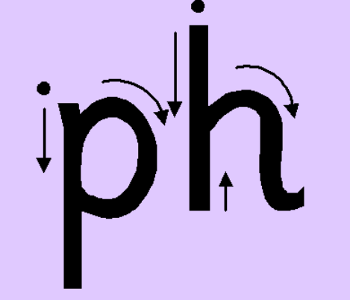   | Use any of the activities to develop your phonics skills. Can you check that you –  - can hear the phoneme in your words  - see the phoneme in your words  - say the phoneme in your words  - sound out the words  - write the words from your phoneme strips and any common words.  Encourage learners to follow the five step rule:  Say it, Break it, Make it, Blend it and Read it, then Write it.  https://ictgames.com/mobilePage/writingRepeater/index.html  Try learning your phoneme and words, through some active spelling strategies too. You could use pasta, shaving foam, porridge oats, sand to practice making your sounds and words. Can you draw a picture of something that has your sound in it? Use the word list this week to help you!  Please continue to practice all initial sounds at home:  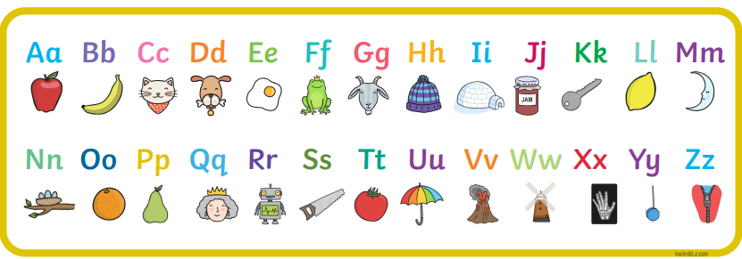  https://www.youtube.com/watch?v=wg-bW_TNmuA
    ph words of the week
    phone
    photo
    dolphin
    phonics
    graph
  Reading  Physical reading books have been sent home in folders today. Please make sure that learners bring these every day for reading in class. New books will be given on a Monday. Please make sure learners bring their old books on a Monday, in order to get their new ones handed out. | Read through your book with an adult. Practice blending all your words.  Can you answer the comprehension questions at the back?  Challenge yourself:  Make a prediction about what could happen next in your stories.
  Writing  Look at the picture prompt and write a sentence about what you can see.  For example, The dog is playing.  You can use the word bank below for any unfamiliar words: | 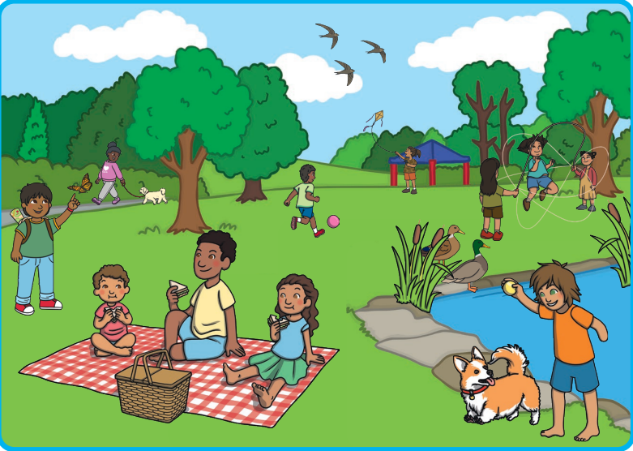
    tree | grass
    picnic | pond
    family | kite
    bird | playing
Numeracy | Data Handling  This week, we are continuing our work on pictograms.  Play these games on TopMarks to explore pictograms and the different ways we can represent data:  https://toytheater.com/fishing/  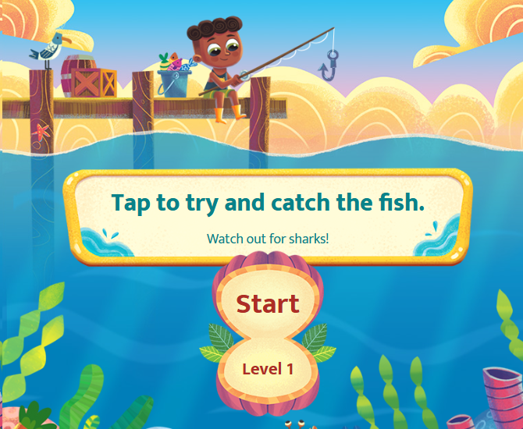  https://toytheater.com/fruit-fall/  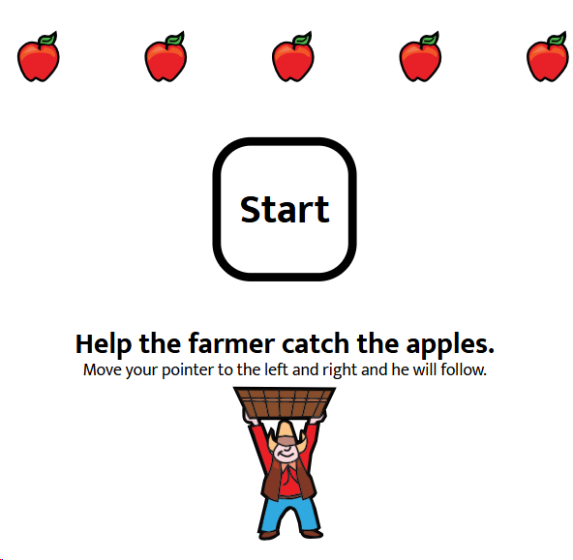
Other | Revise your numbers from 0-10 in French.  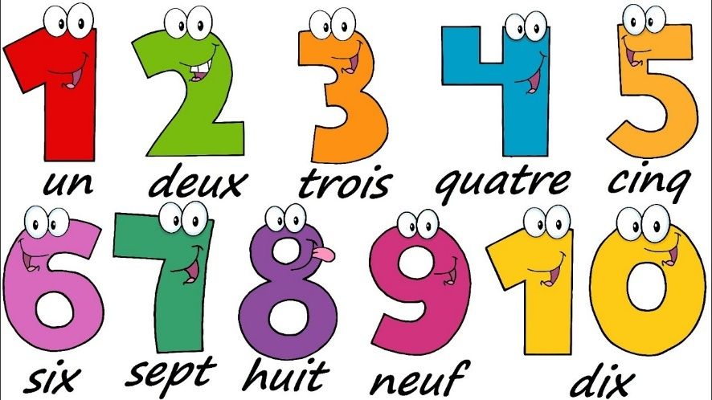  https://www.youtube.com/watch?v=WNOZLPK7-g8  https://www.youtube.com/watch?v=lsc3qLMaCu8
Contact details | If you have any issues about homework, please contact:  Miss Ronald at eaaimee.ronald@glow.sch.uk  Miss Whiteford at eavictoria.whiteford@glow.sch.uk  Miss Barrett at eajaye.barrett@glow.sch.uk

