Homework WB 2nd March 2026

Literacy
  Phonics  Now, we are working on joined phonemes. This week, we are working on:  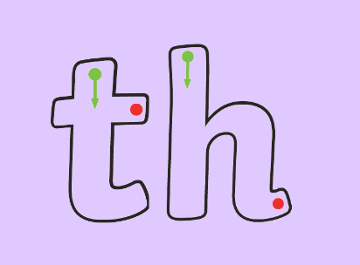  (th, as in thin)  https://www.youtube.com/watch?v=25HeM_ppYDk  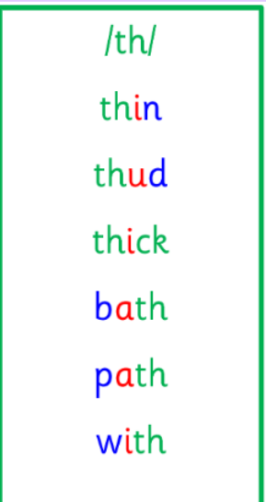  Common words and tricky words  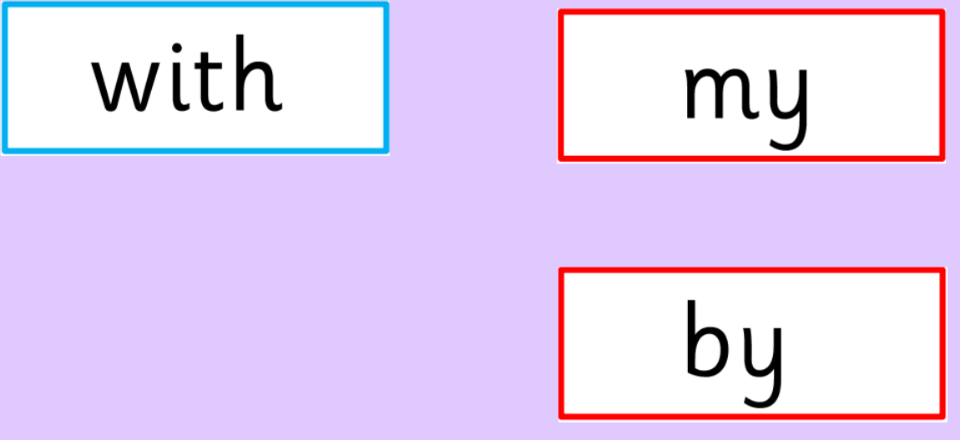  Please continue to practice all initial sounds at home:  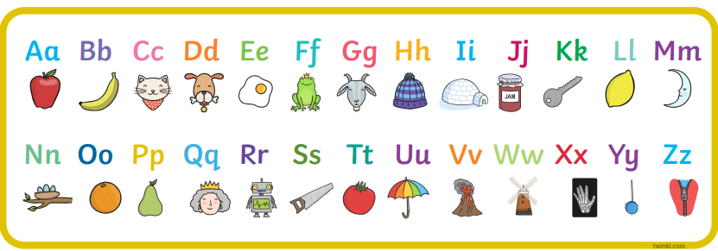  https://www.youtube.com/watch?v=wg-bW_TNmuA | Use any of the activities to develop your phonics skills. Can you check that you –  - can hear the phoneme in your words  - see the phoneme in your words  - say the phoneme in your words  - sound out the words  - write the words from your phoneme strips and any common words.  Encourage learners to follow the five step rule:  Say it, Break it, Make it, Blend it and Read it, then Write it.  https://ictgames.com/mobilePage/writingRepeater/index.html  Try learning your phoneme and words, through some active spelling strategies too. You could use pasta, shaving foam, porridge oats, sand to practice making your sounds and words.  Can you draw a picture of something that has your sound in it? Use the word list this week to help you!
  Reading  Physical reading books have been sent home in folders today. Please make sure that learners bring these every day for reading in class. New books will be given on a Monday. Please make sure learners bring their old books on a Monday, in order to get their new ones handed out. | Read through your book with an adult. Practice blending all your words. Can you answer the comprehension questions at the back?
  Writing  Practice writing your full name.  - Are your letters formed correctly?  - Can you spell and write your surname without help from an adult? | 
Numeracy | Numbers  This week, we have started work on money. Learners are working hard on identifying coins to £2. Talk to an adult about what we need money for? Then, work on recognising the coins on the money mat below:  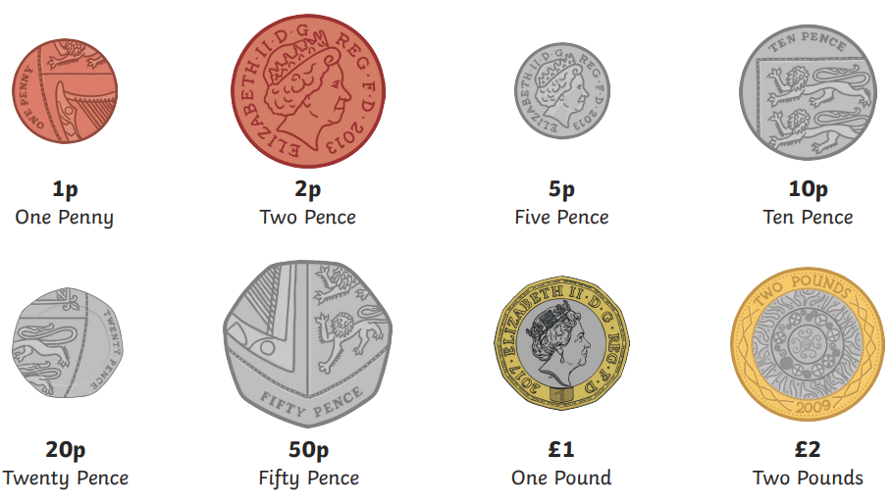  Play TopMarks game – “Coins Game”  https://www.topmarks.co.uk/money/coins-game  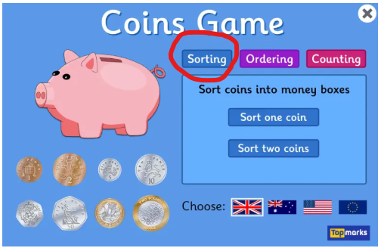  (We have played this game in class, but please remind learners that some of the coins in this are “old money”.)
Other | In Health and Wellbeing, we have been talking about how to look after our bodies. We spoke about food, drinks, exercise, washing our hands, toothbrushing.  Speak to an adult about your learning.  +Draw a picture of ways in which you can look after your body. Use the examples above to help you!
Contact details | If you have any issues about homework, please contact:  Miss Ronald at eaaimee.ronald@glow.sch.uk  Miss Whiteford at eavictoria.whiteford@glow.sch.uk  Miss Barrett at eajaye.barrett@glow.sch.uk

