Homework WB 23rd February 2026

Literacy
  Phonics  We have now finished teaching on all initial taught sounds. Please continue to practice all initial sounds at home:  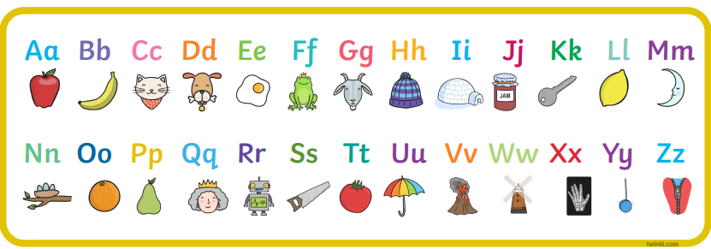  https://www.youtube.com/watch?v=wg-bW_TNmuA  Now, we are beginning to work on joined phonemes. This week, we are working on:      https://www.youtube.com/watch?v=9q-bPLcmPnQ  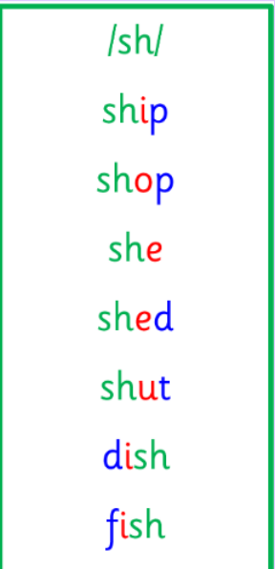  Common words and tricky words  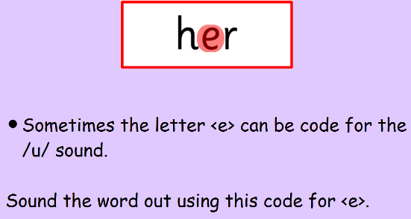  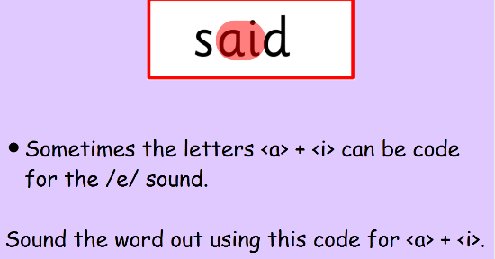  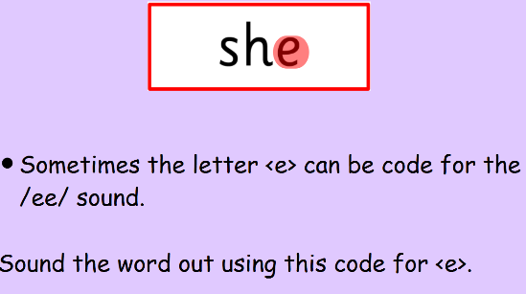 | Use any of the activities to develop your phonics skills. Can you check that you –  - can hear the phoneme in your words  - see the phoneme in your words  - say the phoneme in your words  - sound out the words  - write the words from your phoneme strips and any common words.  Encourage learners to follow the five step rule:  Say it, Break it, Make it, Blend it and Read it, then Write it.  https://ictgames.com/mobilePage/writingRepeater/index.html  Try learning your phoneme and words, through some active spelling strategies too. You could use pasta, shaving foam, porridge oats, sand to practice making your sounds and words.  Can you draw a picture of something that has your sound in it? Use the word list this week to help you!
  Reading  Physical reading books have been sent home in plastic folders today. Please make sure that learners bring these every day for reading in class. New books will be given on a Monday. Please make sure learners bring their old books on a Monday, in order to get their new ones handed out. | Read through your book with an adult. Practice blending all your words. Can you answer the comprehension questions at the back?
  Writing  Write a character description of Katie Morag. You can look at Katie Morag from the books or the TV show. What do you notice about her? Think about her hair, her clothes, her smile.  Use your spelling strategies to sound out your words.  Remember finger spaces, capital letters and full stops. |   
Numeracy | Numbers  Practice your addition, by playing Robot Addition on TopMarks.  Talk to an adult about your answers and explain how you reached your answers.  https://www.topmarks.co.uk/addition/robot-addition  Start with Addition to 10. Can you challenge yourself to try addition to 15, using the number line on Robot Addition?
Other | In P.E., we have been doing ball skills.  Practice rolling, dribbling, throwing and catching with a member of a family. Remember to follow the ball with your eyes!
Contact details | If you have any issues about homework, please contact:  Miss Ronald at eaaimee.ronald@glow.sch.uk  Miss Whiteford at eavictoria.whiteford@glow.sch.uk  Miss Barrett at eajaye.barrett@glow.sch.uk

