Homework WB 9th February 2026

Literacy
  Phonics  This week, we are consolidating two sounds:  Jolly Phonics song ‘qu’ –  https://www.youtube.com/watch?v=zsvzy6DoO54  https://www.youtube.com/watch?v=aurzlkmeuPc&list=RDaurzlkmeuPc&start_radio=1  Jolly Phonics song ‘x’ - https://www.youtube.com/watch?v=fHlUS4NRc9I&list=RDfHlUS4NRc9I&start_radio=1  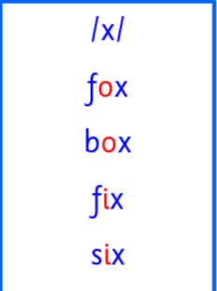  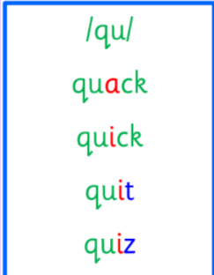  Consolidate common and tricky words from last week:  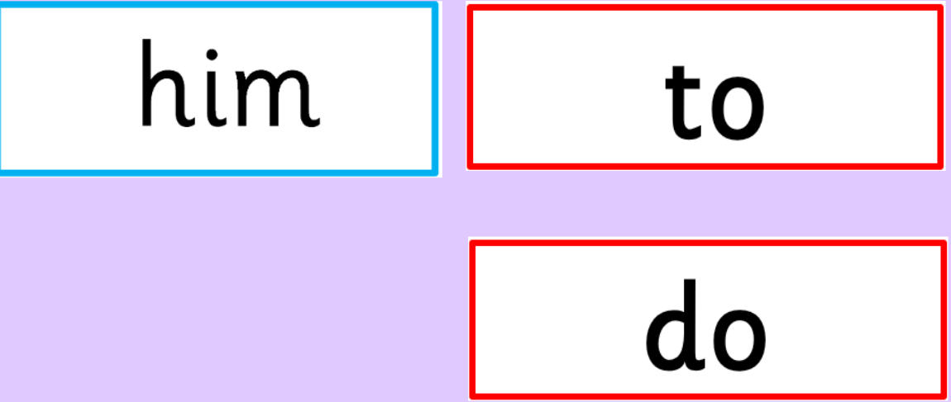 | Work with an adult to check that:  - you can hear your sounds in words  - you can see your sounds in words  - you can say your words of the week  - you can write your sounds and your words of the week  - recognise any rules in your tricky words  Encourage learners to follow the five step rule: Say it, Break it, Make it, Blend it and Read it, then Write it.  https://ictgames.com/mobilePage/writingRepeater/index.html  Try learning your sounds and words, through some active spelling strategies too. You could use pasta, shaving foam, porridge oats, sand to practice making your sounds and words.  Can you draw a picture of something that has your sound in it? Use the word list this week to help you!
    qu
    x
  Reading
  Choose a personal reading story to enjoy with a member of your family.
  You could even go to Stewarton library to pick and read a book!
  New Rocket Phonics books will be sent home on Monday 16th.
  Writing  Write a sentence using one of these words of the week:  fox  box  six  quick | 
Numeracy | Measurement  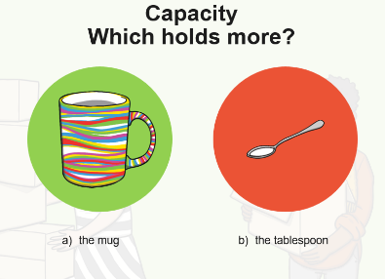  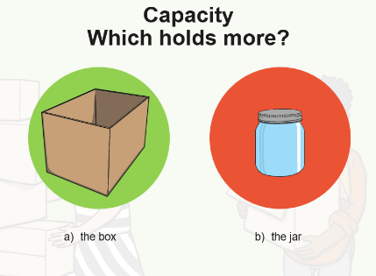  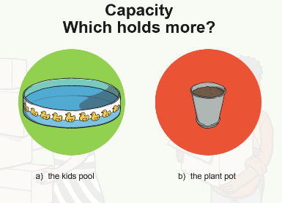  Learners are working on capacity. Answer the following questions with an adult:  Go on a scavenger hunt and see if you can find:  An object that holds 5 pieces of pasta  An object that holds a small teddy  An object that holds more than 5 pieces of pasta  An object that holds more than a small teddy
Other | Go on a senses walk with an adult. Think about what you can hear, see, smell and touch?
Contact details | If you have any issues about homework, please contact:  Miss Ronald at eaaimee.ronald@glow.sch.uk  Miss Whiteford at eavictoria.whiteford@glow.sch.uk  Miss Barrett at eajaye.barrett@glow.sch.uk

