Homework WB 26th January 2026

Literacy
  Phonics  This week, we are working on two new sounds:  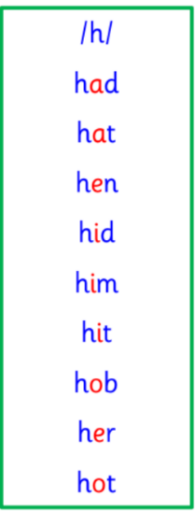  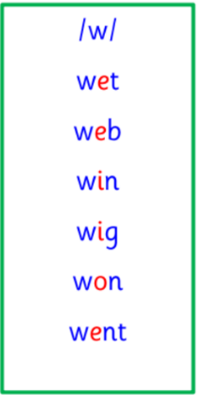  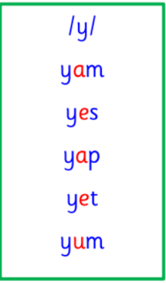  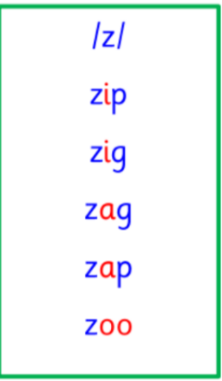  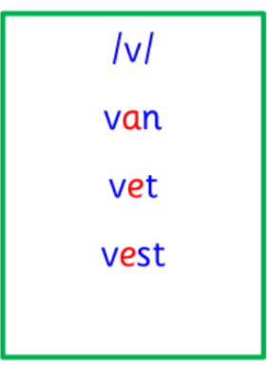  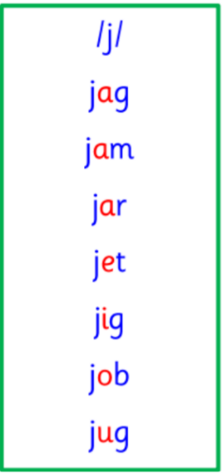  Common and tricky words  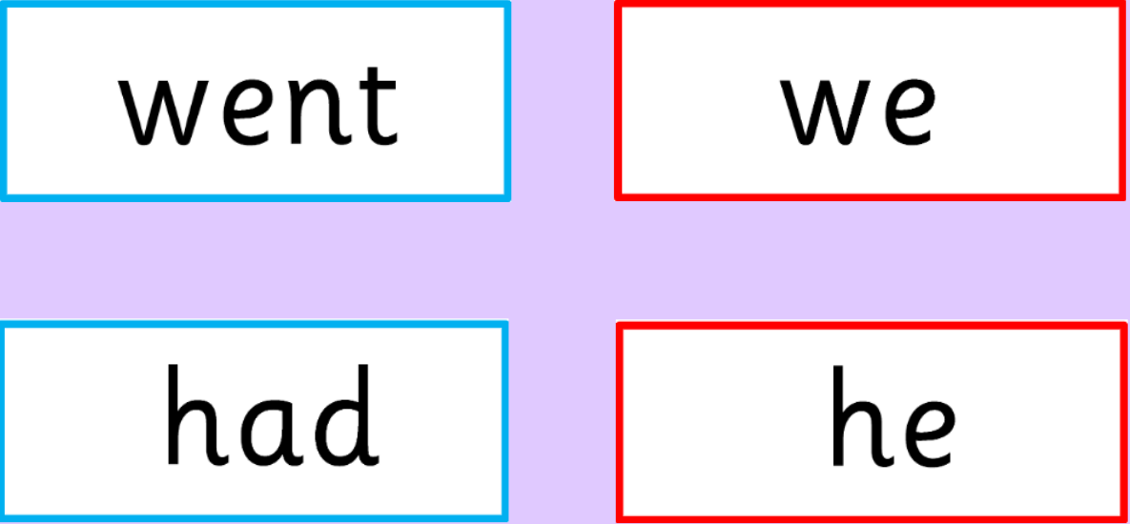    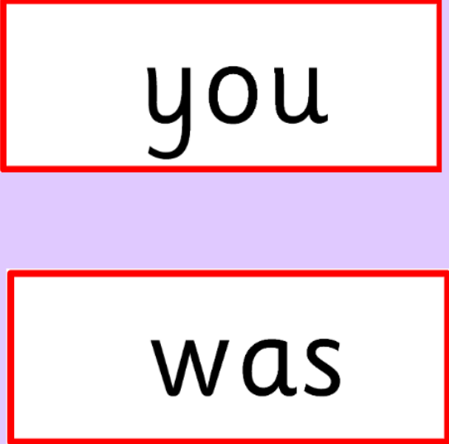 | This week is a consolidation week. We are recapping what we have learnt so far. Check that:  - you can hear your sounds in words  - you can see your sounds in words  - you can say your words of the week  - you can write your sounds and your words of the week  - recognise any rules in your tricky words  Encourage learners to follow the five step rule: Say it, Break it, Make it, Blend it and Read it, then Write it. https://ictgames.com/mobilePage/writingRepeater/index.html  Try learning your sounds and words, through some active spelling strategies too. You could use pasta, shaving foam, porridge oats, sand to practice making your sounds and words.  Create verbal sentences with an adult that include your words of the week.  Challenge: can you write a sentence that includes one or more of your words?
    h | w | j
    v | y | z
  Reading  Physical reading books have been sent home in plastic folders today. Please make sure that learners bring these every day for reading in class. New books will be given on a Monday. Please make sure learners bring their old books on a Monday, in order to get their new ones handed out. | Read through your book with an adult. Practice blending all your words. Can you answer the comprehension questions at the back?
  Writing | Can you use you spelling skills to create some sentences using your words for this week’s sounds (h, w, j, v, y and z)?
Numeracy | Measurement  This week, we continued our work on measurement, looking at weight.  Discuss with an adult what the terms: heavy and light, heavier and lighter mean. Can you give some examples for each?  Then go on a weight hunt around your house. Draw anything you find that is heavy and light.
Other | This week, in topic, we are learning about different Scottish wildlife. Discuss with an adult the wildlife and animals we have been talking about.  For example: red deer, red squirrel, grey seal, otter, highland cow, hedgehog, pine marten, adder, badger, brown hare.  What is your favourite and why?  Have you every been of this Scottish wildlife?  Draw a picture of your favourite Scottish wildlife and write the name of the animal underneath.
Contact details | If you have any issues about homework, please contact:  Miss Ronald at eaaimee.ronald@glow.sch.uk  Miss Barrett at eajaye.barrett@glow.sch.uk

