Homework WB 12th January 2026

Literacy
  Phonics  This week, we are working on two new sounds:  Jolly Phonics song ‘j’ - https://www.youtube.com/watch?v=hHbTRh1TULs&list=RDhHbTRh1TULs&start_radio=1  Jolly Phonics song ‘v’ - https://www.youtube.com/watch?v=IpjfnlCrXyg&list=RDIpjfnlCrXyg&start_radio=1  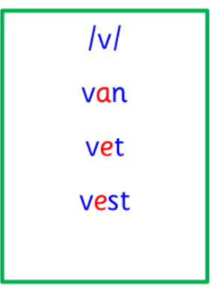  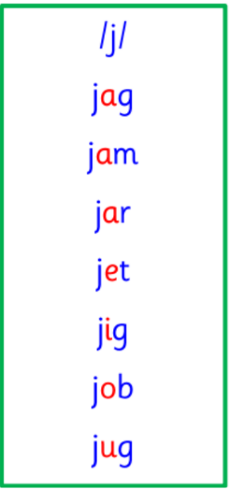  Common and tricky words   | Work with an adult to check that:  - you can hear your sounds in words  - you can see your sounds in words  - you can say your words of the week  - you can write your sounds and your words of the week  - recognise any rules in your tricky words  Encourage learners to follow the five step rule: Say it, Break it, Make it, Blend it and Read it, then Write it.  https://ictgames.com/mobilePage/writingRepeater/index.html  Try learning your sounds and words, through some active spelling strategies too. You could use pasta, shaving foam, porridge oats, sand to practice making your sounds and words.  Can you draw a picture of something that has your sound in it? Use the word list this week to help you!
    j
    v
  Reading  Please note that we plan to send physical reading books home, as of next week. | Activity:  Enjoy some personal reading of your choice with a member of your family. Discuss: what is happening, who is in your story and where the story is taking place.
  Writing | Activity 1:  In class, learners have been working on writing their first and second name. At home, practice writing your full name in your homework jotters.  Activity 2:  Practice your lowercase and uppercase letters, for all taught sounds.
Numeracy | Numbers  This week, we are starting work on position and direction. Show a member of your family how we:  - Move forwards and backwards  - Move in front and behind  - Move over and under  - Move left and right  Play Position and Location on TopMarks - https://www.iknowit.com/lessons/k-position-and-location.html  Then dance along to Cha Cha Slide to practice your lefts and rights - https://www.youtube.com/watch?v=I1gMUbEAUFw&list=RDI1gMUbEAUFw&start_radio=1
Other | P1 are practising for the school’s upcoming Scots Language week.  On Tuesday 20th January, three learners from each P1 will be chosen to represent their class and perform at the school’s Scottish assembly.  P1’s chosen poem is “The Wee Rid Motor”.  For the next two weeks, please practice the poem with learners at home. Learners should work on volume, tone of voice and actions to go with their performance.  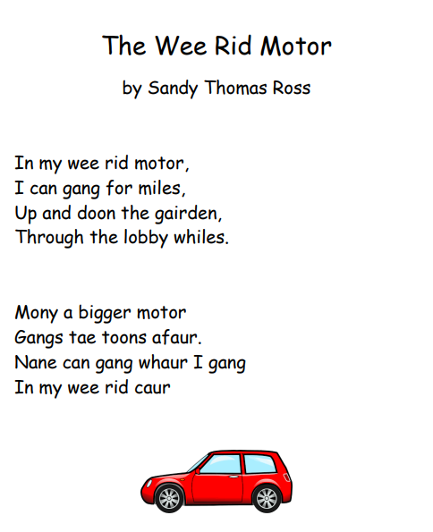  https://www.youtube.com/watch?v=fgVCPTxnQI8
Contact details | If you have any issues about homework, please contact:  Miss Ronald at eaaimee.ronald@glow.sch.uk  Miss Barrett at eajaye.barrett@glow.sch.uk

