Homework WB 5th January 2026

Literacy
  Phonics  This week, we are working on two new sounds:  Jolly Phonics song ‘h’ – https://www.youtube.com/watch?v=v62ivUdHQew  Jolly Phonics song ‘w’ - https://www.youtube.com/watch?v=RRdzsvPUMh0  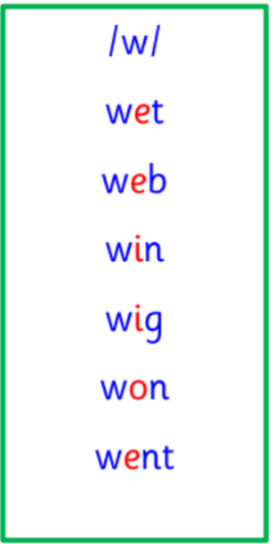  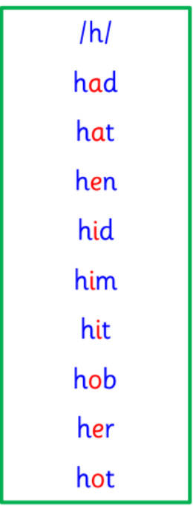  Common and tricky words  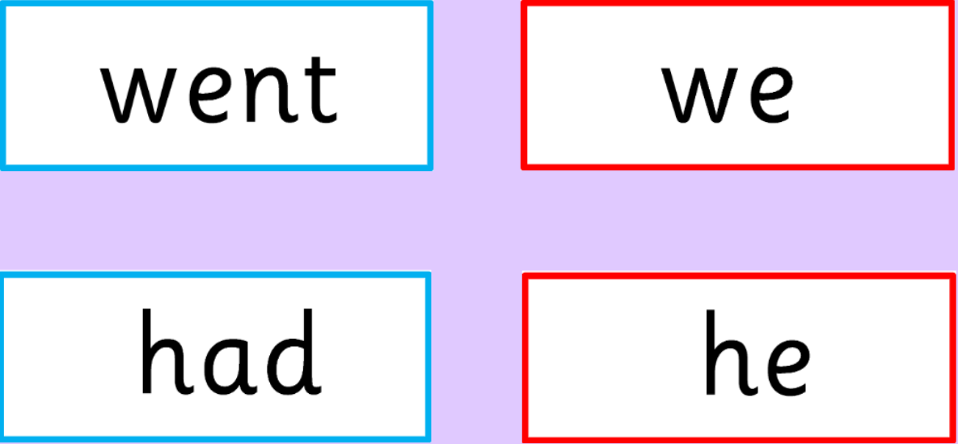 | Work with an adult to check that:  - you can hear your sounds in words  - you can see your sounds in words  - you can say your words of the week  - you can write your sounds and your words of the week  - recognise any rules in your tricky words  Encourage learners to follow the five step rule: Say it, Break it, Make it, Blend it and Read it, then Write it.  https://ictgames.com/mobilePage/writingRepeater/index.html  Try learning your sounds and words, through some active spelling strategies too. You could use pasta, shaving foam, porridge oats, sand to practice making your sounds and words.  Can you draw a picture of something that has your sound in it? Use the word list this week to help you!
    h
    w
  Reading  Watch “The Scarecrows Wedding” on BBC iPlayer and retell the story to a member of your family. | https://www.bbc.co.uk/iplayer/episode/m002hzg2/the-scarecrows-wedding
  Writing  Draw a picture and write a sentence about your Christmas holidays.  Challenge: try to include one of our common words this week in your sentence: went or had. | 
Numeracy | Numbers  This week, we have started learning about symmetry. In P1, we want to be able to identify one line of symmetry in shapes, pictures and patterns.  Play the Symmetry Matching Game on TopMarks to test your knowledge:  https://www.topmarks.co.uk/symmetry/symmetry-matching
Other | P1 are practising for the school’s upcoming Scots Language week.  On Tuesday 20th January, three learners from each P1 will be chosen to represent their class and perform at the school’s Scottish assembly.  P1’s chosen poem is “The Wee Rid Motor”.  For the next two weeks, please practice the poem with learners at home. Learners should work on volume, tone of voice and actions to go with their performance.  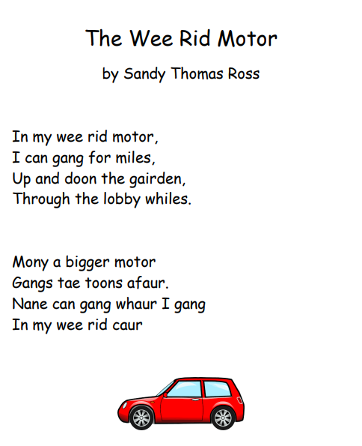  https://www.youtube.com/watch?v=fgVCPTxnQI8  Paper copies of the poem will be handed out on Tuesday 6th January.
Contact details | If you have any issues about homework, please contact:  Miss Ronald at eaaimee.ronald@glow.sch.uk  Miss Barrett at eajaye.barrett@glow.sch.uk

