Homework WB 8th December 2025

Literacy
  Phonics  This week, we are working on two new sounds:  Jolly Phonics song ‘b’ – https://www.youtube.com/watch?v=v62ivUdHQew  Jolly Phonics song ‘u’ - https://www.youtube.com/watch?v=RRdzsvPUMh0  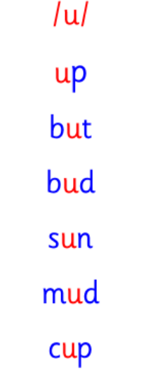  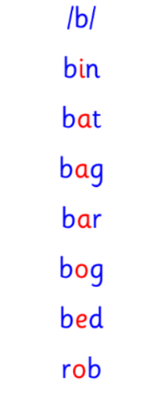  Common and tricky words  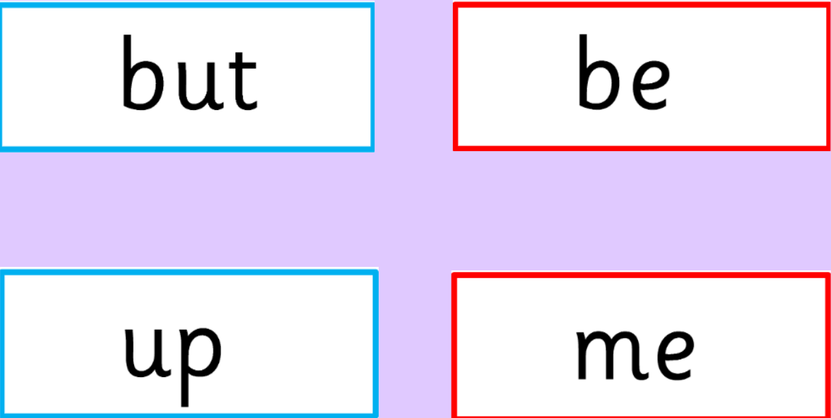 | Work with an adult to check that:  - you can hear your sounds in words  - you can see your sounds in words  - you can say your words of the week  - you can write your sounds and your words of the week  - recognise any rules in your tricky words  Encourage learners to follow the five step rule: Say it, Break it, Make it, Blend it and Read it, then Write it.  https://ictgames.com/mobilePage/writingRepeater/index.html  Try learning your sounds and words, through some active spelling strategies too. You could use pasta, shaving foam, porridge oats, sand to practice making your sounds and words.  Can you draw a picture of something that has your sound in it? Use the word list this week to help you!
    b
    u
  Reading
  There are no Rocket Phonics booked assigned this week.
  Instead, choose a story to read with your family and discuss your favourite characters.
  Writing  There is no set writing homework for this week. However, if learners are wanting to do more at home, then they should practice their lowercase and uppercase letters, and number formation to 20. | 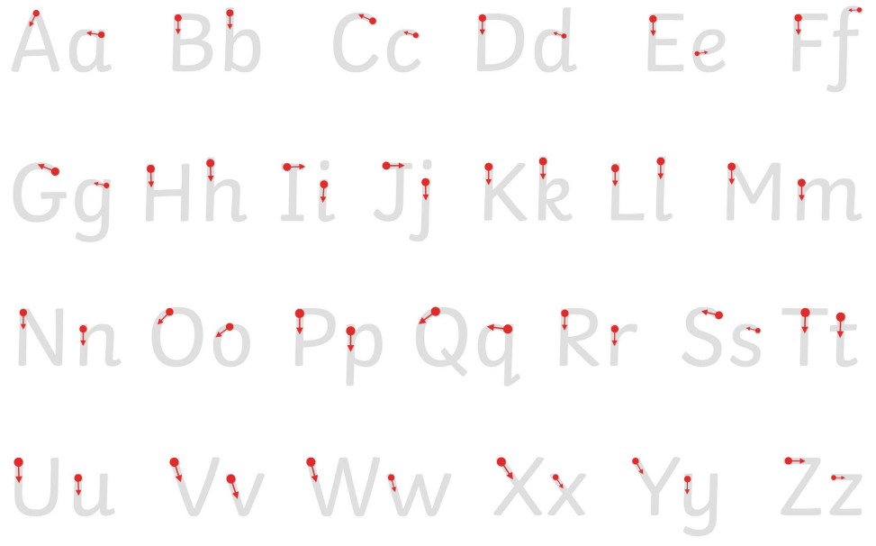  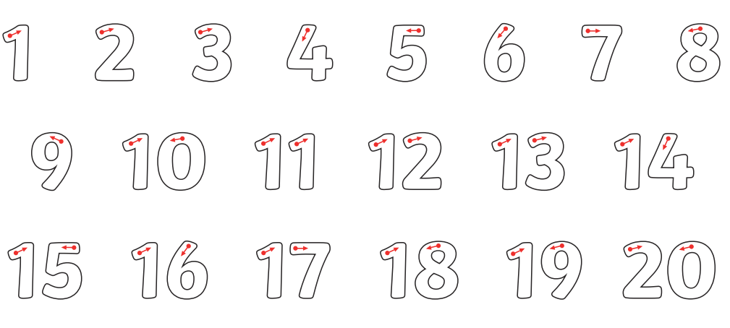
Numeracy | Numbers  Learners have been working on number recognition and ordering, as well as counting to 30.  For consolidation, listen to the songs below and play the following games:  https://www.topmarks.co.uk/learning-to-count/teddy-numbers  https://www.topmarks.co.uk/ordering-and-sequencing/coconut-ordering  https://www.youtube.com/watch?v=S84fcGdEULk&list=RDS84fcGdEULk&start_radio=1  https://www.youtube.com/watch?v=WYJKL62BTTs
Other | Practice and participate in our Nativity
Contact details | If you have any issues about homework, please contact:  Miss Ronald at eaaimee.ronald@glow.sch.uk  Miss Barrett at eajaye.barrett@glow.sch.uk

