Homework WB 1st December 2025

Literacy
  Phonics  This week, we are consolidating the following sounds:  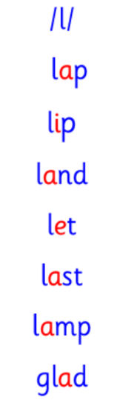  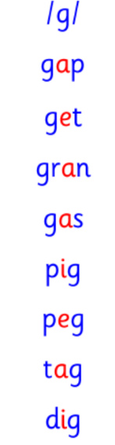  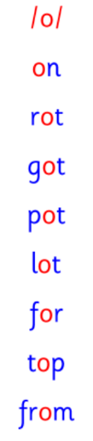  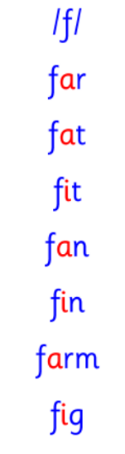  Common and tricky words  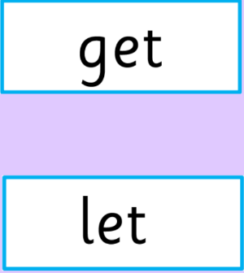  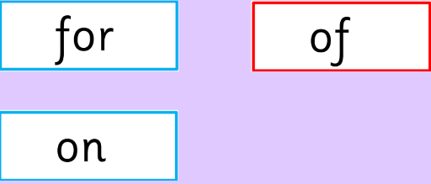 | This week is a consolidation week. We are recapping what we have learnt so far. Check that:  - you can hear your sounds in words  - you can see your sounds in words  - you can say your words of the week  - you can write your sounds and your words of the week  - recognise any rules in your tricky words  Encourage learners to follow the five step rule: Say it, Break it, Make it, Blend it and Read it, then Write it. https://ictgames.com/mobilePage/writingRepeater/index.html  Try learning your sounds and words, through some active spelling strategies too. You could use pasta, shaving foam, porridge oats, sand to practice making your sounds and words.  Challenge: can you write a sentence with one or more of your words?
    g | f
    l | o
  Reading
  Every week, our learners will be assigned a book. Learners should access this online and read their book with an adult. There are also questions and a quiz for each book, to aid learners’ comprehension.
  Please log-in and access your Rockets Phonics account, using the information provided to you at parents’ night. If you have problems, please see Miss Ronald or Miss Barrett at the class door.
  As part of our homework, we are encouraging any pictures of chidren reading to be sent in. As a school we are well on the way to becomming a Gold Reading School and would love to share with our class the different reading oppertunities children have had at home.
  Writing  Draw a picture and write a sentence about our trip to the panto on Wednesday. | 
Numeracy | Fractions  In class, we have started work on fractions. In P1, we are learning about halves.  Talk to an adult about your learning so far.  Activity: draw four shapes in your jotter. Can you show an adult how you would half this shape?  For example:  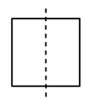
Other | Practice your parts for The Nativity.
Contact details | If you have any issues about homework, please contact:  Miss Ronald at eaaimee.ronald@glow.sch.uk  Miss Barrett at eajaye.barrett@glow.sch.uk

