Homework WB 17th November 2025

Literacy
  Phonics  This week, we are working on two new sounds:  Jolly Phonics song ‘g’ - https://www.youtube.com/watch?v=BKBBmnQBs2Y  Jolly Phonics song ‘l’ - https://www.youtube.com/watch?v=acb_QDHEBPE  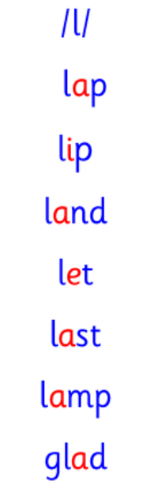  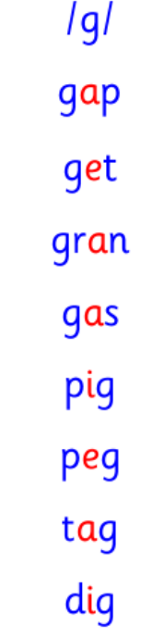  Common words  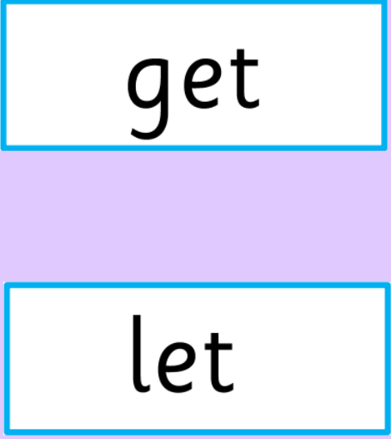 | Work with an adult to check that:  - you can hear your sounds in words  - you can see your sounds in words  - you can say your words of the week  - you can write your sounds and your words of the week  - recognise any rules in your tricky words  Encourage learners to follow the five step rule: Say it, Break it, Make it, Blend it and Read it, then Write it.  https://ictgames.com/mobilePage/writingRepeater/index.html  Try learning your sounds and words, through some active spelling strategies too. You could use pasta, shaving foam, porridge oats, sand to practice making your sounds and words.  Can you draw a picture of something that has your sound in it? Use the word list this week to help you!
    g
    l
  Reading
  Every week, our learners will be assigned a book. Learners should access this online and read their book with an adult. There are also questions and a quiz for each book, to aid learners’ comprehension.
  Please log-in and access your Rockets Phonics account, using the information provided to you at parents’ night.
  Writing  Draw a picture and write a sentence about your favourite part of Children in Need Day in school last Friday. Did you enjoy face painting, designing a biscuit, soaking your teachers with a sponge?! | 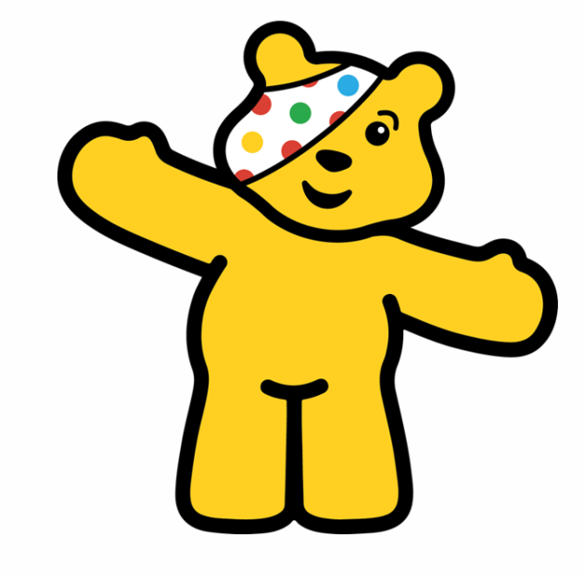
Numeracy | Time  We have been learning to read o’clock on a digital clock.  Using the interactive clock, see if you can make the following times on the digital clock:  2 o’clock  4 o’clock  6 o’clock  8 o’clock  10 o’clock  12 o’clock  https://www.topmarks.co.uk/time/teaching-clock  Challenge: do you remember what AM and PM mean?
Other | Relax your mind and body with some Cosmic Yoga at home - https://www.youtube.com/watch?v=KAT5NiWHFIU
Contact details | If you have any issues about homework, please contact:  Miss Ronald at eaaimee.ronald@glow.sch.uk  Miss Barrett at eajaye.barrett@glow.sch.uk

