Homework WB 27th October 2025

Literacy
  Phonics  This week, we are working on two new sounds:  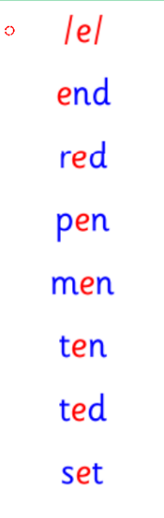  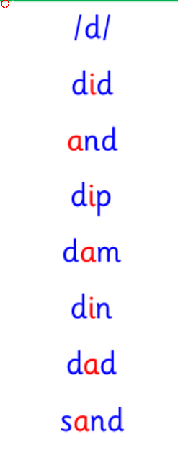  Jolly Phonics song ‘d’ - https://www.youtube.com/watch?v=lyX1CgNfiLI  Jolly Phonics song ‘e’ - https://www.youtube.com/watch?v=6oCvKwLgJOg  Common words  Tricky words  Can you draw a picture of something starting with d and e? | Can you think of words that have your sounds of the week in them? What words have ‘d’? What words have ‘e’? Think of words that start with these sounds too. Work with an adult to check that:  - you can hear your sounds in words  - you can see your sounds in words  - you can say your words of the week  - you can write your sounds and your words of the week  - recognise any rules in your tricky words  Encourage learners to follow the five step rule: Say it, Break it, Make it, Blend it and Read it, then Write it.  https://ictgames.com/mobilePage/writingRepeater/index.html  Try learning your sounds and words, through some active spelling strategies too. You could use pasta, shaving foam, porridge oats, sand to practice making your sounds and words.
    d
    e
    did
    and
    are
  Reading
  In P1, we're learning to share our opinions on texts.
  Choose a personal reading story to enjoy with an adult. Talk to your adult about your favourite character, your favourite part and any parts that you did not like.
  Writing | Draw a witch for Halloween. Remember to add lots of detail!  Challenge: label your witch with the following words: hat, nose and broom.
Numeracy | Time  This week, we are focusing on our days of the week, months of the year and seasons of the year. Listen to the YouTube songs and listen along.  Days of the Week – https://www.youtube.com/watch?v=mXMofxtDPUQ&list=RDmXMofxtDPUQ&start_radio=1  Months of the Year – https://www.youtube.com/watch?v=Fe9bnYRzFvk&list=RDFe9bnYRzFvk&start_radio=1  Seasons of the Year – https://www.youtube.com/watch?v=C_Sc5ZjdfFI&list=RDC_Sc5ZjdfFI&start_radio=1 (Remember in this YouTube video, they sometimes call autumn ‘fall’).  Ask an adult to read out these questions for you to answer:  • What day comes after Tuesday?  • What day comes before Friday?  • What month is Christmas?  • What type of weather do we see in summer?
Other | Go on an autumn walk. Use your senses and see what you notice.  What is the weather like? What colour are the leaves?
Contact details | If you have any issues about homework, please contact:  Miss Ronald at eaaimee.ronald@glow.sch.uk  Miss Barrett at eajaye.barrett@glow.sch.uk

