Homework WB 20th October 2025

Literacy
  Phonics  This week, we are consolidating the following sounds:  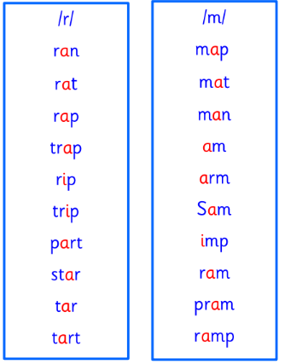  This week, we will also be consolidating our knowledge of common words and tricky words.  Practise the words below with an adult. | This week is a consolidation week. We are recapping what we have learnt so far. Check that:  - you can hear your sounds in words  - you can see your sounds in words  - you can say your words of the week  - you can write your sounds and your words of the week  - recognise any rules in your tricky words  Encourage learners to follow the five step rule: Say it, Break it, Make it, Blend it and Read it, then Write it. https://ictgames.com/mobilePage/writingRepeater/index.html  Try learning your sounds and words, through some active spelling strategies too. You could use pasta, shaving foam, porridge oats, sand to practice making your sounds and words.
    r
    m
    a | at | the
    it | in | I
    an | am | is
  Reading
  This week, in school, we are reading “The Halloween Hustle” on Storyline Online.
  https://storylineonline.net/books/halloween-hustle/
  What adjectives could you use to tell us about ‘Skeleton’ in the story?
  Remember adjectives are describing words.
  Writing | This week, we are focusing on our fine motor skills.  Activity 1: Practice your pencil grip by drawing different types of lines on paper (e.g. straight lines, wavy lines, zig zag lines). See some examples below.  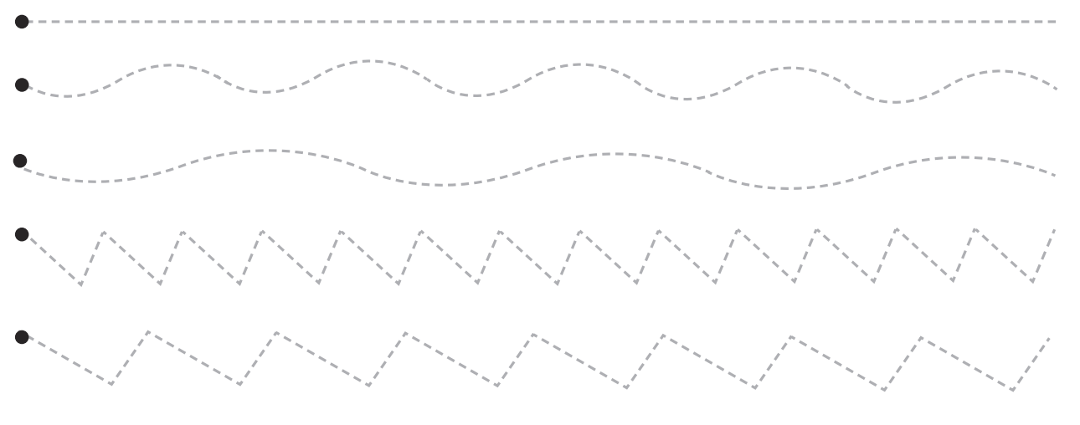  Activity 2: Discuss scissor safety with an adult. Then, practice your scissor skills by cutting along your different types of lines (from activity 1).
Numeracy | Numbers  This week, we are extending our knowledge of numbers.  Activity 1: We are, now, working on counting from 0-30. Practise your counting through songs and rhyme:  https://www.youtube.com/watch?v=WHuuuh9GgP8&list=RDWHuuuh9GgP8&start_radio=1  https://www.youtube.com/watch?v=WYJKL62BTTs  Activity 2: In class, we are also focusing on number recognition.  Can you say the following numbers aloud?  Can you find them on a number line or SPLAT grid?  https://www.topmarks.co.uk/learning-to-count/paint-the-squares
  5 | 9 | 10 | 13 | 17 | 20
Other | On Thursday, P1B are visiting Stewarton Library.  Draw a picture of your favourite part of our class trip.
Contact details | If you have any issues about homework, please contact:  Miss Ronald at eaaimee.ronald@glow.sch.uk  Miss Barrett at eajaye.barrett@glow.sch.uk

