Homework 3rd March

Literacy | Phonics This week, we are working on our next joint phoneme – hard ‘th’. Common words: Use any of the activities to develop your phonics skills. Can you check that you – - can hear the phoneme in your words - see the phoneme in your words - say the phoneme in your words - sound out the words - write the words from your phoneme strips and any common words. Encourage learners to follow the five step rule: Say it, Break it, Make it, Blend it and Read it, then Write it. https://ictgames.com/mobilePage/writingRepeater/index.html  Reading This week, we are launching the new Rockets Phonics resource. Learners have been given their username and password on a slip in their homework pouches. Please log-in and access your Rockets Phonics account. Every learner will be assigned a book this week. Learners should access this online and read their book with an adult. Read your book to your adult. Remember to tell them what your book is called. Use your phonics knowledge to sound out and blend your words. Then, answer the questions at the end of your story.  Writing Draw a picture and write a sentence about our trip to Stewarton library. What did you enjoy? How did we get there? What book did you bring home? Make sure your picture has lots of detail, and your sentence includes full stops and capital letters. https://www.autodraw.com/
Numeracy | In class, we have been learning about money.  We have been learning to pay the exact amount for items by adding.  Access this adding game, follow the yellow highlighted segments.  https://www.topmarks.co.uk/money/coins-game  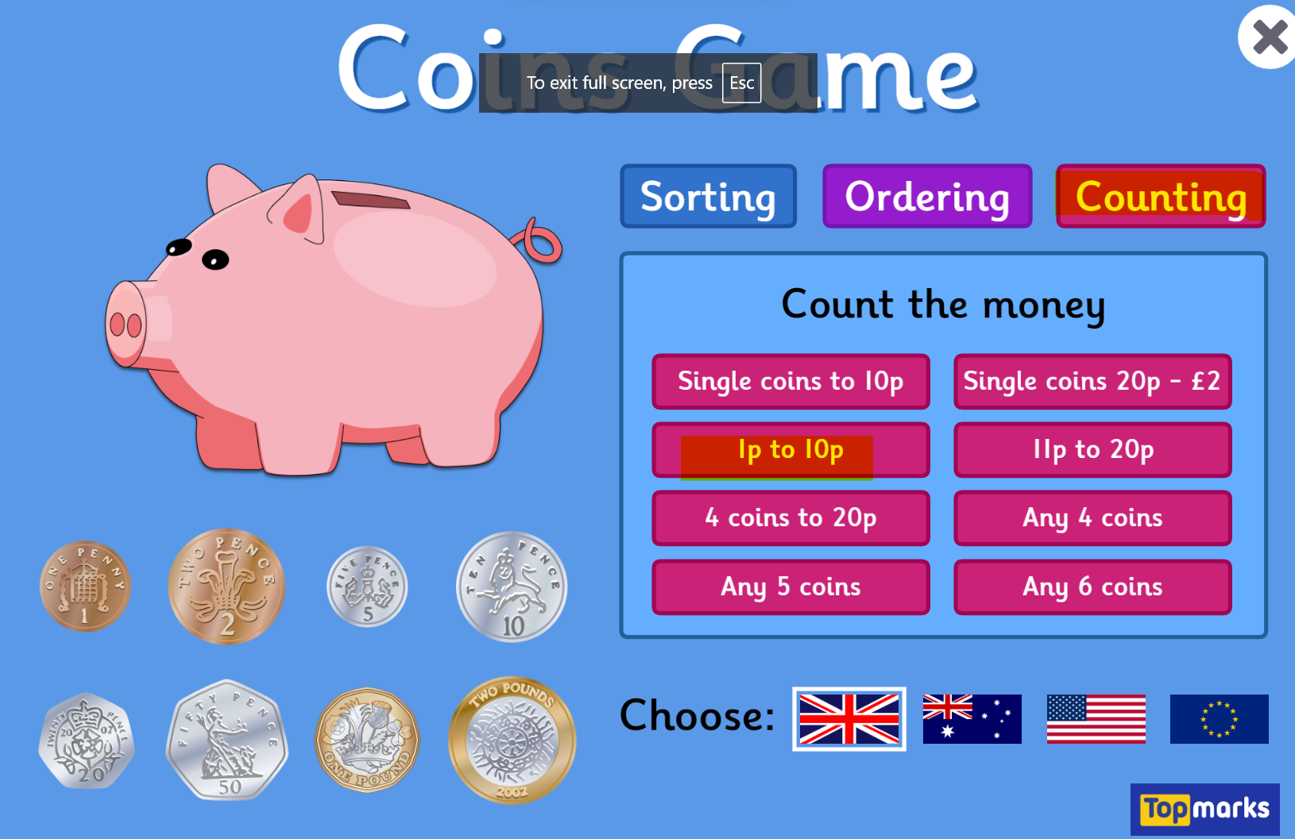  Some of us are needing a little additional focus on the identification of coins. If you have some spare change at home could you find the coins using their values?
Other | Go on a senses walk with an adult. Focus on what you can see, hear, smell, taste and touch.
Contact details | If you have any issues about homework please contact:  Miss Ronald eaaimee.ronald@glow.sch.uk  Miss Barrett at eajaye.barrett@glow.sch.uk

