Homework 19th February
*Please bring your reading book and spelling words in your homework folder everyday as we will be using them in class.*
Literacy | Phonics This week, we are starting work on our first joint phoneme – soft ‘th’. Common words and tricky words: - With - My - By Use any of the activities to develop your phonics skills. Can you check that you – - can hear the phoneme in your words - see the phoneme in your words - say the phoneme in your words - sound out the words - write the words from your phoneme strips and any common words. Encourage learners to follow the five step rule: Say it, Break it, Make it, Blend it and Read it, then Write it. https://ictgames.com/mobilePage/writingRepeater/index.html  Reading Read your book to your adult. Remember to tell them what your book is called. There are some words that we cannot sound out in our books yet as we have not learnt all of our spelling rules. Our adults at home can help with this. With all CVC words, however, we want to be using the letter sounds and blending those words to read. We are also focusing on the importance of using your finger to follow the words as you read.  Writing Draw a picture of a Scottish wild animal and write a sentence telling your family where it lives or what it eats. Use your knowledge of sounds to break words and spell them. https://www.autodraw.com/
Numeracy | In class, we have started learning about money.  We have been learning to pay the exact amount for items by adding.  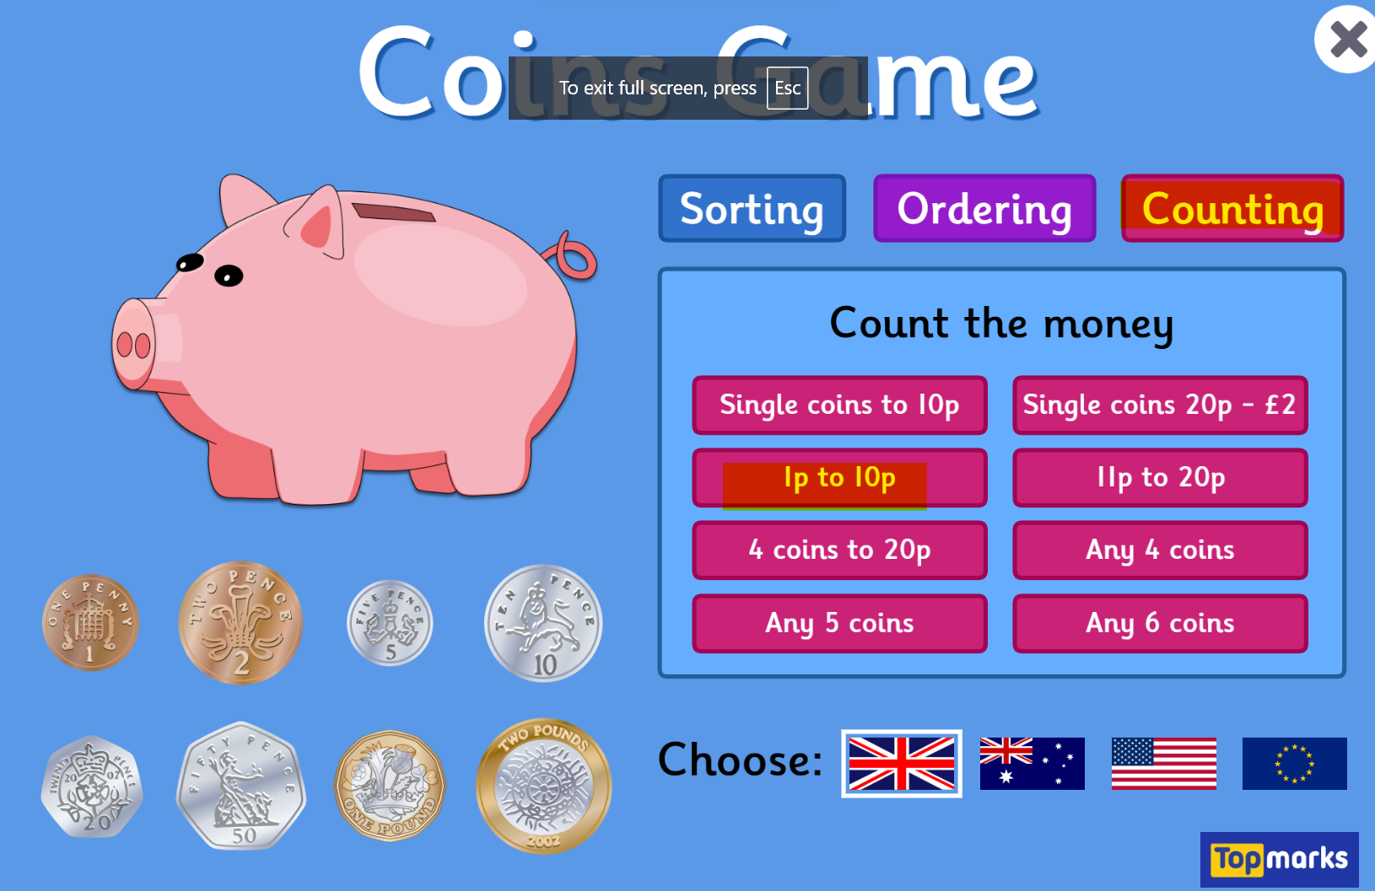  Access this adding game, follow the yellow highlighted segments.  https://www.topmarks.co.uk/money/coins-game
Other | This month’s article from the UNCRC is 16 The Right to Privacy.  Discuss with your adults what you think privacy means.  Think about a fairy tale such as Goldilocks and the Three Bears.  Did Goldilocks respect the privacy of the bears?  What happened because of this?
Contact details | If you have any issues about homework please contact:  Miss Ronald eaaimee.ronald@glow.sch.uk  Miss Barrett at eajaye.barrett@glow.sch.uk

